

Checking Out - Your step-by-step guide

Below is detailed information on making checking out of your flat as straight forward as possible.

Please check you contract to make sure you know when your tenancy ends. Check out time is 10am.

If you have any questions the Sanctuary Students team will be able to help you.

To ensure you do not incur charges for late checkout or non return of keys, here’s what you’ll need to do:

- On the day you’re ready to move out, place your keys in the check out envelope provided.
- Make sure you complete all the details on the front of the envelope so we know who you are.
- Return the completed envelope and keys to the Office/Reception before you leave.

Please be aware that Sanctuary Students will still carry out flat inspections after you have left and if your room/shared areas do not meet the standards required; charges will be applied. To avoid any charges you should:

- Clean your room to these standards and clear up any issues over damages before you leave.
- Include all your keys in the envelope provided, you will be charged for keys/swipe cards/fobs that are not returned!
- Make sure all of your rubbish is removed from the building and placed in the external bins stores and encourage the people you share with to do their bit also.

Remember that anything left in your room or the communal areas on departure will be treated as left property and will be disposed of immediately.

Shared Charges
It is our policy, in the absence of any evidence to the contrary, to apportion any cleaning, repair and redecoration charges for shared flat/kitchen areas equally among all tenants to the flat. You are strongly advised to make every effort to leave your flat and room in a clean and reasonable condition. Even if you are the first person who leaves you will be charged according to the condition of the flat at the time of final inspection.

Here are some images of what an acceptable standard is and what is likely to result in additional charges. If you do not understand what is expected then please contact the Office.
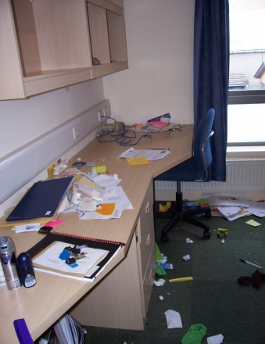
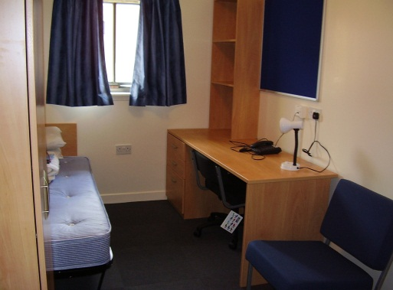

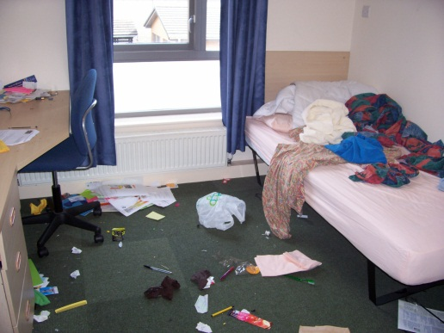
EXAMPLES OF ACCEPTABLE & UNACCEPTABLE BEDROOM
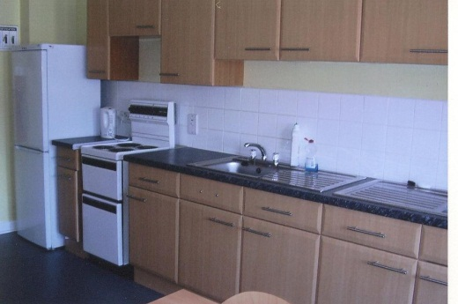
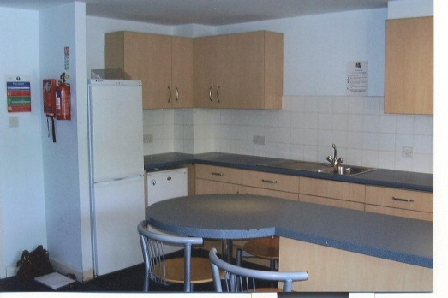
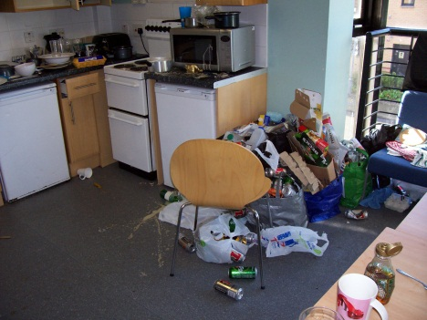
EXAMPLES OF ACCEPTABLE & UNACCEPTABLE KITCHENS
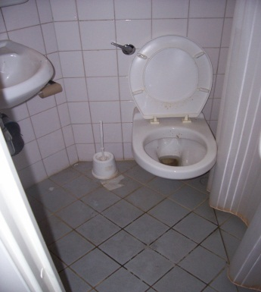
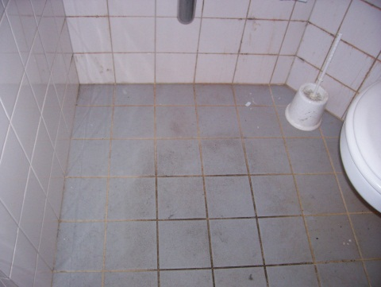
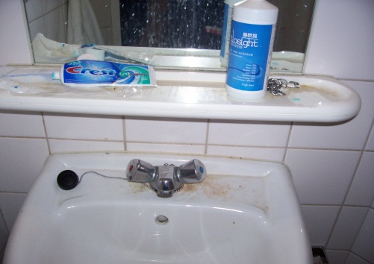

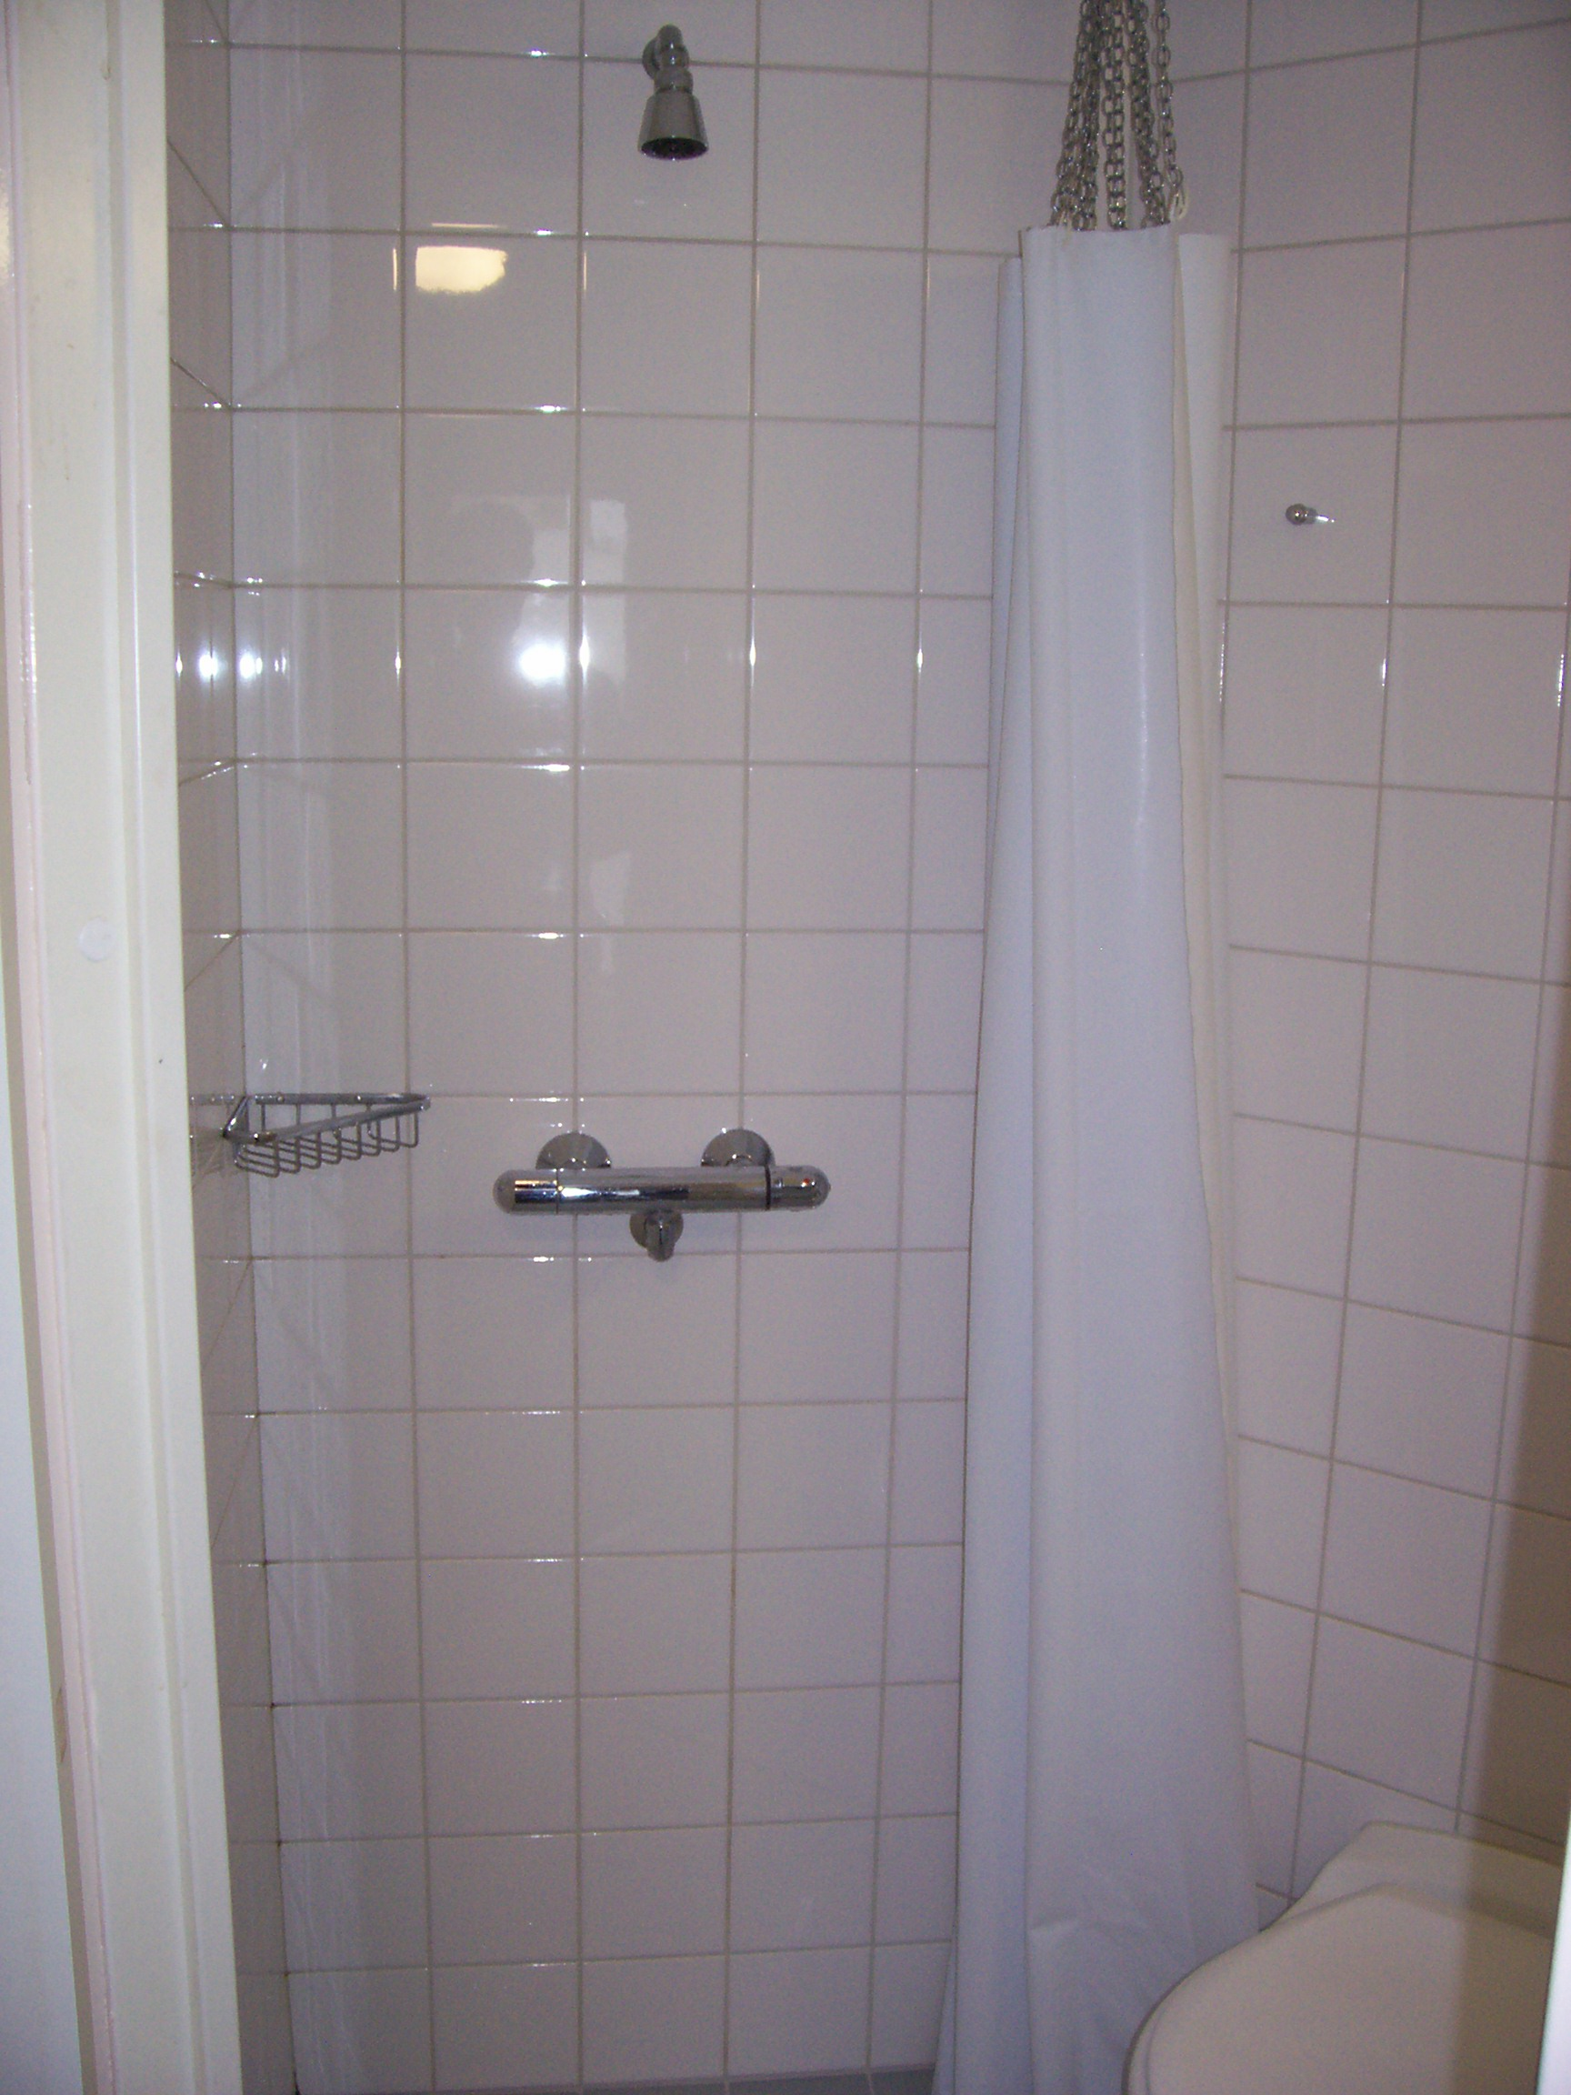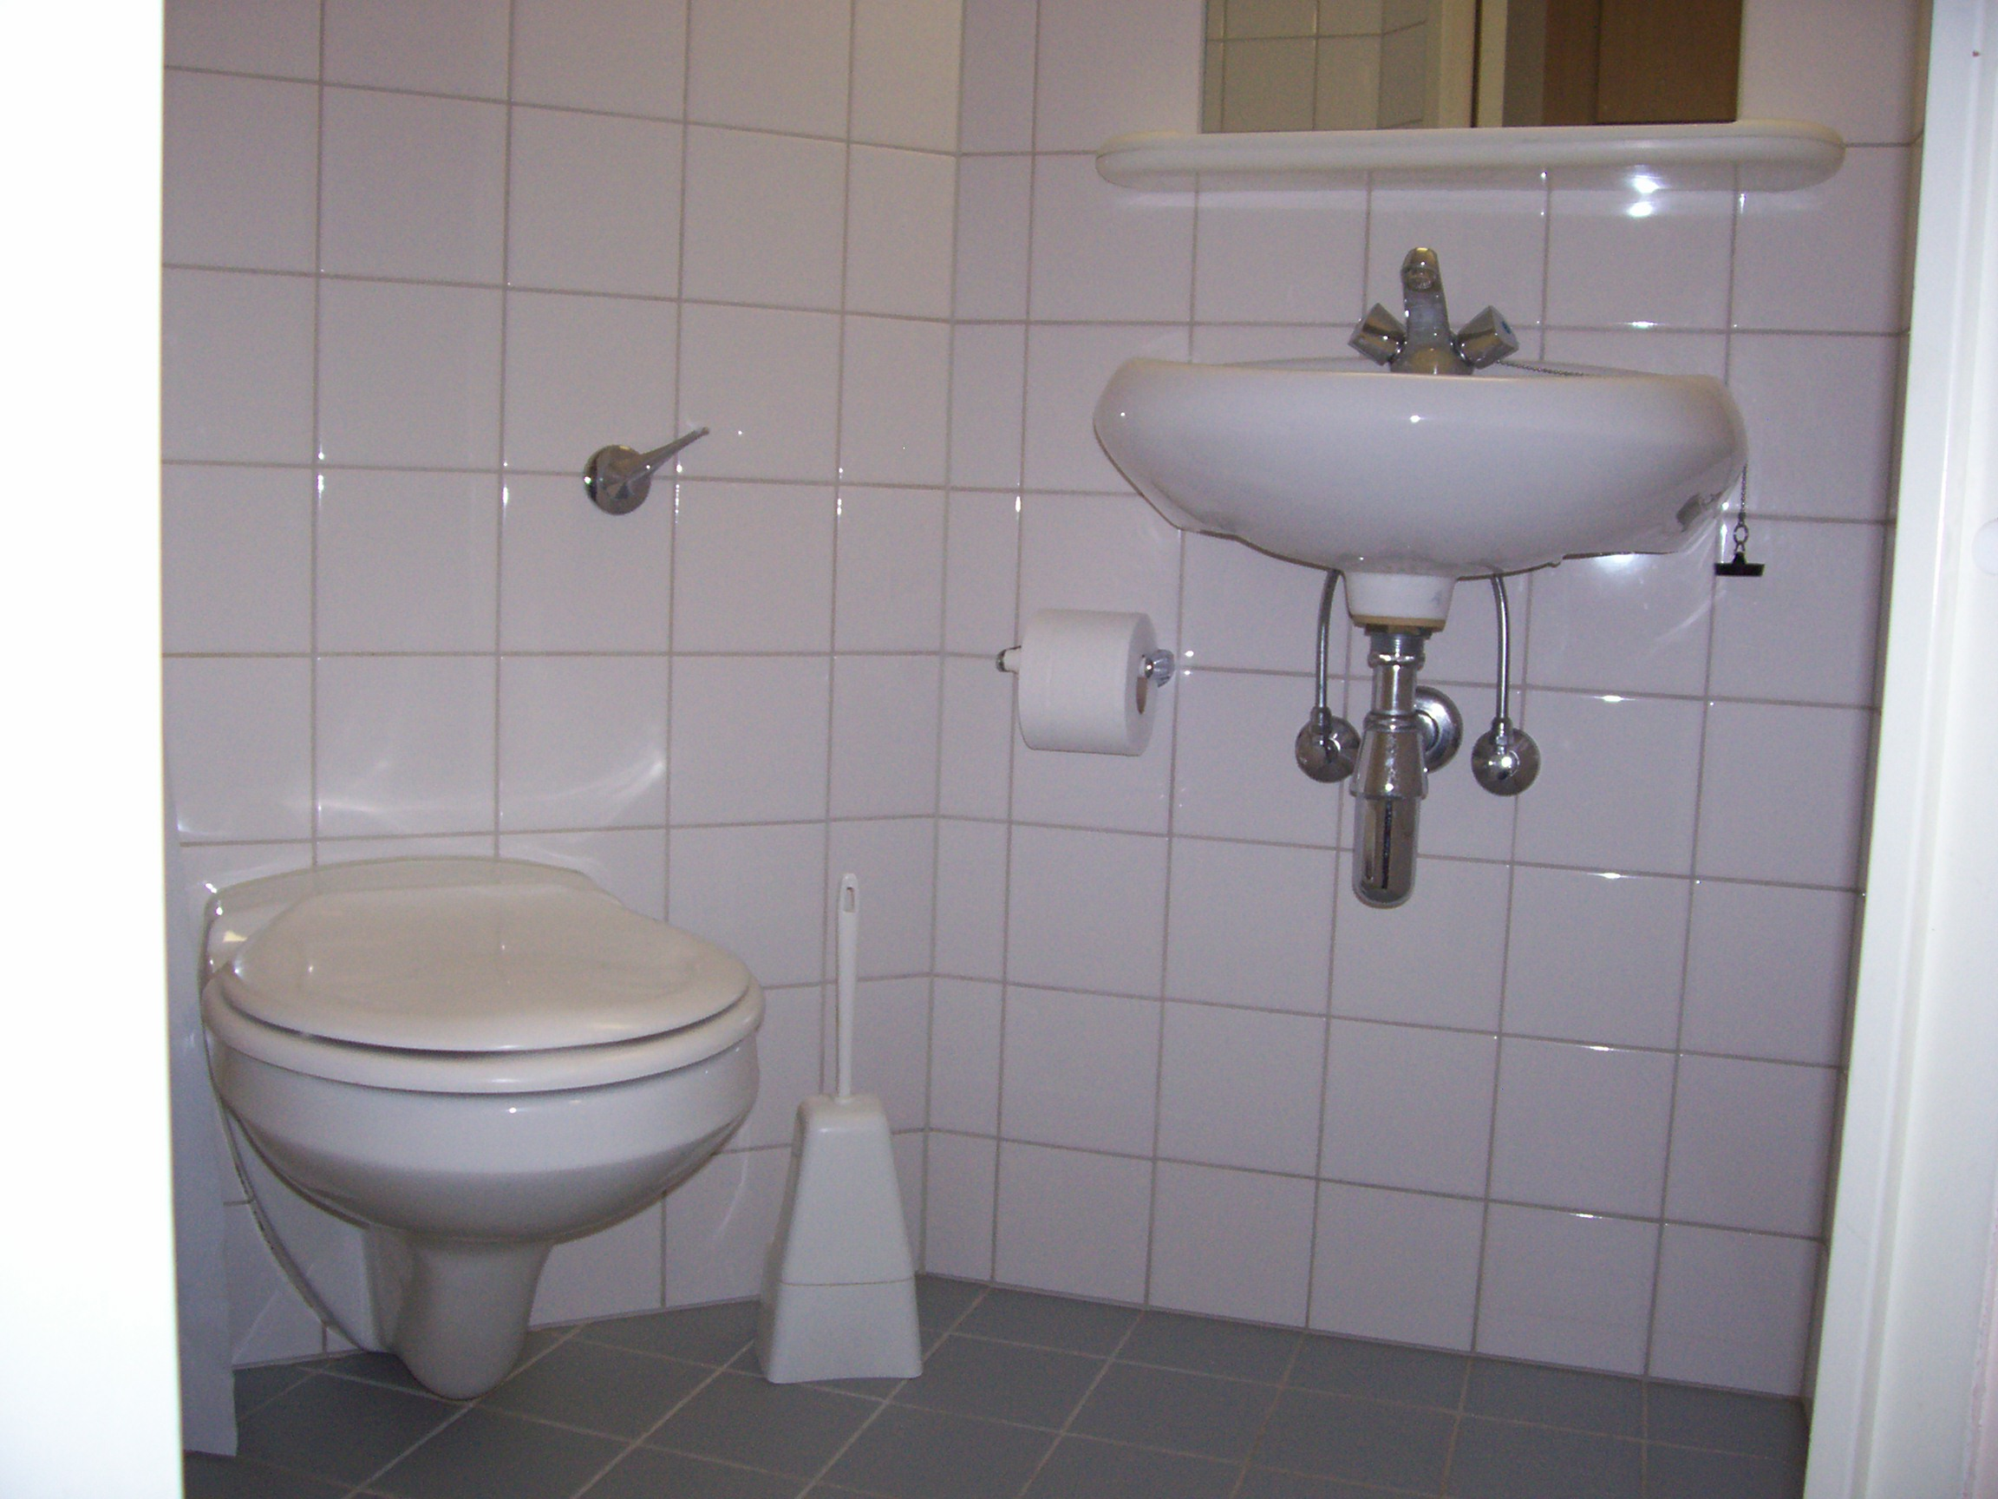

EXAMPLES OF ACCEPTABLE & UNACCEPTABLE SHOWER & TOILET ROOMS

Mail/Parcels
Please make sure that everyone who needs to know is aware of your forwarding address. We are unable to forward or keep mail, any mail that arrives after your departure will be returned to the Post Office marked “Gone Away”/”No Longer At This Address”.

You might like to consider the mail redirection service operated by the Post Office (www.royalmail.com). Please note that the Data Protection Act means that we cannot give your address to anyone.

Your checklist for departing from your Accommodation

- Empty your bin and dispose of any other rubbish in your room.

- Make sure that any rubbish is disposed of appropriately to aid recycling.

- Check your wardrobe, drawers and under the bed for any personal items and clean your room and ensuite (if appropriate).

- Clear out kitchen cupboards and fridge and freezer of any items of food
and belongings. Remember to remove your cutlery and crockery, pots and pans, etc. Clean the communal areas of the flat.

- Remove belongings from communal areas

- Check the laundry for any of your personal items

- Make arrangements for forwarding of your mail and correspondence

- Remember to close all windows and lock all doors

- Pay any outstanding invoices

- Return your keys

Disposal of Recyclable Materials - "Reduce-Re-use-Recycle"
Sanctuary Students actively promote recycling and reuse. In order to reduce the amount of waste sent to landfill a number of recycling points are located close to your accommodation, please dispose of items responsibly.

Wanting to Stay?

If you require accommodation beyond your checkout date you must contact the University to apply for an extension or alternative accommodation.

Queries
If you have any queries after your check out, please call or email us.

