Facilities at work for people who are breastfeeding

The University provides a number of private and quiet facilities for employees who are breast-feeding at home to express and store their milk at work.

When you return to work your line manager will meet with you to re-orientate you back into the workplace, conduct a risk assessment and establish if there are any particular arrangements you may require. Your needs as a breastfeeding parent will be taken into account when scheduling work and this may include changing working conditions or hours of work in addition to providing the facility for breaks to express milk or rest.

Please do not hesitate to contact your School/Directorate HR Officer if you have any questions or need their support and assistance.

City Campus
Basement Floor, Tower Building, Room B.05

The room contains a chair you can relax in, as well as a fridge where the milk can be stored. The room is private and requires a key you can obtain from Tower Reception which you will also be asked to sign in and out when you enter and exit the room. Please contact Tower Reception on 88188 for use of the room.

The expectation is that the room will not be used for any longer than one hour and will be available during normal working hours. If the keys are not returned after one hour a member of reception staff will check in on you for health and safety reasons. You are asked to leave the room clean and ready for the next person to use.

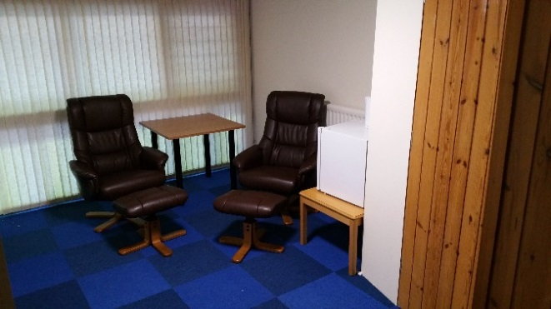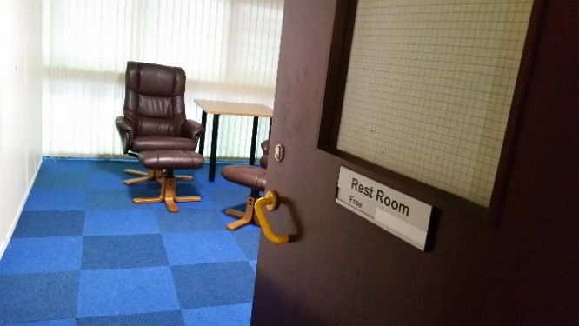

Life Sciences
Wellcome Trust Building

The breastfeeding room contains a chair you can relax in, a bottle warmer, fridge, sink and baby changing area. You are asked to leave the room clean and ready for the next person to use.

This room is located on the Ground Floor of the Wellcome Trust Building and can be booked by contacting CITR Reception on Extension 85828 or email cls-reception@dundee.ac.uk.

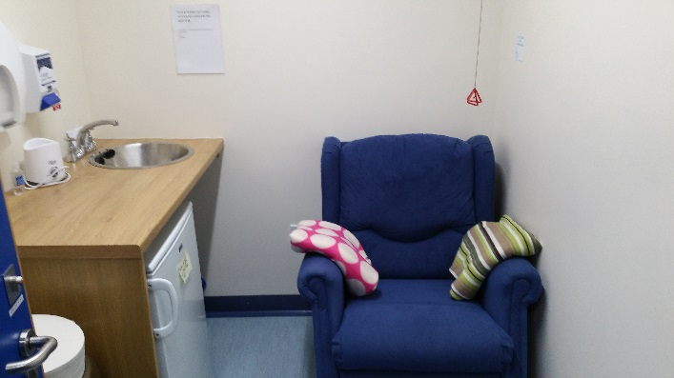 | 