

2025 Annual Staff Diversity Report



Introduction

This Annual Diversity Report summarises the University of Dundee’s data relating to staff and their protected characteristics, and evidences the work done by the University to monitor this data in line with its obligations under the Public Sector Equalities Duties. This information was last published in 2023 and the University’s aim is to publish this report on an annual basis so that it has a clearer and more current understanding of the diversity composition of its staff.

Contents

Introduction 2
Contents 2
About the Data 3
Key Points 4
Overall Staff Composition 5
Age 7
Sex 9
Disability 12
Ethnicity 16
Sexual Orientation 22
Religion 25
Appendix 1 – Data Tables – Staff Composition by School/Directorate, Job Category and Grade 27
Appendix 2 – Data Tables – Composition and Employee Distribution by School/Directorate - Age 29
Appendix 3 – Data Tables – Composition and Employee Distribution by School/Directorate - Sex 30
Appendix 4 – Data Tables – Composition and Employee Distribution by School/Directorate - Disability 35
Appendix 5 – Data Tables – Composition and Employee Distribution by School/Directorate - Ethnicity 38
Appendix 6 – Data Tables – Composition and Employee Distribution by School/Directorate – Sexual Orientation 40
Appendix 7 – Data Tables – Composition and Employee Distribution by School/Directorate – Religion (Grouped) 43
Appendix 8 – Data Tables – Staff Composition by Job Category – Age, Sex, Disability and Ethnicity 46
Appendix 9 – Data Tables – Staff Composition by Grade – Age, Sex, Disability and Ethnicity 50

About the Data

The University routinely collects data from staff in order that it can meet its data collection and reporting obligations to HESA (The Higher Education Statistics Agency). HESA is the official agency for the collection, analysis and dissemination of quantitative information about higher education. The University reports annually to HESA including on employees’ Protected Characteristics data. The definitions and categories used in this report reflect those required by HESA.

In the case of Ethnicity, throughout the report/paper, we have used the acronym ‘BME’ and the term ‘ethnic minority’ interchangeably to denote all those social groups who have been subject to historic and contemporaneous forms of racism and exclusion. We are attentive to the fact that such aggregate forms of conceptualisation are not always ideal and can sometimes mask important differences between groups, and so, when the data are sufficiently robust, we also present information that is disaggregated into categories like Black, Asian and Mixed.

The dataset used to produce the analysis in this report has been expanded to include a wider range of staff than previously. Prior reporting only extended to salaried staff working at the university and directly funded by the university (core funded). The university has a sizable cohort of staff who are non-core funded, i.e. their posts are funded by external partners. These posts are now included in the reporting to provide as complete a picture as possible of the University workforce.

The data used is a snapshot of post holders recorded in the university’s HR system as at 1st August 2024, which is the start of the 2024/25 academic year and does not include non-salaried Associate and Honorary post holders. There are 4367 post holders whose data is analysed within this report comprising 3288 staff with a core funded main post and 1079 staff whose main post is not core funded. All analysis in this report is based on postholders’ most substantive or “main post”. There are only 152 staff members holding more than one post at the census date (3.5% of the total headcount).

Longitudinal data displayed within this report reflects this enhanced method of measuring the University’s staff headcount, i.e. it shows historical data relating to both core funded, and non-core funded main posts.

Of the headcount of 4367 post holders employed at 1st Aug 2024, 3000 posts are in the University’s academic schools, while 1367 staff work in Professional Services Directorates or support functions, including 21 in a subsidiary function (Nursery). 2860 staff hold permanent main posts with 1507 in fixed term or temporary posts.

Key Points

- While the University has an extremely diverse workforce across the range of characteristics examined in this report, there remains an issue with incompleteness of data which should be further examined and address. While information is known for 100% of employees relating to Sex and Age, there are considerable gaps across the remaining four areas. In total, there is a 23% data gap across all data points relating to Disability (18% gap), Ethnicity (15% gap), Sexual Orientation (34% gap) and Religion (26%).

- In respect of both Disability and Ethnicity in particular, there appears to be a correlation between both age and length of service where no data has been collected. We know that the average age of staff has reduced in the last two years and at the same time the rate of unknown data has increased. The University should examine this further to identify the cause of this relationship and to determine whether there is a recent systemic or process related issue affecting data collection.

- Staff are generally evenly represented across all age groups between ages 21 and 60 with a not unsubstantial proportion of staff aged over 60 (10.6%). As stated above, the average age of staff has reduced by over 18 months in the last two years. The University should attempt to understand whether this change relates to older members of staff leaving (or leaving earlier than expected), an increase in recruitment of significantly younger staff, or a combination of both.

- While most of the University’s employees are female (almost 60%), there remain some areas where significant horizontal segregation by sex remains and has traditionally been an issue, for example in Digital and Technology Services (78% male), People (76% female) and Health Sciences (76% female).

- 5.8% of staff have disclosed that they have a disability. This is significantly lower than the local, regional and national rates of disability according to census data. Combined with the fact that disability data has not been collected for over 18% of staff, this may suggest that there is a greater percentage of staff who may have a disability but do not disclose it. The percentage of staff for whom this data is not known has almost doubled since 2022 (from 10% of employees).

- While the University has an ethnically diverse staff population, there remains a data gap of 15%. There is a large range of ethnic diversity across schools and directorates, for example from 0% of staff reporting a BME ethnic origin in the People Directorate up to 31% in the School of Business. Data collection is also an issue in most areas, notably External Relations with a 45% data gap.

- While a substantial data gap exists in relation to Sexual Orientation (33.6%) it has, encouragingly, dropped from 38.8% in 2022. The percentage of staff whose status is known, who are LGB+ has increased from 7.9% of staff to 9.6% of staff and the heterosexual proportion has dropped from 92.1% to 90.4%. This indicates that a disproportionately higher percentage of previously unknown statuses were in fact LGB+, suggesting improving rates of disclosure among LGB+ groups.

Overall Staff Composition

There are 4367 post holders whose data is analysed within this report. The number and percentage of staff in each School and Directorate is shown in the table below, for context.

It shows that almost half (45.2%) of staff are employed across just three schools: Life Sciences with the largest proportion of staff at 17.3%; Medicine with 16.2% of staff and; Humanities, Social Sciences and Law with 11.7% of employees.

Table 1: Staff Composition by School/Directorate at 1 August 2024
School or Directorate | Count of Employees | Percentage of Employees
Life Sciences | 757 | 17.3%
Medicine | 709 | 16.2%
Humanities Social Science and Law | 510 | 11.7%
Science and Engineering | 339 | 7.8%
Art and Design | 297 | 6.8%
Student Services | 293 | 6.7%
Globalisation | 220 | 5.0%
Estates and Campus Services | 214 | 4.9%
Business | 159 | 3.6%
Health Sciences | 144 | 3.3%
External Relations | 129 | 3.0%
Digital and Technology Services | 127 | 2.9%
Dentistry | 85 | 1.9%
Library Academic and Cultural Services | 85 | 1.9%
Peope | 76 | 1.7%
Finance and Procurement | 74 | 1.7%
Research and Innovation | 53 | 1.2%
University Executive and Strategy Office | 48 | 1.1%
Academic and Corporate Governance | 27 | 0.6%
Subsidiaries | 21 | 0.5%
Total | 4367 | 100.0%

Table 2: Staff Composition by Job Category
Job Category | Count of Employees | Percentage of Employees
Academic | 958 | 21.9%
Academic Related | 707 | 16.2%
Clerical | 646 | 14.8%
Research | 525 | 12.0%
Tutors | 444 | 10.2%
Technical | 366 | 8.4%
Casual | 308 | 7.1%
Temporary | 197 | 4.5%
Manual | 190 | 4.4%
External Payroll | 21 | 0.5%
Other Related | 3 | 0.1%
Secondment | 2 | 0.0%
Total | 4367 | 100.0%

The table above shows that the Academic job category is the largest with 21.9% of staff, followed by Academic Related and Clerical Staff at 16.2% and 14.8% respectively.

Age

The average age of staff at the University of Dundee is 43 years and 8 months. The average age of female staff members is marginally younger at 43 years and 5 months compared to 44 years and 1 month for male staff. Directorate staff are also slightly younger at 42 and 8 months compared to 44 and 1 month for staff working in Schools. In both cases these differences are not statistically significant.

Non-core funded staff tend to be younger with an average age of 40 whereas the core funded staff average age is 45.

The largest age decile is the group aged 31-40, accounting for 23% of staff, closely followed by age group 51-60 with 22.6% of staff and 41-50 with 21.9% of staff. Together, staff aged between 31 and 60 account for over two thirds (67.5%) of employees. Only less than 2% of staff are under 21 while 1.5% are aged over 70.

Figure 1: Staff Age Group

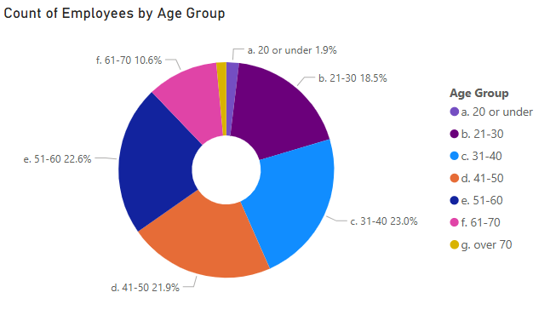

Since the last report, the age group which has grown the most as a percentage of all staff is the 21-30 group which has grown from 10.3% of staff in August 2022 to 18.5% of staff.

The percentage of staff aged 30 or under has increased from 16.2% in 2022 to 20.4% in 2024, an increase of 4.2 percentage points. The same percentage point change was observed in the percentage of all staff 51 or over, which has dropped from 38.9% of staff to 34.7% of staff in the same period. This reflects the overall reduction in the average staff age from 45.3 in 2022 to 43.7. Both male and female staff average age have experienced the same drop (1.6 years).

Figure 2: Average Age by Sex 2022-2024

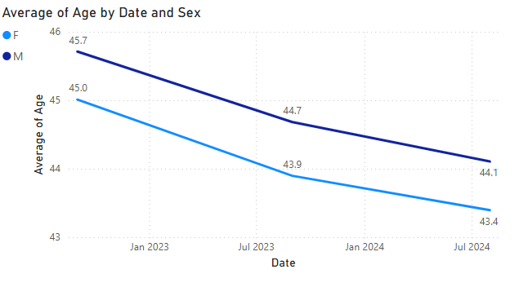

The changing age profile of the university’s staff should continue to be monitored, and work done to determine the causes, whether older staff leaving in greater numbers, more younger staff being recruited or a combination of both.

Table 3: Staff Composition (Age) by Job Category at 01 August 2024
Job Category | 20 or under | 21-30 | 31-40 | 41-50 | 51-60 | 61-70 | Over 70 | Total
Academic | 0.0% | 1.3% | 19.6% | 32.3% | 31.5% | 13.0% | 2.2% | 100.0%
Academic Related | 0.0% | 4.3% | 22.3% | 30.2% | 33.4% | 9.7% | 0.2% | 100.0%
Clerical | 1.4% | 25.2% | 22.1% | 17.8% | 22.5% | 10.1% | 0.9% | 100.0%
External Payroll | 8.3% | 8.3% | 33.3% | 25.0% | 16.7% | 8.3% | 0.0% | 100.0%
Manual | 2.4% | 5.3% | 7.6% | 12.4% | 32.4% | 35.9% | 4.1% | 100.0%
Other Related | 0.0% | 0.0% | 0.0% | 0.0% | 100.0% | 0.0% | 0.0% | 100.0%
Research | 0.0% | 14.3% | 47.0% | 20.8% | 13.0% | 4.2% | 0.7% | 100.0%
Secondment | 0.0% | 0.0% | 0.0% | 0.0% | 100.0% | 0.0% | 0.0% | 100.0%
Technical | 0.7% | 25.3% | 22.9% | 17.8% | 21.2% | 10.8% | 1.3% | 100.0%
Tutors | 0.0% | 4.3% | 34.8% | 34.8% | 17.4% | 8.7% | 0.0% | 100.0%
Total | 1.9% | 18.5% | 23.0% | 21.9% | 22.6% | 10.6% | 1.5% | 100.0%

Sex

There are more female than male staff employed at the University. Across all schools, directorates and employment types, 58.7% of staff are female while 41.3% of staff are male. While the overall comparable cohort of staff has grown since 2022 (by 332 staff), the change in the proportions of each sex is negligible (just 0.09%).

Figure 3: Staff Sex

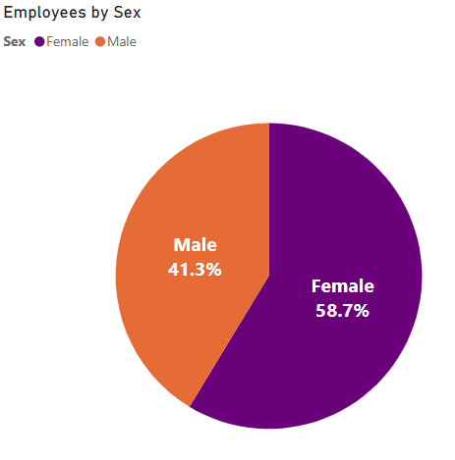
There is a large difference in the proportions of staff by sex between staff in Schools and Directorates. While the proportions in Schools are relatively close to the overall staff percentages, the proportion of female staff in Directorates is significantly higher, where 63.4% of staff are female.

Figure 4: Staff Sex – Schools and Directorates

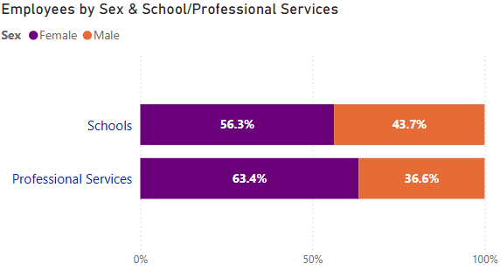

Across schools the proportions of male and female staff differ by only 2.4 percentage points from the overall staff, there is a large variation in the proportion of male and female staff in individual schools. The three Schools with the largest variations are Health Sciences where over 79% of staff are female, Dentistry (66% female) and Science & Engineering (64% male).

Figure 5: Staff Sex - Schools

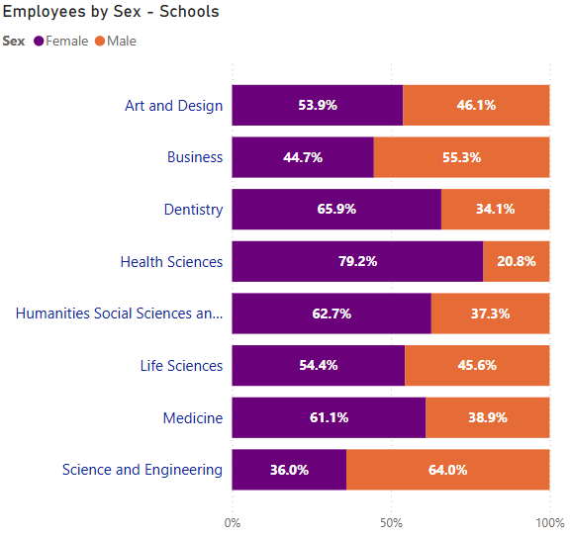

The Directorates overall have a higher proportion of female staff that the whole university, with a female staff proportion of 63.4%. There are five directorates (out of 11) which have a female proportion of staff at 70% or higher. In the Finance and Procurement Directorate 82.4% of staff are female, 79.1% of Globalisation staff are female, 77.4% of Research and Innovation staff are female, 76.3% of the People Directorate staff are female and 70% of Student Services staff are female.

The only two directorates where there are more male than female staff are Digital and Technology Services where 78% of staff are male and Estates and Campus Services (51.4% male).

The proportions of male and female staff have changed very little since 2022, with the male proportion growing by only 0.3 percentage points, therefore statistically insignificant.

Figure 6: Staff Sex - Directorates

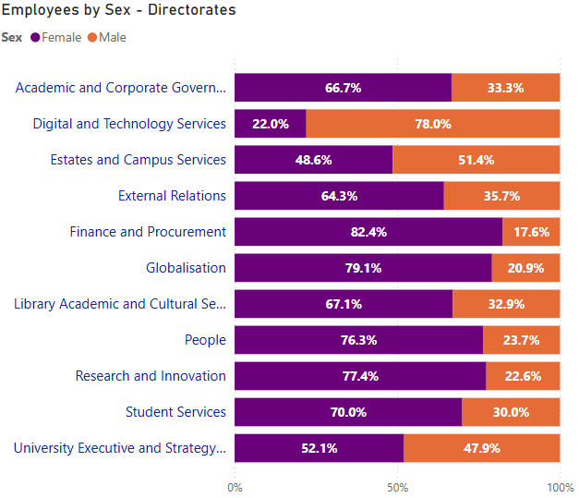

Table 4: Staff Composition (Sex) by Job Category at 01 August 2024
Job Category | Female | Male | Total
Academic | 48.5% | 51.5% | 100.0%
Academic Related | 62.8% | 37.2% | 100.0%
Clerical | 79.0% | 21.0% | 100.0%
External Payroll | 100.0% | 0.0% | 100.0%
Manual | 56.5% | 43.5% | 100.0%
Other Related | 50.0% | 50.0% | 100.0%
Research | 51.7% | 48.3% | 100.0%
Secondment | 0.0% | 100.0% | 100.0%
Technical | 52.9% | 47.1% | 100.0%
Tutors | 47.8% | 52.2% | 100.0%
Total | 58.7% | 41.3% | 100.0%

Disability

Among all 4,367 core and non-core funded staff at the University as at 1 August 2024, 3,314 staff or 75.9% of the cohort disclosed that they have ‘no known impairment, health condition or learning difference’. This proportion of staff is shown in the chart below as ‘no disability’. 5.8% of staff (255 people) disclosed that they have at least one disability, while the disability status of the remaining 18.3% or 798 staff members is not known. This includes those who prefer not to say.

Figure 7: Disability

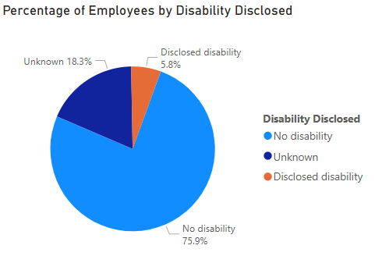

The proportion of staff who have declared that they have a disability is significantly below the rate of disability for Dundee, Tayside and nationally according to the most recent census statistics. It is therefore likely that the true proportion of staff with an undisclosed disability may be significantly higher.

Of the 255 staff members who disclosed that they have a disability, 27% said that they have a long-standing illness, 26% that they have a learning difference such as dyslexia, dyspraxia or AD(H)D and 20% said that they have a mental health condition. 78% of staff who have declared that they have a disability (199 people) have declared that they have only one disability, while the remaining 22% (56 people) have declared that they have more than one disability. The three most commonly declared disabilities are Long Term Illness or Health Condition, accounting for 27% of staff who have declared a disability, Learning Difference 26% and Mental Health Condition, Challenge or Disorder at just under 20%.

Of note is that the average length of service among the 798 staff members whose status is Unknown is slightly under 2 years. The average length of service where staff have made a disclosure of a disability is 8 years and for staff who declared that they have no disability is 9 years. This suggests that there has historically been a better rate of disclosure than there has been more recently.

In the last two years the percentage of staff who have disclosed that they have a disability has increased marginally, from 5.3% in 2022 to 5.8% in 2024. During the same period the percentage of staff whose status is unknown has almost doubled, increasing from 10% in 2022 to 18.3% in 2024.

The average age of those staff who have made a disclosure is 45. The average age of staff who have made no disclosure is 37 and the percentage of staff whose disability status is unknown has increased since 2022. As we know that the average staff age had dropped as newer staff are likely to be younger, it is probable that the increase in the unknown proportion in this category is likely to be connected to the likelihood of older staff having a disability as they age therefore making disclosure more relevant to them, along with younger staff making no disclosure as they may be less likely to have a disability or to recognise the importance of making any disclosure. However, there should also be investigation into whether the increase in the rate of unknown in this category is instead related to systemic issues related to introduction of a new system or issues with the collection process during a period of time where, perhaps coincidentally the average staff age has been dropping.

The table below shows the split of ‘Disability Disclosed’, ‘No Disability’ and ‘Unknown’ responses by School or Directorate. Academic and Corporate Governance have the highest proportion of their staff disclosing a disability at almost 15% of employees. Most other schools and directorates rate of disclosed disability is much closer to the overall rate for the organisation. In two areas – Research and Innovation and Subsidiaries (Nursery), no staff declared that they have a disability. The status of 48.1% of External Relations staff is unknown, followed by School of Business at 25.2%.

Table 5: Disability Disclosure by School/Directorate as at 01 August 2024
School or Directorate | Disclosed Disability | No Disability | Unknown | Total
Academic and Corporate Governance | 14.8% | 77.8% | 7.4% | 100.0%
Art and Design | 4.4% | 71.7% | 23.9% | 100.0%
Business | 7.5% | 67.3% | 25.2% | 100.0%
Dentistry | 7.1% | 87.1% | 5.9% | 100.0%
Digital and Technology Services | 7.9% | 79.5% | 12.6% | 100.0%
Estates and Campus Services | 3.3% | 77.1% | 19.6% | 100.0%
External Relations | 4.7% | 47.3% | 48.1% | 100.0%
Finance and Procurement | 8.1% | 83.8% | 8.1% | 100.0%
Globalisation | 8.2% | 73.2% | 18.6% | 100.0%
Health Sciences | 6.9% | 77.8% | 15.3% | 100.0%
Humanities Social Science and Law | 5.7% | 72.5% | 21.8% | 100.0%
Library Academic and Cultural Services | 8.2% | 77.6% | 14.1% | 100.0%
Life Sciences | 4.6% | 83.5% | 11.9% | 100.0%
Medicine | 5.6% | 79.7% | 14.7% | 100.0%
People | 6.6% | 77.6% | 15.8% | 100.0%
Research and Innovation | 0.0% | 92.5% | 7.5% | 100.0%
Science and Engineering | 7.1% | 70.2% | 22.7% | 100.0%
Student Services | 7.2% | 68.9% | 23.9% | 100.0%
Subsidiaries | 0.0% | 85.7% | 14.3% | 100.0%
University Executive and Strategy Office | 4.2% | 79.2% | 16.7% | 100.0%
Total | 5.8% | 75.9% | 18.3% | 100.0%

In the last two years the percentage of staff who have disclosed that they have a disability has increased marginally, from 5.3% in 2022 to 5.8% in 2024. During the same period the percentage of staff whose status is unknown has almost doubled, increasing from 10% in 2022 to 18.3% in 2024.

Figure 8: Disability disclosure 2022-2024

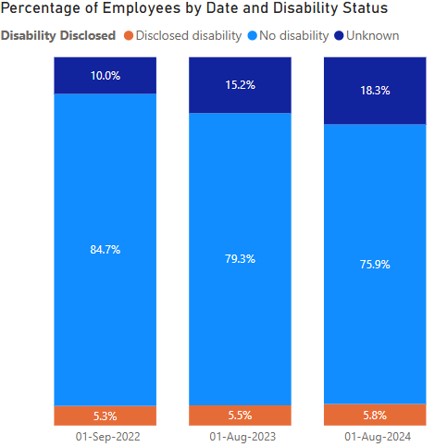

Table 6: Staff Composition (Disability) by Job Category at 01 August 2024
Job Category | Disclosed Disability | No Disability | Unknown | Total
Academic | 5.9% | 86.2% | 7.9% | 100.0%
Academic Related | 5.6% | 86.8% | 7.6% | 100.0%
Clerical | 9.1% | 82.6% | 8.3% | 100.0%
External Payroll | 0.0% | 100.0% | 0.0% | 100.0%
Manual | 4.7% | 75.9% | 19.4% | 100.0%
Other Related | 0.0% | 100.0% | 0.0% | 100.0%
Research | 4.9% | 81.0% | 14.1% | 100.0%
Secondment | 0.0% | 100.0% | 0.0% | 100.0%
Technical | 6.7% | 85.2% | 8.1% | 100.0%
Tutors | 0.0% | 82.6% | 17.4% | 100.0%
Total | 5.8% | 75.9% | 18.3% | 100.0%

Ethnicity

Of the 4,367 core funded and non-core funded staff as at the census date of 1 August 2024, the Ethnicity of 82.9% of staff was known (3,620 staff). 88 staff members had chosen the option to “prefer not to say” (2.0%) while the status of 659 staff or 15.1% of the cohort remains unknown.

13.9% of staff (606 people) have an ethnicity which is considered as a Black and Minority Ethnic group, while 69% of staff are from White ethnic groups.

Of the proportion of staff whose ethnicity is known, 16.7% are from BME ethnic groups.

Figure 9: Ethnic Group
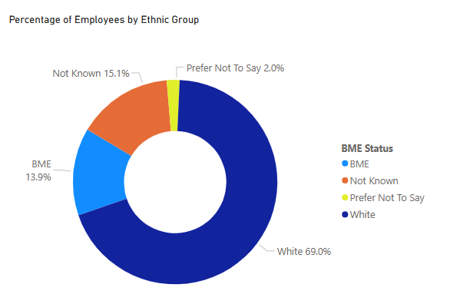
In Schools, the proportion of staff disclosing a BME ethnicity is 15.8% with 16.3% not known or not disclosed and 67.9% White.

In Directorates, the proportion staff disclosing a BME ethnicity is lower, at 9.8% with 18.0% not known or not disclosed and 72.2% White.

Figure 10: Ethnicity

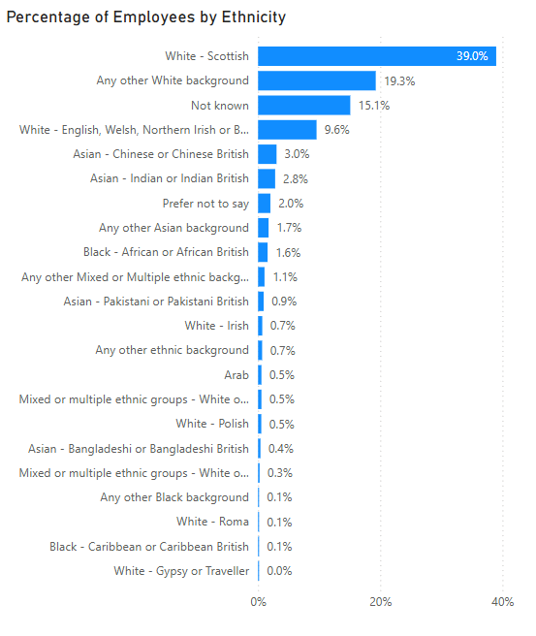

The chart above shows the percentage of employees by individual ethnicity. The largest BME ethnic group is Asian – Chinese or Chinese British, accounting for 3% of all staff and 21.8% of all BME staff, while the next largest BME group is Asian – Indian or Indian British accounting for 2.8% of all staff and a further 20.1% of BME staff. The largest White group is White-Scottish accounting for 39.0% of all staff and 47% of staff where ethnicity has been disclosed.

It is notable that while the average tenure of all staff is 7.92 years, the tenure of staff whose ethnicity is not known is only 1.47 years. The average tenure of staff whose ethnicity is White is 10 years and for BME staff 4.63 years. Along with the average age of staff whose ethnicity is unknown of 36.6 compared to 43.7 for all staff, this suggests an issue like that observed in the Disability protected characteristic suggesting that staff employed in the last two years (as well as being younger) are much less likely to have made a disclosure. There should be investigation to determine whether there is a systemic or process related issue which is causing this more recent trend in non-disclosure or whether it is related to changing employee attitudes. The results of this investigation will form the basis of a future report which will inform future action related to this.

The chart below shows the BME, White, Not Known and Prefer not to say percentages of staff by School.

It shows that the School of Business has, by a significant margin, the largest proportion of staff who have a BME ethnicity at almost 31%, but also the largest proportion of staff for whom ethnicity is unknown (22.6%). Art and Design has the lowest proportion of staff with a BME ethnicity at just 5.1%.

Figure 11: Ethnic Group by School

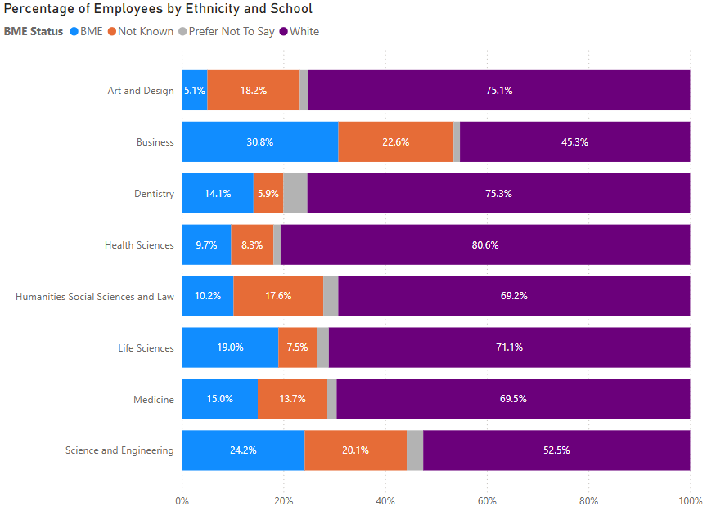

The chart below shows the BME, White, Not Known and Prefer not to say percentages of staff by Directorate.

It shows that the Globalisation directorate has, by a significant margin, the largest proportion of staff who have a BME ethnicity at 20%, but also the second largest proportion of staff for whom ethnicity is unknown (17.3%). The People Directorate has no staff who have declared a BME ethnicity and has 9.2% of staff with unknown ethnicity. External Relations is a significant outlier in terms of unknown ethnicity data with almost half (45% of staff) whose ethnic origin remains unknown.

Figure 12: Ethnic Group by Directorate

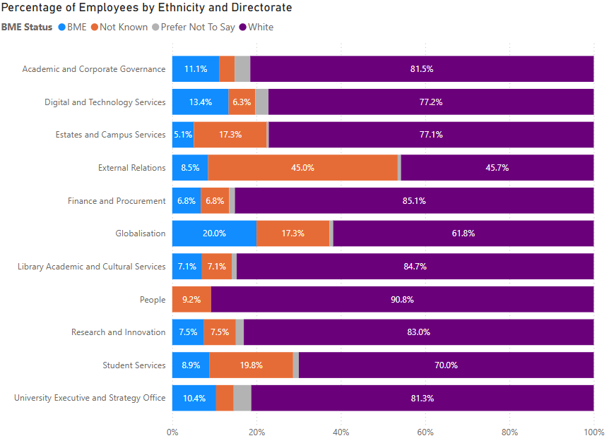

The chart below shows the BME status of staff over the last 3 years. The percentage of staff whose BME status is unknown (excluding those who prefer not to say) has increased from 12.1% of staff in 2022 to 15.1% of staff in August 2024. The proportion of all staff from BME groups has increased from 11.7% of staff to 13.9% while the percentage from White groups has dropped 5.5 percentage points from 74.5% to 69%.

Figure 13: Ethnic Group 2022-2024

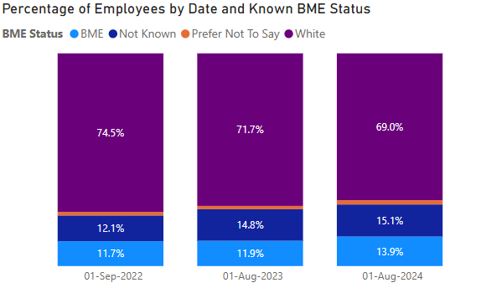
When the unknown and “prefer not to say” groups are removed it shows the percentage of staff whose ethnicity is known and are from a BME group has increased from 13.5% to 16.7%.

Figure 14: Ethnic Group (Known) 2022-2024

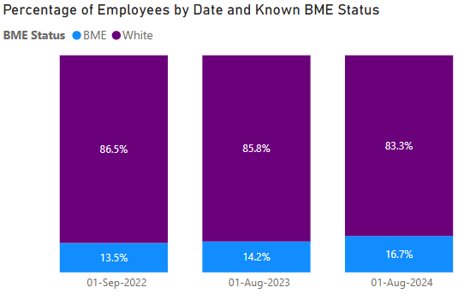

Table 7: Staff Composition (Ethnicity) by Job Category at 01 August 2024
Job Category | BME | Not Known | Prefer Not To Say | White | Total
Academic | 17.9% | 4.6% | 2.4% | 75.1% | 100.0%
Academic Related | 7.8% | 3.2% | 1.9% | 87.1% | 100.0%
Clerical | 7.1% | 4.7% | 1.4% | 86.8% | 100.0%
External Payroll | 0.0% | 75.0% | 0.0% | 25.0% | 100.0%
Manual | 5.9% | 15.3% | 1.2% | 77.6% | 100.0%
Other Related | 0.0% | 0.0% | 0.0% | 100.0% | 100.0%
Research | 24.5% | 9.7% | 2.2% | 63.6% | 100.0%
Secondment | 0.0% | 0.0% | 0.0% | 100.0% | 100.0%
Technical | 11.8% | 4.4% | 0.3% | 83.5% | 100.0%
Tutors | 17.4% | 8.7% | 0.0% | 73.9% | 100.0%
Total | 13.9% | 15.1% | 2.0% | 69.0% | 100.0%

Sexual Orientation

Of the 4,367 core funded and non-core funded staff in scope, the Sexual Orientation of two thirds of staff is known. Information is not held on sexual orientation of 1,467 staff members (33.6%) including 7.4% of staff who responded but prefer not to say.

3% of staff report that they are Bisexual, while 2.5% responded that they are Gay or Lesbian. Under 1% stated that their sexual orientation is “other” while 60.1% of the staff stated that they are “Heterosexual or Straight”.

Figure 15: Sexual Orientation

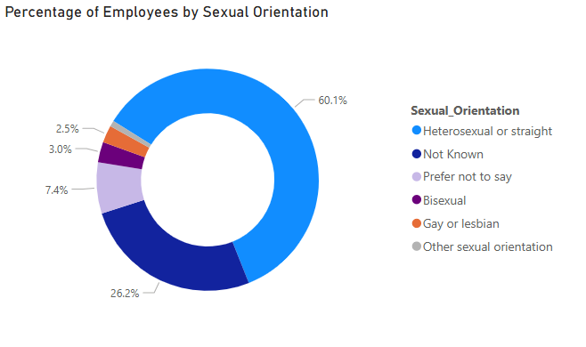
The tables below show the proportions of staff sexual orientation for both Schools and Directorates. Information is not supplied at individual school or directorate levels due to low numbers in some categories. While proportions of staff responding that they are Bisexual, Gay or Lesbian and Other Sexual Orientation are broadly similar between Schools and Directorates, the total percentage of staff whose status is unknown including those who choose “prefer not to say” is higher in Directorates at 37.2% of staff compared to 31.9% of staff in schools.

Table 8: Sexual Orientation - Academic Schools
Sexual Orientation | Count | Percentage
Bisexual | 87 | 2.9%
Gay or Lesbian | 81 | 2.7%
Heterosexual or Straight | 1848 | 61.6%
Not Known | 721 | 24.0%
Other Sexual Orientation | 25 | 0.8%
Prefer Not to Say | 238 | 7.9%
Total | 3000 | 100.0%

Table 9: Sexual Orientation - Directorates
Sexual Orientation | Count | Percentage
Bisexual | 42 | 3.1%
Gay or Lesbian | 29 | 2.1%
Heterosexual or Straight | 775 | 56.7%
Not Known | 421 | 30.8%
Other Sexual Orientation | 13 | 1.0%
Prefer Not to Say | 87 | 6.4%
Total | 1367 | 100.0%

The chart below shows declared Sexual Orientation of staff for the last 3 years. It shows that the percentage of staff whose sexual orientation is unknown did increase slightly from 2022 to 2023 but has since dropped markedly from 39.1% to 33.6%. The reduction in the unknown category is reflected by increases in both LGB+ and Heterosexual groups. The LGB+ percentage of staff has increased from 4.9% in 2022 to 6.3% in August 2024, while the percentage of staff who are Heterosexual has also increased from 55.7% to 60.1%.

Figure 16: Sexual Orientation 2022-2024

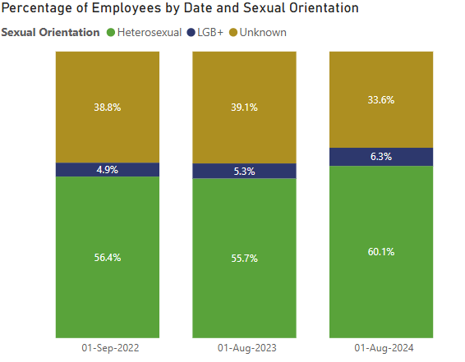

When unknown statuses are removed from the data, of the remaining staff where sexual orientation is known, the percentage who are LGB+ has increased from 7.9% of staff to 9.6% of staff and the heterosexual proportion has dropped from 92.1% to 90.4%. This indicates that a disproportionately higher percentage of previously unknown statuses were in fact LGB+, suggesting improving rates of disclosure among LGB+ groups.

Figure 17: Sexual Orientation (Known) 2022-2024

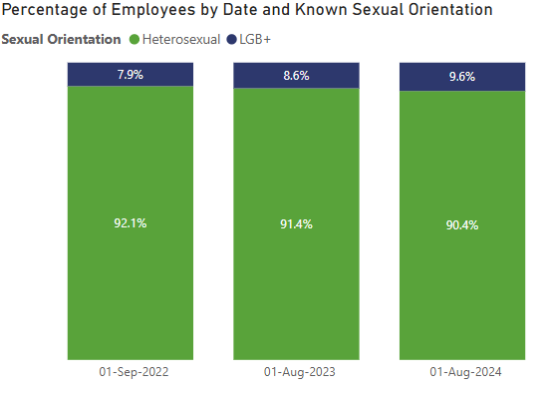

Religion

Religion is not known for 31.4% of the staff population, including 5.7% of staff who prefer not to say. The largest single group is No Religion accounting for 42% of staff, followed by Christian denominations together accounting for a further 20% of staff.

The chart below shows the proportions of staff by religion. Religions Sikh, Pagan and Jewish have not been reported due to very low numbers.

Table 10: Religion (All Staff)
Religion | Count | Percentage
No Religion | 1834 | 42.0%
Not Known | 1123 | 25.7%
Christian – Roman Catholic | 303 | 6.9%
Christian – Other denomination | 300 | 6.9%
Christian – Church of Scotland | 270 | 6.2%
Prefer not to say | 250 | 5.7%
Muslim | 121 | 2.8%
Hindu | 80 | 1.8%
Buddhist | 35 | 0.8%
Any other religion or belief | 34 | 0.8%

Table 11: Religion (Schools)
Religion | Count | Percentage
No Religion | 1295 | 43.2%
Not Known | 709 | 23.6%
Christian – Roman Catholic | 210 | 7.0%
Christian – Other denomination | 207 | 6.9%
Christian – Church of Scotland | 180 | 6.0%
Prefer not to say | 176 | 5.9%
Muslim | 95 | 3.2%
Hindu | 65 | 2.2%
Buddhist | 27 | 0.9%
Any other religion or belief | 24 | 0.8%

Table 12: Religion (Directorates)
Religion | Count | Percentage
No Religion | 539 | 39.4%
Not Known | 414 | 30.3%
Christian – Church of Scotland | 120 | 8.8%
Christian – Roman Catholic | 93 | 6.8%
Prefer not to say | 74 | 5.4%
Christian – Other denomination | 63 | 4.6%
Muslim | 26 | 1.9%
Hindu | 15 | 1.1%
Any other religion or belief | 11 | 0.8%
Buddhist | 7 | 0.5%

The only statistically significant difference between Schools and Directorates is the extent to which Religion is unknown, at 23.6% for Schools' staff and 30.3% for staff in Professional Services Directorates.

Figure 18: Religion 2022-2024

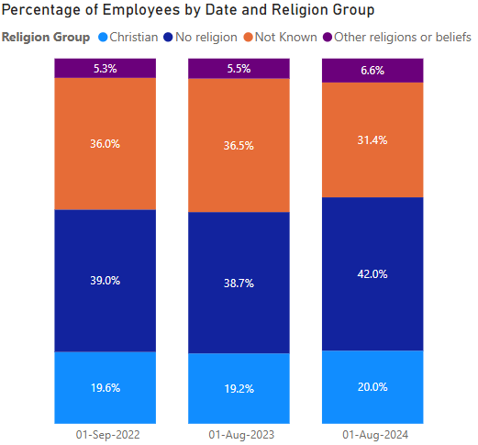

The proportions of staff stating that their religion is Christian or Other religion has increased from 24.9% of all staff in 2022 to 26.6% in 2022. The percentage of staff for whom religion is unknown has dropped by 4.6 percentage points from 36% of staff to 31.4% while the number of staff who reported that they do not have a religion has increased by 3.3%.

Appendix 1 – Data Tables – Staff Composition by School/Directorate, Job Category and Grade

Table 13: Staff Composition by School/Directorate at 1 August 2024
School or Directorate | Count of Employees | Percentage of Employees
Life Sciences | 757 | 17.3%
Medicine | 709 | 16.2%
Humanities, Social Science and Law | 510 | 11.7%
Science and Engineering | 339 | 7.8%
Art and Design | 297 | 6.8%
Student Services | 293 | 6.7%
Globalisation | 220 | 5.0%
Estates and Campus Services | 214 | 4.9%
Business | 159 | 3.6%
Health Sciences | 144 | 3.3%
External Relations | 129 | 3.0%
Digital and Technology Services | 127 | 2.9%
Dentistry | 85 | 1.9%
Library Academic and Cultural Services | 85 | 1.9%
People | 76 | 1.7%
Finance and Procurement | 74 | 1.7%
Research and Innovation | 53 | 1.2%
University Executive and Strategy Office | 48 | 1.1%
Academic and Corporate Governance | 27 | 0.6%
Subsidiaries | 21 | 0.5%
Total | 4367 | 100.0%

Table 14: Staff Composition by Job Category at 1 August 2024
Job Category | Count of Employees | Percentage of Employees
Academic | 958 | 21.9%
Academic Related | 707 | 16.2%
Clerical | 646 | 14.8%
Research | 525 | 12.0%
Tutors | 444 | 10.2%
Technical | 366 | 8.4%
Casual | 308 | 7.1%
Temporary | 197 | 4.5%
Manual | 190 | 4.4%
External Payroll | 21 | 0.5%
Other Related | 3 | 0.1%
Secondment | 2 | 0.0%
Total | 4367 | 100.0%

Table 15: Staff Composition by Grade at 1 August 2024
Grade | Percentage of Employees
Grade 7 | 16.83%
Grade 8 | 13.24%
Grade 6 | 7.37%
Grade 9 | 6.94%
Grade 5 | 6.07%
Grade 4 | 4.28%
Grade 10 | 3.23%
Grade 1 | 2.50%
Offscale Grades 7-10 | 2.15%
Grade 3 | 2.02%
Clinical Consultant | 1.60%
Offscale Grades 1-6 | 0.85%
Clinical Lecturer | 0.57%
Grade 2 | 0.27%
Reader or Clinical Senior Lecturer (Non-Consultant) | 0.18%
Estates Apprentice | 0.05%
MRC Pay Band 3B | 0.05%
MRC Pay Band 4B | 0.05%
MRC Pay Band 5B | 0.05%
Nursery Grade 3 | 0.05%
Total | 100.00%

Appendix 2 – Data Tables – Composition and Employee Distribution by School/Directorate – Age

Table 16: Staff Composition (Age) by School/Directorate at 1 August 2024
School or Directorate | 20 or under | 21-30 | 31-40 | 41-50 | 51-60 | 61-70 | Over 70
Academic and Corporate Governance | 0.0% | 18.5% | 22.2% | 22.2% | 29.6% | 7.4% | 0.0%
Art and Design | 2.0% | 15.2% | 23.6% | 17.2% | 29.0% | 11.8% | 1.3%
Business | 0.6% | 11.9% | 29.6% | 28.3% | 21.4% | 6.9% | 1.3%
Dentistry | 0.0% | 4.7% | 30.6% | 21.2% | 30.6% | 10.6% | 2.4%
Digital and Technology Services | 0.0% | 16.5% | 17.3% | 23.6% | 27.6% | 15.0% | 0.0%
Estates and Campus Services | 1.9% | 9.3% | 8.9% | 15.0% | 30.4% | 31.8% | 2.8%
External Relations | 18.6% | 42.6% | 16.3% | 9.3% | 12.4% | 0.8% | 0.0%
Finance and Procurement | 1.4% | 5.4% | 14.9% | 28.4% | 41.9% | 8.1% | 0.0%
Globalisation | 5.5% | 47.7% | 22.3% | 12.3% | 10.9% | 1.4% | 0.0%
Health Sciences | 0.7% | 8.3% | 21.5% | 20.8% | 35.4% | 13.2% | 0.0%
Humanities, Social Science and Law | 0.4% | 11.6% | 17.8% | 29.8% | 27.1% | 11.2% | 2.2%
Library Academic and Cultural Services | 0.0% | 8.2% | 16.5% | 22.4% | 25.9% | 27.1% | 0.0%
Life Sciences | 0.7% | 20.3% | 32.4% | 23.0% | 15.3% | 6.9% | 1.5%
Medicine | 0.4% | 11.0% | 24.7% | 24.7% | 23.3% | 12.8% | 2.1%
People | 0.0% | 18.4% | 21.1% | 23.7% | 27.6% | 9.2% | 0.0%
Research and Innovation | 0.0% | 11.3% | 17.0% | 22.6% | 35.8% | 9.4% | 3.8%
Science and Engineering | 0.0% | 30.4% | 27.1% | 21.2% | 13.9% | 5.6% | 1.8%
Student Services | 5.1% | 30.4% | 14.3% | 17.4% | 21.2% | 9.6% | 2.0%
Subsidiaries | 4.8% | 14.3% | 38.1% | 14.3% | 14.3% | 14.3% | 0.0%
University Executive & Strategy Office | 0.0% | 12.5% | 18.8% | 20.8% | 33.3% | 14.6% | 0.0%
Total | 1.9% | 18.5% | 23.0% | 21.9% | 22.6% | 10.6% | 1.5%

Table 17: Age - Population by School/Directorate v Employee Distribution
School or Directorate | 20 or under | 21-30 | 31-40 | 41-50 | 51-60 | 61-70 | Over 70
Academic and Corporate Governance | 0.0% | 0.6% | 0.6% | 0.6% | 0.8% | 0.4% | 0.0%
Art and Design | 7.3% | 5.6% | 7.0% | 5.3% | 8.7% | 7.5% | 6.2%
Business | 1.2% | 2.3% | 4.7% | 4.7% | 3.5% | 2.4% | 3.1%
Dentistry | 0.0% | 0.5% | 2.6% | 1.9% | 2.6% | 1.9% | 3.1%
Digital and Technology Services | 0.0% | 2.6% | 2.2% | 3.1% | 3.6% | 4.1% | 0.0%
Estates and Campus Services | 4.9% | 2.5% | 1.9% | 3.3% | 6.6% | 14.6% | 9.2%
External Relations | 29.3% | 6.8% | 2.1% | 1.3% | 1.6% | 0.2% | 0.0%
Finance and Procurement | 1.2% | 0.5% | 1.1% | 2.2% | 3.1% | 1.3% | 0.0%
Globalisation | 14.6% | 13.0% | 4.9% | 2.8% | 2.4% | 0.6% | 0.0%
Health Sciences | 1.2% | 1.5% | 3.1% | 3.1% | 5.2% | 4.1% | 0.0%
Humanities, Social Science and Law | 2.4% | 7.3% | 9.1% | 15.9% | 14.0% | 12.3% | 16.9%
Library Academic and Cultural Services | 0.0% | 0.9% | 1.4% | 2.0% | 2.2% | 4.9% | 0.0%
Life Sciences | 6.1% | 19.0% | 24.4% | 18.2% | 11.8% | 11.2% | 16.9%
Medicine | 12.2% | 9.6% | 17.4% | 18.3% | 16.8% | 19.6% | 23.1%
People | 0.0% | 1.7% | 1.6% | 1.9% | 2.1% | 1.5% | 0.0%
Research and Innovation | 0.0% | 0.7% | 0.9% | 1.3% | 1.9% | 1.1% | 3.1%
Science and Engineering | 0.0% | 12.7% | 9.2% | 7.5% | 4.8% | 4.1% | 9.2%
Student Services | 18.3% | 11.0% | 4.2% | 5.3% | 6.3% | 6.0% | 9.2%
Subsidiaries | 1.2% | 0.4% | 0.8% | 0.3% | 0.3% | 0.6% | 0.0%
University Executive & Strategy Office | 0.0% | 0.7% | 0.9% | 1.0% | 1.6% | 1.5% | 0.0%
Total | 100.0% | 100.0% | 100.0% | 100.0% | 100.0% | 100.0% | 100.0%

Table 18: Age Group by Mode/Basis
Mode & Basis | 20 or under | 21-30 | 31-40 | 41-50 | 51-60 | 61-70 | Over 70
Full-Time Permanent | 0.1% | 10.6% | 23.3% | 26.6% | 29.1% | 9.9% | 0.5%
Full-Time Temporary | 2.7% | 36.9% | 41.7% | 11.4% | 5.2% | 1.5% | 0.6%
Part-Time Permanent | 0.5% | 4.2% | 15.5% | 23.8% | 27.1% | 24.2% | 4.8%
Part-Time Temporary | 6.3% | 36.7% | 18.2% | 15.6% | 13.6% | 7.9% | 1.8%
Total | 1.9% | 18.5% | 23.0% | 21.9% | 22.6% | 10.7% | 1.5%

Table 19: Age Group by Mode
Mode | 20 or under | 21-30 | 31-40 | 41-50 | 51-60 | 61-70 | Over 70
Full-Time | 0.6% | 15.3% | 26.6% | 23.9% | 24.8% | 8.3% | 0.6%
Part-Time | 3.9% | 23.8% | 17.1% | 18.9% | 19.0% | 14.4% | 3.0%
Total | 1.9% | 18.5% | 23.0% | 21.9% | 22.6% | 10.7% | 1.5%

Table 20: Age Group by Basis
Basis | 20 or under | 21-30 | 31-40 | 41-50 | 51-60 | 61-70 | Over 70
Permanent | 0.2% | 9.1% | 21.5% | 25.9% | 28.6% | 13.2% | 1.5%
Temporary | 5.1% | 36.8% | 25.8% | 14.2% | 10.9% | 5.8% | 1.4%
Total | 1.9% | 18.5% | 23.0% | 21.9% | 22.6% | 10.7% | 1.5%

Table 21: Age Group - Population by Mode/Basis v Employee Distribution
Mode & Basis | 20 or under | 21-30 | 31-40 | 41-50 | 51-60 | 61-70 | Over 70
Full-Time Permanent | 3.7% | 28.9% | 51.4% | 61.4% | 65.3% | 46.9% | 18.5%
Full-Time Temporary | 15.9% | 22.0% | 20.1% | 5.7% | 2.5% | 1.5% | 4.6%
Part-Time Permanent | 3.7% | 3.5% | 10.3% | 16.5% | 18.3% | 34.6% | 49.2%
Part-Time Temporary | 76.8% | 45.6% | 18.3% | 16.4% | 13.9% | 17.0% | 27.7%
Total | 100.0% | 100.0% | 100.0% | 100.0% | 100.0% | 100.0% | 100.0%

Table 22: Age Group - Population by Mode v Employee Distribution
Mode | 20 or under | 21-30 | 31-40 | 41-50 | 51-60 | 61-70 | Over 70
Full-Time | 19.5% | 50.9% | 71.5% | 67.1% | 67.8% | 48.4% | 23.1%
Part-Time | 80.5% | 49.1% | 28.5% | 32.9% | 32.2% | 51.6% | 76.9%
Total | 100.0% | 100.0% | 100.0% | 100.0% | 100.0% | 100.0% | 100.0%

Table 23: Age Group - Population by Basis v Employee Distribution
Basis | 20 or under | 21-30 | 31-40 | 41-50 | 51-60 | 61-70 | Over 70
Permanent | 19.5% | 50.9% | 71.5% | 67.1% | 67.8% | 48.4% | 23.1%
Temporary | 80.5% | 49.1% | 28.5% | 32.9% | 32.2% | 51.6% | 76.9%
Total | 100.0% | 100.0% | 100.0% | 100.0% | 100.0% | 100.0% | 100.0%

Appendix 3 – Data Tables – Composition and Employee Distribution by School/Directorate – Sex

Table 24: Staff Composition (Sex) by School/Directorate at 1 August 2024
School or Directorate | Female | Male | Total
Academic and Corporate Governance | 66.7% | 33.3% | 100.0%
Art and Design | 53.9% | 46.1% | 100.0%
Business | 44.7% | 55.3% | 100.0%
Dentistry | 65.9% | 34.1% | 100.0%
Digital and Technology Services | 22.0% | 78.0% | 100.0%
Estates and Campus Services | 48.6% | 51.4% | 100.0%
External Relations | 64.3% | 35.7% | 100.0%
Finance and Procurement | 82.4% | 17.6% | 100.0%
Globalisation | 79.1% | 20.9% | 100.0%
Health Sciences | 79.2% | 20.8% | 100.0%
Humanities, Social Science and Law | 62.7% | 37.3% | 100.0%
Library Academic and Cultural Services | 67.1% | 32.9% | 100.0%
Life Sciences | 54.4% | 45.6% | 100.0%
Medicine | 61.1% | 38.9% | 100.0%
People | 76.3% | 23.7% | 100.0%
Research and Innovation | 77.4% | 22.6% | 100.0%
Science and Engineering | 36.0% | 64.0% | 100.0%
Student Services | 70.0% | 30.0% | 100.0%
Subsidiaries | 95.2% | 4.8% | 100.0%
University Executive & Strategy Office | 52.1% | 47.9% | 100.0%
Total | 58.7% | 41.3% | 100.0%

Table 25: Sex - Population by School/Directorate v Employee Distribution
School or Directorate | Female | Male | Total
Academic and Corporate Governance | 0.7% | 0.5% | 0.6%
Art and Design | 6.2% | 7.6% | 6.8%
Business | 2.8% | 4.9% | 3.6%
Dentistry | 2.2% | 1.6% | 1.9%
Digital and Technology Services | 1.1% | 5.5% | 2.9%
Estates and Campus Services | 4.1% | 6.1% | 4.9%
External Relations | 3.2% | 2.5% | 3.0%
Finance and Procurement | 2.4% | 0.7% | 1.7%
Globalisation | 6.8% | 2.5% | 5.0%
Health Sciences | 4.4% | 1.7% | 3.3%
Humanities, Social Science and Law | 12.5% | 10.5% | 11.7%
Library Academic and Cultural Services | 2.2% | 1.6% | 1.9%
Life Sciences | 16.1% | 19.1% | 17.3%
Medicine | 16.9% | 15.3% | 16.2%
People | 2.3% | 1.0% | 1.7%
Research and Innovation | 1.6% | 0.7% | 1.2%
Science and Engineering | 4.8% | 12.0% | 7.8%
Student Services | 8.0% | 4.9% | 6.7%
Subsidiaries | 0.8% | 0.1% | 0.5%
University Executive & Strategy Office | 1.0% | 1.3% | 1.1%
Total | 100.0% | 100.0% | 100.0%

Table 26: Sex by Mode/Basis
Mode & Basis | Female | Male | Total
Full-Time Permanent | 55.7% | 44.3% | 100.0%
Full-Time Temporary | 52.7% | 47.3% | 100.0%
Part-Time Permanent | 71.9% | 28.1% | 100.0%
Part-Time Temporary | 59.4% | 40.6% | 100.0%
Total | 58.7% | 41.3% | 100.0%

Table 27: Sex by Mode
Mode | Female | Male | Total
Full-Time | 55.1% | 44.9% | 100.0%
Part-Time | 64.4% | 35.6% | 100.0%
Total | 58.7% | 41.3% | 100.0%

Table 28: Sex by Basis
Basis | Female | Male | Total
Permanent | 59.4% | 40.6% | 100.0%
Temporary | 57.3% | 42.7% | 100.0%
Total | 58.7% | 41.3% | 100.0%

Table 29: Sex - Population by Mode/Basis v Employee Distribution
Mode & Basis | Female | Male | Total
Full-Time Permanent | 48.1% | 54.4% | 50.7%
Full-Time Temporary | 9.9% | 12.6% | 11.0%
Part-Time Permanent | 18.7% | 10.4% | 15.2%
Part-Time Temporary | 23.3% | 22.6% | 23.0%
Total | 100.0% | 100.0% | 100.0%

Table 30: Sex - Population by Mode v Employee Distribution
Mode | Female | Male | Total
Full-Time | 58.0% | 67.0% | 61.7%
Part-Time | 42.0% | 33.0% | 38.3%
Total | 100.0% | 100.0% | 100.0%

Table 31: Sex - Population by Basis v Employee Distribution
Basis | Female | Male | Total
Permanent | 58.0% | 67.0% | 61.7%
Temporary | 42.0% | 33.0% | 38.3%
Total | 100.0% | 100.0% | 100.0%

Appendix 4 – Data Tables – Composition and Employee Distribution by School/Directorate – Disability

Table 32: Staff Composition (Disability) by School/Directorate at 1 August 2024
School or Directorate | Disability Disclosed | No Disability | Unknown | Total
Academic and Corporate Governance | 14.8% | 77.8% | 7.4% | 100.0%
Art and Design | 4.4% | 71.7% | 23.9% | 100.0%
Business | 7.5% | 67.3% | 25.2% | 100.0%
Dentistry | 7.1% | 87.1% | 5.9% | 100.0%
Digital and Technology Services | 7.9% | 79.5% | 12.6% | 100.0%
Estates and Campus Services | 3.3% | 77.1% | 19.6% | 100.0%
External Relations | 4.7% | 47.3% | 48.1% | 100.0%
Finance and Procurement | 8.1% | 83.8% | 8.1% | 100.0%
Globalisation | 8.2% | 73.2% | 18.6% | 100.0%
Health Sciences | 6.9% | 77.8% | 15.3% | 100.0%
Humanities, Social Science and Law | 5.7% | 72.5% | 21.8% | 100.0%
Library Academic and Cultural Services | 8.2% | 77.6% | 14.1% | 100.0%
Life Sciences | 4.6% | 83.5% | 11.9% | 100.0%
Medicine | 5.6% | 79.7% | 14.7% | 100.0%
People | 6.6% | 77.6% | 15.8% | 100.0%
Research and Innovation | 0.0% | 92.5% | 7.5% | 100.0%
Science and Engineering | 7.1% | 70.2% | 22.7% | 100.0%
Student Services | 7.2% | 68.9% | 23.9% | 100.0%
Subsidiaries | 0.0% | 85.7% | 14.3% | 100.0%
University Executive & Strategy Office | 4.2% | 79.2% | 16.7% | 100.0%
Total | 5.8% | 75.9% | 18.3% | 100.0%

Table 33: Disability - Population by School/Directorate v Employee Distribution
School or Directorate | Disability Disclosed | No Disability | Unknown | Total
Academic and Corporate Governance | 1.6% | 0.6% | 0.3% | 0.6%
Art and Design | 5.1% | 6.4% | 8.9% | 6.8%
Business | 4.7% | 3.2% | 5.0% | 3.6%
Dentistry | 2.4% | 2.2% | 0.6% | 1.9%
Digital and Technology Services | 3.9% | 3.0% | 2.0% | 2.9%
Estates and Campus Services | 2.7% | 5.0% | 5.3% | 4.9%
External Relations | 2.4% | 1.8% | 7.8% | 3.0%
Finance and Procurement | 2.4% | 1.9% | 0.8% | 1.7%
Globalisation | 7.1% | 4.9% | 5.1% | 5.0%
Health Sciences | 3.9% | 3.4% | 2.8% | 3.3%
Humanities, Social Science and Law | 11.4% | 11.2% | 13.9% | 11.7%
Library Academic and Cultural Services | 2.7% | 2.0% | 1.5% | 1.9%
Life Sciences | 13.7% | 19.1% | 11.3% | 17.3%
Medicine | 15.7% | 17.0% | 13.0% | 16.2%
People | 2.0% | 1.8% | 1.5% | 1.7%
Research and Innovation | 0.0% | 1.5% | 0.5% | 1.2%
Science and Engineering | 9.4% | 7.2% | 9.6% | 7.8%
Student Services | 8.2% | 6.1% | 8.8% | 6.7%
Subsidiaries | 0.0% | 0.5% | 0.4% | 0.5%
University Executive & Strategy Office | 0.8% | 1.1% | 1.0% | 1.1%
Total | 100.0% | 100.0% | 100.0% | 100.0%

Table 34: Disability Disclosure by Mode/Basis
Mode & Basis | Disability Disclosed | No Disability | Unknown | Total
Full-Time Permanent | 6.1% | 85.7% | 8.2% | 100.0%
Full-Time Temporary | 7.1% | 68.5% | 24.5% | 100.0%
Part-Time Permanent | 7.1% | 83.9% | 9.0% | 100.0%
Part-Time Temporary | 3.9% | 52.7% | 43.4% | 100.0%
Total | 5.8% | 75.9% | 18.3% | 100.0%

Table 35: Disability Disclosure by Mode
Mode | Disability Disclosed | No Disability | Unknown | Total
Full-Time | 6.3% | 82.6% | 11.1% | 100.0%
Part-Time | 5.1% | 65.1% | 29.7% | 100.0%
Total | 5.8% | 75.9% | 18.3% | 100.0%

Table 36: Disability Disclosure by Basis
Basis | Disability Disclosed | No Disability | Unknown | Total
Permanent | 6.3% | 85.3% | 8.4% | 100.0%
Temporary | 4.9% | 57.8% | 37.3% | 100.0%
Total | 5.8% | 75.9% | 18.3% | 100.0%

Table 37: Disability - Population by Mode/Basis v Employee Distribution
Mode & Basis | Disability Disclosed | No Disability | Unknown | Total
Full-Time Permanent | 52.9% | 57.2% | 22.8% | 50.7%
Full-Time Temporary | 13.3% | 10.0% | 14.8% | 11.0%
Part-Time Permanent | 18.4% | 16.8% | 7.5% | 15.2%
Part-Time Temporary | 15.3% | 16.0% | 54.8% | 23.0%
Total | 100.0% | 100.0% | 100.0% | 100.0%

Table 38: Disability by Mode v Employee Distribution
Mode | Disability Disclosed | No Disability | Unknown | Total
Permanent | 66.3% | 67.2% | 37.6% | 61.7%
Temporary | 33.7% | 32.8% | 62.4% | 38.3%
Total | 100.0% | 100.0% | 100.0% | 100.0%

Table 39: Disability - Population by Basis v Employee Distribution
Basis | Disability Disclosed | No Disability | Unknown | Total
Permanent | 66.3% | 67.2% | 37.6% | 61.7%
Temporary | 33.7% | 32.8% | 62.4% | 38.3%
Total | 100.0% | 100.0% | 100.0% | 100.0%

Appendix 5 – Data Tables – Composition and Employee Distribution by School/Directorate – Ethnicity

Table 40: Staff Composition (Ethnicity) by School/Directorate at 1 August 2024
School or Directorate | BME | Not Known | Prefer not to say | White | Total
Academic and Corporate Governance | 11.1% | 3.7% | 3.7% | 81.5% | 100.0%
Art and Design | 5.1% | 18.2% | 1.7% | 75.1% | 100.0%
Business | 30.8% | 22.6% | 1.3% | 45.3% | 100.0%
Dentistry | 14.1% | 5.9% | 4.7% | 75.3% | 100.0%
Digital and Technology Services | 13.4% | 6.3% | 3.1% | 77.2% | 100.0%
Estates and Campus Services | 5.1% | 17.3% | 0.5% | 77.1% | 100.0%
External Relations | 8.5% | 45.0% | 0.8% | 45.7% | 100.0%
Finance and Procurement | 6.8% | 6.8% | 1.4% | 85.1% | 100.0%
Globalisation | 20.0% | 17.3% | 0.9% | 61.8% | 100.0%
Health Sciences | 9.7% | 8.3% | 1.4% | 80.6% | 100.0%
Humanities, Social Science and Law | 10.2% | 17.6% | 2.9% | 69.2% | 100.0%
Library Academic and Cultural Services | 7.1% | 7.1% | 1.2% | 84.7% | 100.0%
Life Sciences | 19.0% | 7.5% | 2.4% | 71.1% | 100.0%
Medicine | 15.0% | 13.7% | 1.8% | 69.5% | 100.0%
People | 0.0% | 9.2% | 0.0% | 90.8% | 100.0%
Research and Innovation | 7.5% | 7.5% | 1.9% | 83.0% | 100.0%
Science and Engineering | 24.2% | 20.1% | 3.2% | 52.5% | 100.0%
Student Services | 8.9% | 19.8% | 1.4% | 70.0% | 100.0%
Subsidiaries | 0.0% | 76.2% | 0.0% | 23.8% | 100.0%
University Executive & Strategy Office | 10.4% | 4.2% | 4.2% | 81.3% | 100.0%
Total | 13.9% | 15.1% | 2.0% | 69.0% | 100.0%

Table 41: Ethnicity - Population by School/Directorate v Employee Distribution
School or Directorate | BME | Not Known | Prefer not to say | White | Total
Academic and Corporate Governance | 0.5% | 0.2% | 1.1% | 0.7% | 0.6%
Art and Design | 2.5% | 8.2% | 5.7% | 7.4% | 6.8%
Business | 8.1% | 5.5% | 2.3% | 2.4% | 3.6%
Dentistry | 2.0% | 0.8% | 4.5% | 2.1% | 1.9%
Digital and Technology Services | 2.8% | 1.2% | 4.5% | 3.3% | 2.9%
Estates and Campus Services | 1.8% | 5.6% | 1.1% | 5.5% | 4.9%
External Relations | 1.8% | 8.8% | 1.1% | 2.0% | 3.0%
Finance and Procurement | 0.8% | 0.8% | 1.1% | 2.1% | 1.7%
Globalisation | 7.3% | 5.8% | 2.3% | 4.5% | 5.0%
Health Sciences | 2.3% | 1.8% | 2.3% | 3.8% | 3.3%
Humanities, Social Science and Law | 8.6% | 13.7% | 17.0% | 11.7% | 11.7%
Library Academic and Cultural Services | 1.0% | 0.9% | 1.1% | 2.4% | 1.9%
Life Sciences | 23.8% | 8.6% | 20.5% | 17.9% | 17.3%
Medicine | 17.5% | 14.7% | 14.8% | 16.4% | 16.2%
People | 0.0% | 1.1% | 0.0% | 2.3% | 1.7%
Research and Innovation | 0.7% | 0.6% | 1.1% | 1.5% | 1.2%
Science and Engineering | 13.5% | 10.3% | 12.5% | 5.9% | 7.8%
Student Services | 4.3% | 8.8% | 4.5% | 6.8% | 6.7%
Subsidiaries | 0.0% | 2.4% | 0.0% | 0.2% | 0.5%
University Executive & Strategy Office | 0.8% | 0.3% | 2.3% | 1.3% | 1.1%
Total | 100.0% | 100.0% | 100.0% | 100.0% | 100.0%

Table 42: Ethnic Group by Mode/BasisTable
Mode & Basis | BME | Not Known | Prefer not to say | White | Total
Full-Time Permanent | 13.4% | 4.9% | 2.1% | 79.5% | 100.0%
Full-Time Temporary | 27.4% | 16.8% | 2.9% | 52.9% | 100.0%
Part-Time Permanent | 5.7% | 6.6% | 1.1% | 86.6% | 100.0%
Part-Time Temporary | 13.7% | 42.2% | 2.0% | 42.0% | 100.0%
Total | 13.9% | 15.1% | 2.0% | 69.0% | 100.0%

Table 43: Ethnic Group by Mode
Mode | BME | Not Known | Prefer not to say | White | Total
Permanent | 15.9% | 7.1% | 2.3% | 74.8% | 100.0%
Temporary | 10.5% | 28.1% | 1.6% | 59.8% | 100.0%
Total | 13.9% | 15.1% | 2.0% | 69.0% | 100.0%

Table 44: Ethnic Group by BasisTable
Basis | BME | Not Known | Prefer not to say | White | Total
Permanent | 11.6% | 5.3% | 1.9% | 81.2% | 100.0%
Temporary | 18.1% | 34.0% | 2.3% | 45.6% | 100.0%
Total | 13.9% | 15.0% | 2.0% | 69.0% | 100.0%

Table 45: Ethnic Group - Population by Mode/Basis v Employee Distribution
Mode & Basis | BME | Not Known | Prefer not to say | White | Total
Full-Time Permanent | 49.1% | 16.5% | 53.4% | 58.4% | 50.7%
Full-Time Temporary | 21.8% | 12.3% | 15.9% | 8.5% | 11.0%
Part-Time Permanent | 6.3% | 6.7% | 8.0% | 19.1% | 15.2%
Part-Time Temporary | 22.8% | 64.5% | 22.7% | 14.0% | 23.0%
Total | 100.0% | 100.0% | 100.0% | 100.0% | 100.0%

Table 46: Ethnic Group - Population by Mode v Employee Distribution
Mode | BME | Not Known | Prefer not to say | White | Total
Full-Time | 70.9% | 28.8% | 69.3% | 66.9% | 61.7%
Part-Time | 29.1% | 71.2% | 30.7% | 33.1% | 38.3%
Total | 100.0% | 100.0% | 100.0% | 100.0% | 100.0%

Table 47: Ethnic Group - Population by Basis v Employee Distribution
Basis | BME | Not Known | Prefer not to say | White | Total
Permanent | 70.9% | 28.8% | 69.3% | 66.9% | 61.7%
Temporary | 29.1% | 71.2% | 30.7% | 33.1% | 38.3%
Total | 100.0% | 100.0% | 100.0% | 100.0% | 100.0%

Appendix 6 – Data Tables – Composition and Employee Distribution by School/Directorate – Sexual Orientation

Table 48: Staff Composition (Sexual Orientation) by School/Directorate at 1 August 2024
School or Directorate | Bisexual | Gay or Lesbian | Heterosexual or Straight | Not Known | Other Sexual Orientation | Prefer not to say
Academic and Corporate Governance | 0.0% | 7.4% | 66.7% | 18.5% | 3.7% | 3.7%
Art and Design | 3.7% | 2.0% | 50.5% | 34.7% | 2.4% | 6.7%
Business | 0.6% | 1.9% | 63.5% | 28.3% | 0.0% | 5.7%
Dentistry | 0.0% | 0.0% | 70.6% | 21.2% | 0.0% | 8.2%
Digital and Technology Services | 2.4% | 2.4% | 64.6% | 16.5% | 0.0% | 14.2%
Estates and Campus Services | 0.5% | 0.9% | 43.9% | 53.3% | 0.9% | 0.5%
External Relations | 4.7% | 0.8% | 36.4% | 48.1% | 2.3% | 7.8%
Finance and Procurement | 0.0% | 0.0% | 82.4% | 16.2% | 0.0% | 1.4%
Globalisation | 6.8% | 2.7% | 63.6% | 19.5% | 1.4% | 5.9%
Health Sciences | 4.2% | 4.9% | 66.7% | 13.9% | 0.7% | 9.7%
Humanities, Social Science and Law | 2.4% | 2.5% | 56.9% | 28.6% | 1.0% | 8.6%
Library Academic & Cultural Services | 4.7% | 1.2% | 51.8% | 31.8% | 1.2% | 9.4%
Life Sciences | 4.4% | 3.4% | 65.1% | 17.0% | 0.7% | 9.4%
Medicine | 2.3% | 2.5% | 64.9% | 23.7% | 0.6% | 6.1%
People | 1.3% | 2.6% | 75.0% | 21.1% | 0.0% | 0.0%
Research and Innovation | 1.9% | 5.7% | 64.2% | 17.0% | 0.0% | 11.3%
Science and Engineering | 2.4% | 2.4% | 58.4% | 27.1% | 0.9% | 8.8%
Student Services | 2.7% | 2.7% | 53.6% | 32.1% | 0.7% | 8.2%
Subsidiaries | 4.8% | 0.0% | 23.8% | 71.4% | 0.0% | 0.0%
University Executive & Strategy Office | 4.2% | 2.1% | 75.0% | 6.3% | 2.1% | 10.4%
Total | 3.0% | 2.5% | 60.1% | 26.2% | 0.9% | 7.4%

Table 49: Sexual Orientation - Population by School/Directorate v Employee Distribution
School or Directorate | Bisexual | Gay or Lesbian | Heterosexual or Straight | Not Known | Other Sexual Orientation | Prefer not to say
Academic and Corporate Governance | 0.0% | 1.8% | 0.7% | 0.4% | 2.6% | 0.3%
Art and Design | 8.5% | 5.5% | 5.7% | 9.0% | 18.4% | 6.2%
Business | 0.8% | 2.7% | 3.9% | 3.9% | 0.0% | 2.8%
Dentistry | 0.0% | 0.0% | 2.3% | 1.6% | 0.0% | 2.2%
Digital and Technology Services | 2.3% | 2.7% | 3.1% | 1.8% | 0.0% | 5.5%
Estates and Campus Services | 0.8% | 1.8% | 3.6% | 10.0% | 5.3% | 0.3%
External Relations | 4.7% | 0.9% | 1.8% | 5.4% | 7.9% | 3.1%
Finance and Procurement | 0.0% | 0.0% | 2.3% | 1.1% | 0.0% | 0.3%
Globalisation | 11.6% | 5.5% | 5.3% | 3.8% | 7.9% | 4.0%
Health Sciences | 4.7% | 6.4% | 3.7% | 1.8% | 2.6% | 4.3%
Humanities, Social Science and Law | 9.3% | 11.8% | 11.1% | 12.8% | 13.2% | 13.5%
Library Academic & Cultural Services | 3.1% | 0.9% | 1.7% | 2.4% | 2.6% | 2.5%
Life Sciences | 25.6% | 23.6% | 18.8% | 11.3% | 13.2% | 21.8%
Medicine | 12.4% | 16.4% | 17.5% | 14.7% | 10.5% | 13.2%
People | 0.8% | 1.8% | 2.2% | 1.4% | 0.0% | 0.0%
Research and Innovation | 0.8% | 2.7% | 1.3% | 0.8% | 0.0% | 1.8%
Science and Engineering | 6.2% | 7.3% | 7.5% | 8.1% | 7.9% | 9.2%
Student Services | 6.2% | 7.3% | 6.0% | 8.2% | 5.3% | 7.4%
Subsidiaries | 0.8% | 0.0% | 0.2% | 1.3% | 0.0% | 0.0%
University Executive & Strategy Office | 1.6% | 0.9% | 1.4% | 0.3% | 2.6% | 1.5%
Total | 100.0% | 100.0% | 100.0% | 100.0% | 100.0% | 100.0%

Table 50: Sexual Orientation by Mode/Basis
Mode & Basis | Bisexual | Gay or Lesbian | Heterosexual or Straight | Not Known | Other Sexual Orientation | Prefer not to say
Full-Time Permanent | 2.8% | 2.7% | 67.8% | 18.3% | 0.7% | 7.7%
Full-Time Temporary | 4.4% | 4.4% | 60.4% | 17.4% | 1.0% | 12.4%
Part-Time Permanent | 1.4% | 1.7% | 60.5% | 31.1% | 0.8% | 4.7%
Part-Time Temporary | 3.6% | 1.8% | 42.5% | 44.4% | 1.3% | 6.4%
Total | 3.0% | 2.5% | 60.1% | 26.2% | 0.9% | 7.4%

Table 51: Sexual Orientation by Mode
Mode | Bisexual | Gay or Lesbian | Heterosexual or Straight | Not Known | Other Sexual Orientation | Prefer not to say
Full-Time | 3.1% | 3.0% | 66.5% | 18.1% | 0.7% | 8.5%
Part-Time | 2.7% | 1.7% | 49.7% | 39.1% | 1.1% | 5.7%
Total | 3.0% | 2.5% | 60.1% | 26.2% | 0.9% | 7.4%

Table 52: Sexual Orientation by Basis
Basis | Bisexual | Gay or Lesbian | Heterosexual or Straight | Not Known | Other Sexual Orientation | Prefer not to say
Permanent | 2.5% | 2.5% | 66.1% | 21.2% | 0.7% | 7.0%
Temporary | 3.8% | 2.6% | 48.3% | 35.7% | 1.2% | 8.3%
Total | 3.0% | 2.5% | 60.1% | 26.2% | 0.9% | 7.4%

Table 53: Sexual Orientation - Population by Mode/Basis v Employee Distribution
Mode & Basis | Bisexual | Gay or Lesbian | Heterosexual or Straight | Not Known | Other Sexual Orientation | Prefer not to say
Full-Time Permanent | 48.8% | 54.5% | 57.2% | 35.4% | 39.5% | 52.3%
Full-Time Temporary | 16.3% | 19.1% | 11.1% | 7.4% | 13.2% | 18.5%
Part-Time Permanent | 7.0% | 10.0% | 15.3% | 18.1% | 13.2% | 9.5%
Part-Time Temporary | 27.9% | 16.4% | 16.3% | 39.1% | 34.2% | 19.7%
Total | 100.0% | 100.0% | 100.0% | 100.0% | 100.0% | 100.0%

Table 54: Sexual Orientation - Population by Mode v Employee Distribution
Mode | Bisexual | Gay or Lesbian | Heterosexual or Straight | Not Known | Other Sexual Orientation | Prefer not to say
Full-Time | 65.1% | 73.6% | 68.3% | 42.7% | 52.6% | 70.8%
Part-Time | 34.9% | 26.4% | 31.7% | 57.3% | 47.4% | 29.2%
Total | 100.0% | 100.0% | 100.0% | 100.0% | 100.0% | 100.0%

Table 55: Sexual Orientation - Population by Basis v Employee Distribution
Basis | Bisexual | Gay or Lesbian | Heterosexual or Straight | Not Known | Other Sexual Orientation | Prefer not to say
Permanent | 65.1% | 73.6% | 68.3% | 42.7% | 52.6% | 70.8%
Temporary | 34.9% | 26.4% | 31.7% | 57.3% | 47.4% | 29.2%
Total | 100.0% | 100.0% | 100.0% | 100.0% | 100.0% | 100.0%

Appendix 7 – Data Tables – Composition and Employee Distribution by School/Directorate – Religion (Grouped)

Table 56: Staff Composition (Religion - Grouped) by School/Directorate at 1 August 2024
School or Directorate | Christian | No Religion | Not Known | Other Religion | Total
Academic and Corporate Governance | 25.9% | 40.7% | 25.9% | 7.4% | 100.0%
Art and Design | 12.8% | 45.1% | 40.4% | 1.7% | 100.0%
Business | 21.4% | 27.7% | 30.8% | 20.1% | 100.0%
Dentistry | 28.2% | 36.5% | 28.2% | 7.1% | 100.0%
Digital and Technology Services | 22.8% | 44.9% | 22.0% | 10.2% | 100.0%
Estates and Campus Services | 19.2% | 22.4% | 55.1% | 3.3% | 100.0%
External Relations | 10.1% | 38.8% | 50.4% | 0.8% | 100.0%
Finance and Procurement | 31.1% | 43.2% | 20.3% | 5.4% | 100.0%
Globalisation | 19.5% | 45.5% | 27.7% | 7.3% | 100.0%
Health Sciences | 27.8% | 45.8% | 20.1% | 6.3% | 100.0%
Humanities, Social Science and Law | 21.0% | 41.4% | 33.7% | 3.9% | 100.0%
Library Academic and Cultural Services | 22.4% | 36.5% | 35.3% | 5.9% | 100.0%
Life Sciences | 16.2% | 53.6% | 22.6% | 7.5% | 100.0%
Medicine | 23.3% | 40.1% | 28.3% | 8.3% | 100.0%
People | 21.1% | 52.6% | 25.0% | 1.3% | 100.0%
Research and Innovation | 15.1% | 56.6% | 22.6% | 5.7% | 100.0%
Science and Engineering | 19.5% | 35.1% | 35.1% | 10.3% | 100.0%
Student Services | 19.1% | 39.2% | 38.2% | 3.4% | 100.0%
Subsidiaries | 19.0% | 9.5% | 71.4% | 0.0% | 100.0%
University Executive & Strategy Office | 35.4% | 47.9% | 12.5% | 4.2% | 100.0%
Total | 20.0% | 42.0% | 31.4% | 6.6% | 100.0%

Table 57: Religion (Grouped) - Population by School/Directorate v Employee Distribution
School or Directorate | Christian | No Religion | Not Known | Other Religion | Total
Academic and Corporate Governance | 0.8% | 0.6% | 0.5% | 0.7% | 100.0%
Art and Design | 4.4% | 7.3% | 8.7% | 1.7% | 100.0%
Business | 3.9% | 2.4% | 3.6% | 11.1% | 100.0%
Dentistry | 2.7% | 1.7% | 1.7% | 2.1% | 100.0%
Digital and Technology Services | 3.3% | 3.1% | 2.0% | 4.5% | 100.0%
Estates and Campus Services | 4.7% | 2.6% | 8.6% | 2.4% | 100.0%
External Relations | 1.5% | 2.7% | 4.7% | 0.3% | 100.0%
Finance and Procurement | 2.6% | 1.7% | 1.1% | 1.4% | 100.0%
Globalisation | 4.9% | 5.5% | 4.4% | 5.6% | 100.0%
Health Sciences | 4.6% | 3.6% | 2.1% | 3.1% | 100.0%
Humanities, Social Science and Law | 12.3% | 11.5% | 12.5% | 7.0% | 100.0%
Library Academic and Cultural Services | 2.2% | 1.7% | 2.2% | 1.7% | 100.0%
Life Sciences | 14.1% | 22.1% | 12.5% | 19.9% | 100.0%
Medicine | 18.9% | 15.5% | 14.6% | 20.6% | 100.0%
People | 1.8% | 2.2% | 1.4% | 0.3% | 100.0%
Research and Innovation | 0.9% | 1.6% | 0.9% | 1.0% | 100.0%
Science and Engineering | 7.6% | 6.5% | 8.7% | 12.2% | 100.0%
Student Services | 6.4% | 6.3% | 8.2% | 3.5% | 100.0%
Subsidiaries | 0.5% | 0.1% | 1.1% | 0.0% | 100.0%
University Executive & Strategy Office | 1.9% | 1.3% | 0.4% | 0.7% | 100.0%
Total | 100.0% | 100.0% | 100.0% | 100.0% | 100.0%

Table 58: Religion (Grouped) by Mode/Basis
Mode & Basis | Christian | No Religion | Not Known | Other Religion | Total
Full-Time Permanent | 22.2% | 47.9% | 23.9% | 6.1% | 100.0%
Full-Time Temporary | 12.7% | 48.3% | 25.9% | 13.1% | 100.0%
Part-Time Permanent | 25.0% | 36.8% | 34.7% | 3.5% | 100.0%
Part-Time Temporary | 15.3% | 29.4% | 48.6% | 6.7% | 100.0%
Total | 20.0% | 42.0% | 31.4% | 6.6% | 100.0%

Table 59: Religion (Grouped) by Mode
Mode | Christian | No Religion | Not Known | Other Religion | Total
Full-Time | 20.5% | 47.9% | 24.2% | 7.3% | 100.0%
Part-Time | 19.2% | 32.4% | 43.1% | 5.4% | 100.0%
Total | 20.0% | 42.0% | 31.4% | 6.6% | 100.0%

Table 60: Religion (Grouped) by Basis
Basis | Christian | No Religion | Not Known | Other Religion | Total
Permanent | 22.9% | 45.3% | 26.4% | 5.5% | 100.0%
Temporary | 14.4% | 35.6% | 41.3% | 8.7% | 100.0%
Total | 20.0% | 42.0% | 31.4% | 6.6% | 100.0%

Table 61: Religion (Grouped) - Population by Mode/Basis v Employee Distribution
Mode & Basis | Christian | No Religion | Not Known | Other Religion | Total
Full-Time Permanent | 54.6% | 57.8% | 38.5% | 46.7% | 50.7%
Full-Time Temporary | 7.0% | 12.7% | 9.1% | 22.0% | 11.0%
Part-Time Permanent | 19.0% | 13.4% | 16.8% | 8.0% | 15.2%
Part-Time Temporary | 17.6% | 16.1% | 35.6% | 23.3% | 23.1%
Total | 100.0% | 100.0% | 100.0% | 100.0% | 100.0%

Table 62: Religion (Grouped) - Population by Mode v Employee Distribution
Mode | Christian | No Religion | Not Known | Other Religion | Total
Full-Time | 63.3% | 70.5% | 47.6% | 68.6% | 61.7%
Part-Time | 36.7% | 29.5% | 52.4% | 31.4% | 38.3%
Total | 100.0% | 100.0% | 100.0% | 100.0% | 100.0%

Table 63: Religion (Grouped) - Population by Basis v Employee Distribution
Basis | Christian | No Religion | Not Known | Other Religion | Total
Permanent | 63.3% | 70.5% | 47.6% | 68.6% | 61.7%
Temporary | 36.7% | 29.5% | 52.4% | 31.4% | 38.3%
Total | 100.0% | 100.0% | 100.0% | 100.0% | 100.0%

Appendix 8 – Data Tables – Staff Composition by Job Category – Age, Sex, Disability and Ethnicity

Table 64: Staff Composition (Age) by Job Category at 1 August 2024
Job Category | 20 or under | 21-30 | 31-40 | 41-50 | 51-60 | 61-70 | Over 70
Academic | 0.0% | 1.3% | 19.6% | 32.3% | 31.5% | 13.0% | 2.2%
Academic Related | 0.0% | 4.3% | 22.3% | 30.2% | 33.4% | 9.7% | 0.2%
Clerical | 1.4% | 25.2% | 22.1% | 17.8% | 22.5% | 10.1% | 0.9%
External payroll | 8.3% | 8.3% | 33.3% | 25.0% | 16.7% | 8.3% | 0.0%
Manual | 2.4% | 5.3% | 7.6% | 12.4% | 32.4% | 35.9% | 4.1%
Other Related | 0.0% | 0.0% | 0.0% | 0.0% | 100.0% | 0.0% | 0.0%
Research | 0.0% | 14.3% | 47.0% | 20.8% | 13.0% | 4.2% | 0.7%
Secondment | 0.0% | 0.0% | 0.0% | 0.0% | 100.0% | 0.0% | 0.0%
Technical | 0.7% | 25.3% | 22.9% | 17.8% | 21.2% | 10.8% | 1.3%
Tutors | 0.0% | 4.3% | 34.8% | 34.8% | 17.4% | 8.7% | 0.0%
Total | 1.9% | 18.5% | 23.3% | 21.9% | 22.6% | 10.6% | 1.5%

Table 65: Age - Population by Job Category v Employee Distribution
Job Category | 20 or under | 21-30 | 31-40 | 41-50 | 51-60 | 61-70 | Over 70
Academic | 0.0% | 1.4% | 16.6% | 28.5% | 27.0% | 23.7% | 29.2%
Academic Related | 0.0% | 3.3% | 14.0% | 19.8% | 21.3% | 13.1% | 1.5%
Clerical | 9.8% | 17.2% | 12.2% | 10.2% | 12.6% | 12.0% | 7.7%
External payroll | 1.2% | 0.1% | 0.4% | 0.3% | 0.2% | 0.2% | 0.0%
Manual | 4.9% | 1.1% | 1.3% | 2.2% | 5.6% | 13.1% | 10.8%
Other Related | 0.0% | 0.0% | 0.0% | 0.0% | 0.2% | 0.0% | 0.0%
Research | 0.0% | 8.0% | 21.2% | 9.8% | 6.0% | 4.1% | 4.6%
Secondment | 0.0% | 0.0% | 0.0% | 0.0% | 0.1% | 0.0% | 0.0%
Technical | 2.4% | 9.3% | 6.8% | 5.5% | 6.4% | 6.9% | 6.2%
Tutors | 0.0% | 0.1% | 0.8% | 0.8% | 0.4% | 0.4% | 0.0%
Total | 100.0% | 100.0% | 100.0% | 100.0% | 100.0% | 100.0% | 100.0%

Table 66: Staff Composition (Sex) by Job Category at 1 August 2024
Job Category | Female | Male | Total
Academic | 48.5% | 51.5% | 100.0%
Academic Related | 62.8% | 37.2% | 100.0%
Clerical | 79.0% | 21.0% | 100.0%
External payroll | 100.0% | 0.0% | 100.0%
Manual | 56.5% | 43.5% | 100.0%
Other Related | 50.0% | 50.0% | 100.0%
Research | 51.7% | 48.3% | 100.0%
Secondment | 0.0% | 100.0% | 100.0%
Technical | 52.9% | 47.1% | 100.0%
Tutors | 47.8% | 52.2% | 100.0%
Total | 58.7% | 41.3% | 100.0%

Table 67: Sex - Population by Job Category v Employee Distribution
Job Category | Female | Male | Total
Academic | 16.0% | 24.1% | 19.3%
Academic Related | 15.4% | 13.0% | 14.4%
Clerical | 17.0% | 6.4% | 12.6%
External payroll | 0.5% | 0.0% | 0.3%
Manual | 3.7% | 4.1% | 3.9%
Other Related | 0.0% | 0.1% | 0.0%
Research | 9.1% | 12.1% | 10.4%
Secondment | 0.0% | 0.1% | 0.0%
Technical | 6.1% | 7.8% | 6.8%
Tutors | 0.4% | 0.7% | 0.5%
Total | 100.0% | 100.00% | 100.0%

Table 68: Staff Composition (Disability) by Job Category at 1 August 2024
Job Category | Disability Disclosed | No Disability | Unknown | Total
Academic | 5.9% | 86.2% | 7.9% | 100.0%
Academic Related | 5.6% | 86.8% | 7.6% | 100.0%
Clerical | 9.1% | 82.6% | 8.3% | 100.0%
External payroll | 0.0% | 100.0% | 0.0% | 100.0%
Manual | 4.7% | 75.9% | 19.4% | 100.0%
Other Related | 0.0% | 100.0% | 0.0% | 100.0%
Research | 4.9% | 81.0% | 14.1% | 100.0%
Secondment | 0.0% | 100.0% | 0.0% | 100.0%
Technical | 6.7% | 85.2% | 8.1% | 100.0%
Tutors | 0.0% | 82.6% | 17.4% | 100.0%
Total | 5.8% | 75.9% | 18.3% | 100.0%

Table 69: Disability - Population by Job Category v Employee Distribution
Job Category | Disability Disclosed | No Disability | Unknown | Total
Academic | 19.6% | 22.0% | 8.4% | 19.3%
Academic Related | 13.7% | 16.5% | 6.0% | 14.4%
Clerical | 19.6% | 13.8% | 5.8% | 12.6%
External payroll | 0.0% | 0.4% | 0.0% | 0.3%
Manual | 3.1% | 3.9% | 4.1% | 3.9%
Other Related | 0.0% | 0.1% | 0.0% | 0.0%
Research | 8.6% | 11.1% | 8.0% | 10.4%
Secondment | 0.0% | 0.0% | 0.0% | 0.0%
Technical | 7.8% | 7.6% | 3.0% | 6.8%
Tutors | 0.0% | 0.6% | 0.5% | 0.5%
Total | 100.0% | 100.0% | 100.0% | 100.0%

Table 70: Staff Composition (Ethnicity) by Job Category at 1 August 2024
Job Category | BME | Not Known | Prefer not to say | White | Total
Academic | 17.9% | 4.6% | 2.4% | 75.1% | 100.0%
Academic Related | 7.8% | 3.2% | 1.9% | 87.1% | 100.0%
Clerical | 7.1% | 4.7% | 1.4% | 86.8% | 100.0%
External payroll | 0.0% | 75.0% | 0.0% | 25.0% | 100.0%
Manual | 5.9% | 15.3% | 1.2% | 77.6% | 100.0%
Other Related | 0.0% | 0.0% | 0.0% | 100.0% | 100.0%
Research | 24.5% | 9.7% | 2.2% | 63.6% | 100.0%
Secondment | 0.0% | 0.0% | 0.0% | 100.0% | 100.0%
Technical | 11.8% | 4.4% | 0.3% | 83.5% | 100.0%
Tutors | 17.4% | 8.7% | 0.0% | 73.9% | 100.0%
Total | 13.9% | 15.1% | 2.0% | 69.0% | 100.0%

Table 71: Ethnicity - Population by Job Category v Employee Distribution
Job Category | BME | Not Known | Prefer not to say | White | Total
Academic | 24.9% | 5.9% | 22.7% | 21.1% | 19.3%
Academic Related | 8.1% | 3.0% | 13.6% | 18.2% | 14.4%
Clerical | 6.4% | 3.9% | 9.1% | 15.9% | 12.6%
External payroll | 0.0% | 1.4% | 0.0% | 0.1% | 0.3%
Manual | 1.7% | 3.9% | 2.3% | 4.4% | 3.9%
Other Related | 0.0% | 0.0% | 0.0% | 0.1% | 0.0%
Research | 18.3% | 6.7% | 11.4% | 9.6% | 10.4%
Secondment | 0.0% | 0.0% | 0.0% | 0.0% | 0.0%
Technical | 5.8% | 2.0% | 1.1% | 8.2% | 6.8%
Tutors | 0.7% | 0.3% | 0.0% | 0.6% | 0.5%
Total | 100.0% | 100.0% | 100.0% | 100.0% | 100.0%

Appendix 9 – Data Tables – Staff Composition by Grade – Age, Sex, Disability and Ethnicity

Table 72: Staff Composition (Age) by Grade at 1 August 2024
Grade | 20 or under | 21-30 | 31-40 | 41-50 | 51-60 | 61-70 | Over 70
Clinical Consultant | 0.0% | 0.0% | 14.3% | 34.3% | 31.4% | 18.6% | 1.4%
Clinical Lecturer | 0.0% | 4.0% | 64.0% | 28.0% | 4.0% | 0.0% | 0.0%
Estates Apprentice | 50.0% | 50.0% | 0.0% | 0.0% | 0.0% | 0.0% | 0.0%
Grade 1 | 2.8% | 3.7% | 4.6% | 11.9% | 29.4% | 42.2% | 5.5%
Grade 2 | 0.0% | 0.0% | 0.0% | 8.3% | 25.0% | 66.7% | 0.0%
Grade 3 | 1.1% | 20.5% | 11.4% | 19.3% | 25.0% | 14.8% | 8.0%
Grade 4 | 0.5% | 29.4% | 19.3% | 12.8% | 21.9% | 15.0% | 1.1%
Grade 5 | 0.0% | 26.8% | 21.9% | 17.4% | 22.6% | 10.9% | 0.4%
Grade 6 | 0.0% | 21.1% | 28.9% | 21.4% | 22.7% | 5.9% | 0.0%
Grade 7 | 0.0% | 12.0% | 40.7% | 22.7% | 17.7% | 6.7% | 0.3%
Grade 8 | 0.0% | 2.4% | 25.6% | 33.4% | 30.8% | 7.3% | 0.5%
Grade 9 | 0.0% | 0.0% | 11.2% | 36.3% | 40.6% | 10.9% | 1.0%
Grade 10 | 0.0% | 0.0% | 1.4% | 21.3% | 42.6% | 28.4% | 6.4%
MRC Pay Band 3B | 0.0% | 0.0% | 0.0% | 0.0% | 100.0% | 0.0% | 0.0%
MRC Pay Band 4B | 0.0% | 0.0% | 0.0% | 100.0% | 0.0% | 0.0% | 0.0%
MRC Pay Band 5B | 0.0% | 0.0% | 0.0% | 100.0% | 0.0% | 0.0% | 0.0%
Nursery Grade 3 | 0.0% | 0.0% | 50.0% | 50.0% | 0.0% | 0.0% | 0.0%
Offscale Grades 1–6 | 24.3% | 16.2% | 10.8% | 8.1% | 24.3% | 16.2% | 0.0%
Offscale Grades 7-10 | 0.0% | 2.1% | 18.1% | 30.9% | 27.2% | 17.0% | 4.3%
Reader or Clinical Senior Lecturer | 0.0% | 0.0% | 12.5% | 25.0% | 50.0% | 0.0% | 12.5%
Total | 1.9% | 18.5% | 23.0% | 21.9% | 22.6% | 10.6% | 1.5%

Table 73: Age - Population by Grade v Employee Distribution
Grade | 20 or under | 21-30 | 31-40 | 41-50 | 51-60 | 61-70 | Over 70
Clinical Consultant | 0.0% | 0.0% | 1.0% | 2.5% | 2.2% | 2.8% | 1.5%
Clinical Lecturer | 0.0% | 0.1% | 1.6% | 0.7% | 0.1% | 0.0% | 0.0%
Estates Apprentice | 1.2% | 0.1% | 0.0% | 0.0% | 0.0% | 0.0% | 0.0%
Grade 1 | 3.7% | 0.5% | 0.5% | 1.4% | 3.2% | 9.9% | 9.2%
Grade 2 | 0.0% | 0.0% | 0.0% | 0.1% | 0.3% | 1.7% | 0.0%
Grade 3 | 1.2% | 2.2% | 1.0% | 1.8% | 2.2% | 2.8% | 10.8%
Grade 4 | 1.2% | 6.8% | 3.6% | 2.5% | 4.2% | 6.0% | 3.1%
Grade 5 | 0.0% | 8.8% | 5.8% | 4.8% | 6.1% | 6.2% | 1.5%
Grade 6 | 0.0% | 8.4% | 9.3% | 7.2% | 7.4% | 4.1% | 0.0%
Grade 7 | 0.0% | 10.9% | 29.8% | 17.4% | 13.2% | 10.5% | 3.1%
Grade 8 | 0.0% | 1.7% | 14.8% | 20.1% | 18.1% | 9.0% | 4.6%
Grade 9 | 0.0% | 0.0% | 3.4% | 11.5% | 12.5% | 7.1% | 4.6%
Grade 10 | 0.0% | 0.0% | 0.2% | 3.1% | 6.1% | 8.6% | 13.8%
MRC Pay Band 3B | 0.0% | 0.0% | 0.0% | 0.0% | 0.2% | 0.0% | 0.0%
MRC Pay Band 4B | 0.0% | 0.0% | 0.0% | 0.2% | 0.0% | 0.0% | 0.0%
MRC Pay Band 5B | 0.0% | 0.0% | 0.0% | 0.2% | 0.0% | 0.0% | 0.0%
Nursery Grade 3 | 0.0% | 0.0% | 0.1% | 0.1% | 0.0% | 0.0% | 0.0%
Offscale Grades 1–6 | 11.0% | 0.7% | 0.4% | 0.3% | 0.9% | 1.3% | 0.0%
Offscale Grades 7-10 | 0.0% | 0.2% | 1.7% | 3.0% | 2.6% | 3.4% | 6.2%
Reader or Clinical Senior Lecturer | 0.0% | 0.0% | 0.1% | 0.2% | 0.4% | 0.0% | 1.5%
Total | 100.0% | 100.0% | 100.0% | 100.0% | 100.0% | 100.0% | 100.0%

Table 74: Staff Composition (Sex) by Grade at 1 August 2024
Grade | Female | Male | Total
Clinical Consultant | 40.0% | 60.0% | 100.0%
Clinical Lecturer | 60.0% | 40.0% | 100.0%
Estates Apprentice | 0.0% | 100.0% | 100.0%
Grade 1 | 73.4% | 26.6% | 100.0%
Grade 2 | 39.7% | 60.3% | 100.0%
Grade 3 | 58.3% | 41.7% | 100.0%
Grade 4 | 48.9% | 51.1% | 100.0%
Grade 5 | 75.9% | 24.1% | 100.0%
Grade 6 | 72.5% | 27.5% | 100.0%
Grade 7 | 65.2% | 34.8% | 100.0%
Grade 8 | 58.4% | 41.6% | 100.0%
Grade 9 | 55.0% | 45.0% | 100.0%
Grade 10 | 51.8% | 48.2% | 100.0%
MRC Pay Band 3B | 50.0% | 50.0% | 100.0%
MRC Pay Band 4B | 0.0% | 100.0% | 100.0%
MRC Pay Band 5B | 50.0% | 50.0% | 100.0%
Nursery Grade 3 | 100.0% | 0.0% | 100.0%
Offscale Grades 1–6 | 62.2% | 37.8% | 100.0%
Offscale Grades 7-10 | 45.7% | 54.3% | 100.0%
Reader or Clinical Senior Lecturer | 62.5% | 37.5% | 100.0%
Total | 58.7% | 41.3% | 100.0%

Table 75: Sex - Population by Grade v Employee Distribution
Grade | Female | Male | Total
Clinical Consultant | 1.1% | 2.3% | 1.6%
Clinical Lecturer | 0.6% | 0.6% | 0.6%
Estates Apprentice | 0.0% | 0.1% | 0.0%
Grade 1 | 3.1% | 1.6% | 2.5%
Grade 2 | 2.2% | 4.7% | 3.2%
Grade 3 | 0.3% | 0.3% | 0.3%
Grade 4 | 1.7% | 2.5% | 2.0%
Grade 5 | 5.5% | 2.5% | 4.3%
Grade 6 | 7.5% | 4.0% | 6.1%
Grade 7 | 8.2% | 6.2% | 7.4%
Grade 8 | 16.7% | 17.0% | 16.8%
Grade 9 | 12.4% | 14.4% | 13.2%
Grade 10 | 6.1% | 8.1% | 6.9%
MRC Pay Band 3B | 0.0% | 0.1% | 0.0%
MRC Pay Band 4B | 0.0% | 0.1% | 0.0%
MRC Pay Band 5B | 0.0% | 0.1% | 0.0%
Nursery Grade 3 | 0.1% | 0.0% | 0.0%
Offscale Grades 1–6 | 0.9% | 0.8% | 0.8%
Offscale Grades 7-10 | 1.7% | 2.8% | 2.2%
Reader or Clinical Senior Lecturer | 0.2% | 0.2% | 0.2%
Total | 100.0% | 100.0% | 100.0%

Table 76: Staff Composition (Disability) by Job Category at 1 August 2024
Grade | Disability Disclosed | No Disability | Unknown | Total
Clinical Consultant | 4.3% | 94.3% | 1.4% | 100.0%
Clinical Lecturer | 8.0% | 84.0% | 8.0% | 100.0%
Estates Apprentice | 0.0% | 0.0% | 100.0% | 100.0%
Grade 1 | 5.5% | 72.5% | 22.0% | 100.0%
Grade 2 | 6.4% | 89.4% | 4.3% | 100.0%
Grade 3 | 0.0% | 83.3% | 16.7% | 100.0%
Grade 4 | 6.8% | 77.3% | 15.9% | 100.0%
Grade 5 | 11.8% | 80.7% | 7.5% | 100.0%
Grade 6 | 8.7% | 81.5% | 9.8% | 100.0%
Grade 7 | 5.9% | 88.5% | 5.6% | 100.0%
Grade 8 | 5.7% | 80.8% | 13.5% | 100.0%
Grade 9 | 5.4% | 86.0% | 8.7% | 100.0%
Grade 10 | 4.6% | 89.4% | 5.9% | 100.0%
MRC Pay Band 3B | 0.0% | 100.0% | 0.0% | 100.0%
MRC Pay Band 4B | 0.0% | 100.0% | 0.0% | 100.0%
MRC Pay Band 5B | 0.0% | 100.0% | 0.0% | 100.0%
Nursery Grade 3 | 0.0% | 100.0% | 0.0% | 100.0%
Offscale Grades 1–6 | 5.4% | 89.2% | 5.4% | 100.0%
Offscale Grades 7-10 | 5.3% | 87.2% | 7.4% | 100.0%
Reader or Clinical Senior Lecturer | 12.5% | 75.0% | 12.5% | 100.0%
Total | 5.8% | 75.9% | 18.3% | 100.0%

Table 77: Disability - Population by Job Category v Employee Distribution
Grade | Disability Disclosed | No Disability | Unknown | Total
Clinical Consultant | 1.2% | 2.0% | 0.1% | 1.6%
Clinical Lecturer | 0.8% | 0.6% | 0.3% | 0.6%
Estates Apprentice | 0.0% | 0.0% | 0.3% | 0.0%
Grade 1 | 2.4% | 2.4% | 3.0% | 2.5%
Grade 2 | 3.5% | 3.8% | 0.8% | 3.2%
Grade 3 | 0.0% | 0.3% | 0.3% | 0.3%
Grade 4 | 2.4% | 2.1% | 1.8% | 2.0%
Grade 5 | 8.6% | 4.6% | 1.8% | 4.3%
Grade 6 | 9.0% | 6.5% | 3.3% | 6.1%
Grade 7 | 7.5% | 8.6% | 2.3% | 7.4%
Grade 8 | 16.5% | 17.9% | 12.4% | 16.8%
Grade 9 | 12.2% | 15.0% | 2.3% | 13.2%
Grade 10 | 5.5% | 8.2% | 0.0% | 6.9%
MRC Pay Band 3B | 0.0% | 0.1% | 0.0% | 0.0%
MRC Pay Band 4B | 0.0% | 0.1% | 0.0% | 0.0%
MRC Pay Band 5B | 0.0% | 0.1% | 0.0% | 0.0%
Nursery Grade 3 | 0.0% | 0.1% | 0.0% | 0.0%
Offscale Grades 1–6 | 0.8% | 1.0% | 0.3% | 0.8%
Offscale Grades 7-10 | 2.0% | 2.5% | 0.9% | 2.2%
Reader or Clinical Senior Lecturer | 0.4% | 0.2% | 0.1% | 0.2%
Total | 100.0% | 100.0% | 100.0% | 100.0%

Table 78: Staff Composition (Ethnicity) by Job Category at 1 August 2024
Grade | BME | Not Known | Prefer not to say | White | Total
Clinical Consultant | 20.0% | 5.7% | 4.3% | 70.0% | 100.0%
Clinical Lecturer | 16.0% | 20.0% | 0.0% | 64.0% | 100.0%
Estates Apprentice | 0.0% | 50.0% | 0.0% | 50.0% | 100.0%
Grade 1 | 8.3% | 17.4% | 0.0% | 74.3% | 100.0%
Grade 2 | 12.1% | 2.1% | 2.8% | 83.0% | 100.0%
Grade 3 | 0.0% | 0.0% | 8.3% | 91.7% | 100.0%
Grade 4 | 2.3% | 12.5% | 0.0% | 85.2% | 100.0%
Grade 5 | 7.0% | 5.9% | 2.7% | 84.5% | 100.0%
Grade 6 | 4.9% | 4.9% | 0.8% | 89.4% | 100.0%
Grade 7 | 13.7% | 2.2% | 0.9% | 83.2% | 100.0%
Grade 8 | 20.4% | 7.9% | 1.5% | 70.2% | 100.0%
Grade 9 | 14.4% | 4.5% | 2.2% | 78.9% | 100.0%
Grade 10 | 11.6% | 2.0% | 2.6% | 83.8% | 100.0%
MRC Pay Band 3B | 0.0% | 0.0% | 0.0% | 100.0% | 100.0%
MRC Pay Band 4B | 0.0% | 0.0% | 0.0% | 100.0% | 100.0%
MRC Pay Band 5B | 0.0% | 0.0% | 0.0% | 100.0% | 100.0%
Nursery Grade 3 | 0.0% | 100.0% | 0.0% | 0.0% | 100.0%
Offscale Grades 1–6 | 8.1% | 24.3% | 0.0% | 67.6% | 100.0%
Offscale Grades 7-10 | 12.8% | 4.3% | 2.1% | 80.9% | 100.0%
Reader or Clinical Senior Lecturer | 0.0% | 0.0% | 12.5% | 87.5% | 100.0%
Total | 13.9% | 15.1% | 2.0% | 69.0% | 100.0%

Table 79: Ethnicity - Population by Job Category v Employee Distribution
Grade | BME | Not Known | Prefer not to say | White | Total
Grade 7 | 24.8% | 8.8% | 12.5% | 17.1% | 16.8%
Grade 8 | 13.7% | 3.9% | 14.8% | 15.1% | 13.2%
Grade 6 | 7.3% | 1.1% | 3.4% | 8.9% | 7.4%
Grade 9 | 5.8% | 0.9% | 9.1% | 8.4% | 6.9%
Grade 5 | 2.1% | 2.0% | 2.3% | 7.9% | 6.1%
Grade 4 | 2.1% | 1.7% | 5.7% | 5.2% | 4.3%
Grade 10 | 2.8% | 0.5% | 4.5% | 3.9% | 3.2%
Grade 1 | 1.5% | 2.9% | 0.0% | 2.7% | 2.5%
Offscale Grades 7-10 | 2.0% | 0.6% | 2.3% | 2.5% | 2.2%
Grade 3 | 0.3% | 1.7% | 0.0% | 2.5% | 2.0%
Clinical Consultant | 2.3% | 0.6% | 3.4% | 1.6% | 1.6%
Offscale Grades 1-6 | 0.5% | 1.4% | 0.0% | 0.8% | 0.8%
Clinical Lecturer | 0.7% | 0.8% | 0.0% | 0.5% | 0.6%
Grade 2 | 0.0% | 0.0% | 1.1% | 0.4% | 0.3%
Reader or Clinical Senior Lecturer | 0.0% | 0.0% | 1.1% | 0.2% | 0.2%
Estates Apprentice | 0.0% | 0.2% | 0.0% | 0.0% | 0.0%
MRC Pay Band 3B | 0.0% | 0.0% | 0.0% | 0.1% | 0.0%
MRC Pay Band 4B | 0.0% | 0.0% | 0.0% | 0.1% | 0.0%
MRC Pay Band 5B | 0.0% | 0.0% | 0.0% | 0.1% | 0.0%
Nursery Grade 3 | 0.0% | 0.3% | 0.0% | 0.0% | 0.0%
Total | 100.0% | 100.0% | 100.0% | 100.0% | 100.0%

University of Dundee
Nethergate
Dundee
DD1 4HN
t: +44 (0)1382 383000 w: dundee.ac.uk

The University of Dundee is a registered Scottish Charity, No. SC015096

