Policy and Guidance on the Approval of New Taught Provision
CONTENT
 |  |  | Page
1. |  | Overview | 3
 | 1.1 | Introduction | 3
 | 1.2 | Approval of new programmes | 3
 | 1.3 | Approval of new modules | 4
 | 1.4 | Approval of non-credit-bearing programmes | 4
2. |  | New programme approval | 5
 | 2.1 | Preamble | 5
 | 2.2 | Development and approval of a rationale and business case for a new taught programme | 5
 | 2.3 | Design of a new taught programme | 5
 | 2.4 | Drafting of the programme documentation | 6
 | 2.5 | Initial discussions with Professional Services | 6
 | 2.6 | Scrutiny of the draft programme documentation by a Panel of Assessors | 6
 | 2.7 | Formative feedback from Schools, Professional Services, DUSA and senior executives | 8
 | 2.8 | Formal consideration of the programme documentation by School committee(s) | 8
 | 2.9 | Formal academic approval of the proposed new taught programme | 9
 | 2.10 | Launch and review of the new programme | 9
3. |  | New module approval | 10
 | 3.1 | Preamble | 10
 | 3.2 | Development of the idea and rationale for a new module | 10
 | 3.3 | Design of the new module and drafting of the module documentation | 10
 | 3.4 | Initial discussions with Professional Services | 11
 | 3.5 | Scrutiny of the draft module documentation | 11
 | 3.6 | Formative feedback from Schools, Professional Services, DUSA and senior executives | 12
 | 3.7 | Formal consideration of the module documentation by School committee(s) | 12
 | 3.8 | Formal academic approval of the proposed new module | 12
 | 3.9 | Launch and review of the new module | 12
Appendix 1 |  | Considerations of good practice for taught programmes | 13
Appendix 2 |  | Process diagram for the approval of new programmes | 17
Appendix 3 |  | Process diagram for the approval of new modules | 18

1. Overview

1.1 Introduction
1.1.1 This Policy and Guidance on the Approval of New Taught Provision has been developed to ensure that proposals for new taught provision:
- are integrated with planning and strategies at University and School levels;
- have shown there is suitable market demand;
- have given appropriate consideration to the prospects for graduates;
- have given appropriate consideration to accessibility, equality and diversity;
- satisfy expectations about quality and academic standards which are aligned with the UK Quality Code and University polices;
- benefit from appropriate consultation across the University and externally; and
- provide the basis for a source of clear and accurate information to stakeholders including prospective and current students, employers, the Registry, External Relations and the University Schools.
1.1.2 The Policy and Guidance applies to all proposals for new taught undergraduate and postgraduate programmes and/or modules. A separate, related approach applies to approval of changes to existing programmes or modules, as well as suspensions and withdrawals.

1.2 Approval of new programmes
1.2.1 The academic approval of a new programme must be preceded by an analysis and approval of a rationale and business case by the School(s) and the University. The formal academic approval of a new programme can only proceed once the business case has been agreed by the University’s Educational Business Development Oversight Group (EBDOG) or its designated subgroup for business case approval.
1.2.2 The first stage of the academic approval process involves the development of Programme Specification and Supporting Information (PSSI) documentation. The information requested within the PSSI template is designed to provide both public-facing information and information required for internal management of the programme.
1.2.3 The academic approval process requires consideration of the PSSI documentation, including the supporting module information, through a scrutiny event organised by the School. The event is convened by an Associate Dean (Quality and Academic Standards). The scrutiny process involves externality in the shape of both institutional and external inputs.
1.2.4 As part of the formative stage of approval the draft programme documentation is also shared with key stakeholders (including relevant Associate Deans, the Academic Skills Centre, the Library and Learning Centre, External Relations, Registry, Academic and Corporate Governance, Vice-Principals) through the University’s e-consultation process organised by the Quality and Academic Standards (QAS) office. The e-consultation is normally carried out after the scrutiny event and is always carried out before formal consideration of the documentation by the School(s).
1.2.5 The minute and recommendations from the scrutiny event, any comments from the e-consultation, a note of how any recommendations and comments were addressed and the PSSI draft are submitted to the relevant School committee(s) for recommendation for approval. The previously approved rationale and business case is also included with the documentation to provide context. The final programme documentation is considered by the University Quality and Academic Standards Committee (QASC) for formal approval on behalf of Senate.

1.3 Approval of new modules
1.3.1 The approval of a new module involves the development of a Module Specification and Supporting Information (MSSI) document. The information requested within the MSSI template is designed to contain the rationale as well as providing both public-facing information and information required for internal management of the module.
1.3.2 The academic approval process requires consideration of the MSSI documentation by the School(s) through the School QASC(s) and/or School Board(s). Prior to consideration by the relevant School committee(s) there is both internal and external and internal consultation including sharing the draft documentation with key internal stakeholders (including relevant Associate Deans, the Academic Skills Centre, the Library and Learning Centre, External Relations, Registry, Academic and Corporate Governance, Vice-Principals) through the University’s e-consultation process organised by the QAS office prior to consideration by the relevant School(s) committee(s).
1.3.3 The recommendation(s) from the School(s), along with the MSSI documentation that has been agreed through the School approval process, is reported to the University QASC. The QASC gives formal approval of the MSSI documentation on behalf of Senate.

1.4 Approval of non-credit-bearing programmes
1.4.1 Non-credit-bearing taught provision is approved and reviewed in accordance with the University’s Policy and Guidance on the Approval and Review of Non-Credit-Bearing Taught Provision.

2. New programme approval

2.1 Preamble
2.1.1 The process for programme approval has been designed to align with the expectations and indicators of sound practice described in the QAA’s UK Quality Code, especially Chapter B1: Programme Design, Development and Approval. The process applies to all proposals for new taught programmes, both undergraduate and postgraduate.
2.1.2 The design and approval of a new programme requires significant consultation and development work. Due allowance should be made for this. The expected norm is for proposals to be formally approved during semester time and for an adequate period to be allocated for promotional marketing, the provision of accurate public-facing information and administration related to student records. Consultation with External Relations, the Registry and the Library and Learning Centre (LLC) at the earliest possible stage is essential.
2.1.3 In situations where approvals need to be made outwith the normal reporting process the University’s Emergency Powers process should be used. This involves obtaining retrospective approval from the University QASC. Emergency Powers should only be used under exceptional circumstances for the approval of new programmes. QASC meetings are convened throughout the calendar year, with 6-7 scheduled meetings per annum.

2.2 Development and approval of a rationale and business case for a new taught programme
2.2.1 Prior to developing a full rationale and business case, the idea should be discussed in principle at School level, involving the Dean(s) and Associate Deans (Learning and Teaching, Quality and Academic Standards, Internationalisation, as appropriate) to consider:
- how the idea relates to operational plans and strategies at School and University levels;
- whether staff time should be spent on development of the proposal; and
- sources of guidance and support to help the development process.
2.2.2 Once there is agreement to proceed, there should be an early discussion with External Relations (Student Recruitment and Admissions and Marketing teams) to consider likely demand for the proposed programme and considerations and timescales for marketing and recruitment. This must involve market research and the production of a marketing plan. Any needs beyond current service provision should be discussed at an early stage with relevant Professional Services.
2.2.3 The rationale and business case for a new taught programme should be developed in consultation with the Educational Partnerships Development Unit (EPDU). The New Taught Programme Rationale and Business Case template must be completed as part of the process. The EPDU also provides templates and guidance for financial planning. The rationale and business case must be approved by the senior management group(s) of the School(s) and by the Educational Business Development Oversight Group (EBDOG) or its designated subgroup for business case approval before progressing to the academic approval stage.

2.3 Design of a new taught programme
2.3.1 Programme design should consider the academic and/or professional purpose of the programme, the intended learning outcomes (ILOs) that are necessary to achieve that purpose and how students will be enabled to achieve these. An integral part of programme design is the strategy to assess how students have achieved the ILOs, including formative assessment elements.
2.3.2 The document Considerations of good practice for taught programmes (Appendix 1) defines a set of considerations of good practice for the design, approval and review of taught provision. Where possible, the design of the programme should involve input or feedback from students on related programmes and input from potential employers/industry.
2.3.3 The ILOs for the programme should be designed and written to reflect the level of the intended final qualification through the level descriptors provided by the Scottish Credit and Qualifications Framework (SCQF) and the Framework for Qualifications of Higher Education Institutions in Scotland. The QAA subject benchmark statements and the requirements of PSRBs should be taken into account where relevant. The ILOs should be described under the following headings:
- Knowledge and understanding.
- Subject-specific practical and intellectual skills and attributes.
- Transferable, employability and enterprise skills and attributes.
Ideally there should be no more than 5 ILOs per heading under these three headline areas.
2.3.4 In the development and description of ILOs, programme developers may find the Bloom’s Taxonomy referenced by the SCQF in their booklet SCQF Credit Rating Criteria Explained to be a helpful resource.
2.3.5 Advice may be sought from the Head of the Academic Skills Centre (ASC) about the development of ILOs and the alignment of approaches to teaching, learning and assessment with the ILOs. The Higher Education Academy also provides useful resources and toolkits to help with the design of taught provision.

2.4 Drafting of the programme documentation
2.4.1 A detailed description of the proposed programme should be prepared using the standard University Programme Specification and Supporting Information (PSSI) template. There are separate templates for undergraduate and postgraduate programmes. The completed template will provide the basis for the definitive programme specification, much of which will be publicly-facing information. Detailed guidance on how to complete the PSSI is provided in separate guidance documents. External Relations requires that a separate marketing information form (Update My Course) is also completed in order to start the promotion of a new programme. A link to their form is provided in the PSSI templates.

2.5 Initial discussions with Professional Services
2.5.1 It is essential that academic staff consult with the following Professional Services during the drafting of any new programme proposal (and prior to the internet posting stage):
- External Relations — to discuss the proposed details relating to admissions, recruitment and marketing. Contact: Initial contact should be with the School Marketing Manager.
- The LLC — to discuss the required library resources (e.g. learning support material, teaching input to support the development of digital literacies, proposed use of the VLE and technology enhanced learning). Contacts: The relevant Library Liaison Manager and the Head of the Centre for Technology and Innovation in Learning.
- The Registry — to discuss timetabling requirements and, where relevant, requirements for formal examinations. Contacts: see the Directory of Registry Staff (registry@dundee.ac.uk).
- The ASC — for support (where necessary) with alignment of the curriculum and its ILOs, teaching methods and assessment tasks, and to discuss requirements for academic skills support and staff development opportunities.

2.6 Scrutiny of the draft programme documentation by a Panel of Assessors
2.6.1 Part of the development of a new programme should involve the detailed scrutiny of the proposal by a Panel of Assessors. This should normally take the form of a face-to-face event where details can be discussed and clarified with senior managers of the School, the programme team and School administrators. Scrutiny by a Panel of Assessors provides objectivity and externality, and the Panel has the authority to stipulate conditions and make suggestions which should be addressed prior to the formal consideration of the programme documentation by the relevant School committees.
2.6.2 The Panel of Assessors should normally comprise the following members:
1. A convener. | An Associate Dean (Quality and Academic Standards) from a separate discipline to that of the proposed new programme, and ideally from a different School.
2. Two experienced members of academic staff from a different School. | If the proposed programme is to be delivered, wholly or in part, in blended or distance learning modes the Panel of Assessors must include an academic who has knowledge and experience of distance learning.
3. A student representative, nominated by the President or Vice-President for Academia of the Dundee University Students' Association (DUSA). | This would normally be a member of the DUSA Executive who has received training and guidance from the University’s QAS office.
4. A representative from the LLC. | If the proposed programme is to be delivered, wholly or in part, in blended or distance learning modes the Panel of Assessors must include a representative from CTIL. If a LLC representative is unable to attend the scrutiny event, their written comments on the programme documentation should be considered by the Panel at the event.
5. A representative from the ASC/Careers/EIS hub. | The ASC/Careers/EIS representative will consider aspects of quality enhancement relating to academic skills, learning, teaching, and employability. If a representative from the ASC/Careers/EIS hub is unable to attend the scrutiny event, their written comments on the programme documentation should be considered by the Panel at the event.
6. A representative from External Relations. | The External Relations representative will consider the public-facing information and the details concerning student recruitment and admission. If an External Relations representative is unable to attend the scrutiny event, their written comments on the programme documentation should be considered by the Panel at the event.
7. A minimum of one external subject expert. | The development of a new programme must be informed by the views of subject experts from outside the University. If the external subject experts are unable to attend the scrutiny event, their written comments on the programme documentation should be considered by the Panel at the scrutiny event.
2.6.3 It is the responsibility of the lead School’s Associate Dean (Quality and Academic Standards) to decide on the composition of the Panel of Assessors. Whilst written comments and questions from Professional Services panel members are acceptable, it is essential that at least one member of Professional Services is present at the scrutiny event.
2.6.4 The Panel of Assessors must be provided with all of the relevant programme documentation including the proposed PSSI (including the completed External Relations ‘Update My Course’ form) and all of the component module specifications. The approved Rationale and Business Case should also be provided as contextual information. Where there are commercial sensitivities within the Rationale and Business Case a version with redactions or a summarised version should be provided to the Panel.
2.6.5 The work of the Panel of Assessors should be supported by the quality manager of the lead School, who will work with the convener of the Panel to ensure appropriate organisation of the scrutiny event and subsequent reporting and management of the outcomes of the event.
2.6.6 Following the scrutiny event the draft programme documentation should be revised (where necessary) taking into account any conditions or suggestions made by the Panel of Assessors. A note of the meeting of the scrutiny event, including the final recommendations, should be recorded by the School quality manger and appended or linked electronically to the draft of the programme documentation to be formally considered by the relevant School committee(s).

2.7 Formative feedback from Schools, Professional Services, DUSA and senior executives
2.7.1 Once the programme documentation has been developed to meet any conditions and/or recommendations from the scrutiny event there should be an opportunity for further formative feedback from Schools, Professional Services, DUSA and senior executives. The relevant School quality manager should provide the QAS office with the draft PSSI (revised, as necessary, following feedback from the Panel of Assessors), along with all of the relevant module documentation for wider consultation through posting on the University internet site. The procedures detailed at the University E-consultation posting process for new taught provision, changes to taught provision and changes to regulations should be followed. The posting process involves notification to key executives in Professional Services and Schools, DUSA and the Vice-Principals.
2.7.2 The approval documents must be available for consultation for a minimum period of two weeks. Any member of staff or DUSA may:
- discuss any issues with staff who are leading the proposal; and/or
- submit comments on the proposal to the School quality manager.
2.7.3 Members of the e-consultation group are encouraged to consider the draft PSSI and to raise any questions or concerns in order that their formative feedback can inform the formal consideration of the programme documentation by the School. The consultation with Schools, Professional Services, DUSA and senior executives through the posting process should therefore take place before the formal consideration of the programme documentation at the level of the relevant School committee(s) (i.e. the School QASC and/or the School Board).

2.8 Formal consideration of the programme documentation by School committee(s)
2.8.1 The revised programme documentation (including the previously-approved Rationale and Business Case, the PSSI and the completed External Relations ‘Update My Course’ form), along with a commentary on how the proposal was considered, who was involved and the revisions made as part of the scrutiny and consultation process, should be presented to the relevant School committee(s) (i.e. the School QASC and/or the School Board) to request endorsement from the School for approval of the new programme.
2.8.2 Once the School(s) has endorsed the proposal for a new programme through its formal committee structures, the endorsed programme documentation along with the Rationale and Business Case should be sent to the QAS office so that formal approval by the QASC can be taken forward. The programme documentation must include the PSSI, all of the MSSI documents and the External Relations ‘Update My Course’ form as separate Word documents. Composite documents or pdfs (other than the rationale and business case) will not be accepted. If there are proposed changes to any existing modules as part of the approval of the new programme the process described in the University Policy and Guidance on Changes to Taught Provision should be followed.

2.9 Formal academic approval of the proposed new taught programme
2.9.1 The formal academic approval of a new taught programme is the responsibility of the University QASC, acting on behalf of the Senate. Following consideration and endorsement by the School(s) the QASC will review the programme documentation and the process through which the School has endorsed the approval of the proposed programme.
2.9.2 The QASC will make a decision on the approval of new programmes based on the information provided by the School. The QASC will not approve a new programme if the programme documentation is unsatisfactory; if the information provided by the School is incomplete; or if the expected processes have not been followed.

2.10 Launch and review of the new programme
2.10.1 A programme may be promoted as ‘subject to University approval’ (e.g. through External Relations and external websites such as UCAS and UKPASS) after School endorsement of the programme. The programme will only be open to accept applications after it has been formally approved by the QASC unless, under exceptional circumstances, Emergency Powers have been used.
2.10.2 As with all taught provision, new programmes will undergo an annual quality enhancement review. It is expected that in the first few years this takes account of the need to look critically at the new programme's initial operation, with adjustments being made as deemed necessary.
2.10.3 In addition to the normal annual quality enhancement reviews Schools should ensure that all new programmes are subject to annual sustainability reviews over the first 4 years of their operation. The sustainability reviews should assess the relationship between the original business plan projections and the actual income, costs and benefits of delivery of the programme.
2.10.4 Senate approval of a new programme is for a maximum period of 6 years after the first student intake, with a normal requirement for cyclical re-approval every 6 years as part of the University’s periodic programme review process. If there is a significant delay (i.e. more than 2 years) between approval of the new programme and the first student intake arrangements for re-approval and review must be discussed and agreed with the Director of Quality and Academic Standards.

3. New module approval

3.1 Preamble
3.1.1 The process for module approval has been designed to align with the expectations and indicators of sound practice described in the QAA’s UK Quality Code, especially Chapter B1: Programme Design, Development and Approval. The process applies to all proposals for new taught modules, both undergraduate and postgraduate.
3.1.2 The expected norm is for proposals to be formally approved during semester time and for an adequate period to be allocated for administration related to associated programme specifications, public information, student records and library requirements. Consultation with External Relations, Registry and the LLC at the earliest possible stage is desirable.
3.1.3 In situations where approvals need to be made outwith the normal reporting process the University’s Emergency Powers process should be used. This involves obtaining retrospective approval from the QASC. Emergency Powers should only be used under exceptional circumstances for the approval of a new module. The QASC meets 6-7 times a year.

3.2 Development of the idea and rationale for a new module
3.2.1 The impetus for developing a new module may be for several different reasons including:
- University and School learning and teaching strategies;
- the development of a new programme;
- research-teaching linkages;
- PSRB requirements; or/and
- the outcomes of periodic or annual programme review, or curriculum review.
3.2.2 The idea should be discussed in principle with members of the relevant programme team(s). Following this there should be preliminary discussions with the relevant Associate Deans (Learning and Teaching, Quality and Academic Standards) and the Manager(s) of the School(s) to ensure that the proposal is aligned with relevant strategies and operational plans. The decision to proceed with development of a new module must be endorsed by the Associate Deans (Learning and Teaching, Quality and Academic Standards) and School Manager(s) before the detailed development work takes place.
3.2.3 Where the proposed new module is being designed to replace an existing core or optional module consideration should also be given to the resulting changes to the programme specification(s) and whether this impacts on the reasonable expectations of applicants and/or continuing students. The procedures described in University’s Policy and Guidance on Changes to Taught Provision should be followed.
3.2.4 Staff are encouraged to seek early advice and guidance from relevant Professional Services. In particular, there should be early discussion about any requirements that go beyond the current standard level of service provision.

3.3 Design of the new module and drafting of the module documentation
3.3.1 Module design should consider the academic and/or professional purpose of the module, the ILOs that are necessary to achieve that purpose and how students will be enabled to achieve these. An integral part of module design is the strategy to assess how students have achieved the ILOs, including formative assessment elements.
3.3.2 Where possible, students should be encouraged to provide their input and feedback on the design of the new module. Opportunities should be put in place for students studying on the ‘parent’ or related programme(s) to provide meaningful input to the approach to the student learning experience and assessment of the ILOs.
3.3.3 The ILOs for the module should be designed and written to reflect the appropriate Scottish Credit and Qualifications Framework (SCQF) level. The QAA subject benchmark statements and the requirements of PSRBs should be taken into account where relevant.
3.3.4 The ILOs should be concise statements of what students should know, understand and be able to carry out as a result of their learning on the module. They should be described under the following headings:
- Knowledge and understanding.
- Subject-specific practical and intellectual skills and attributes.
- Transferable, employability and enterprise skills and attributes.
3.3.5 It is recommended that Schools suggest an upper limit to the number of ILOs that should be defined for any module. A maximum of five ILOs for a typical 20 or 30 credit module would normally be appropriate.
3.3.6 In the development and description of ILOs, module developers may find the Bloom’s Taxonomy referenced by the SCQF in their booklet SCQF Credit Rating Criteria Explained to be a helpful resource.
3.3.7 Advice may be sought from the Head of the Academic Skills Centre (ASC) about the development of ILOs and the alignment of approaches to teaching, learning and assessment with the ILOs. The Higher Education Academy also provides useful resources and toolkits to help with the design of taught provision.
3.3.8 A detailed description of the proposed module should be prepared using the standard University Module Specification and Supporting Information (MSSI) template. The completed template will provide the basis for the definitive module specification, much of which may be publicly-facing information. Detailed guidance on how to complete the MSSI is available as a separate document.

3.4 Initial discussions with Professional Services
3.4.1 Module developers should consult with the following Professional Services during the drafting of the new module proposal (and prior to the internet posting stage):
- The LLC — to discuss the required library resources (e.g. the composition of reading lists, teaching input to support the development of digital literacies, proposed use of the VLE and technology enhanced learning). Contact: The relevant Library Liaison Manager and the Head of the Centre for Technology and Innovation in Learning.
- The Registry — to discuss timetabling requirements and, where relevant, requirements for formal examinations. Contact: see the Directory of Registry Staff (registry@dundee.ac.uk).

3.5 Scrutiny of the draft module documentation
3.5.1 The Associate Dean (Quality and Academic Standards) from the lead School should decide on how proposals should be scrutinised within the School(s) prior to submission of new module documentation to the relevant School committee(s) for recommendation for approval.
3.5.2 As part of the scrutiny of the proposal for a new module, the relevant Associate Dean (Quality and Academic Standards) should ensure that there is an appropriate degree of externality in the consideration of the new module proposal. External inputs should normally include the views of experienced members of staff from other Schools, external examiners of ‘parent’ or related programme(s) and PRSBs (where relevant).
3.5.3 In considering proposals for new modules particular attention should be paid to the proposed amount of contact time, the assessment regime (to ensure that any major variations from the norm for other modules on the programme are explicable) and the appropriateness of the ILOs.

3.6 Formative feedback from Schools, Professional Services, DUSA and senior executives
3.6.1 Once the module documentation has been developed to meet School requirements there should be an opportunity for further formative feedback from other Schools, Professional Services, DUSA and senior executives. The relevant School quality manager should provide the QAS office with the draft MSSI documentation. The procedures detailed at the University E-consultation posting process for new taught provision, changes to taught provision and changes to regulations should be followed. The posting process involves notification to key executives in Professional Services and Schools, DUSA and the Vice-Principals.
3.6.2 The approval documents must be available for consultation for a minimum period of two weeks. Any member of staff or DUSA may:
- discuss any issues with staff who are leading the proposal; and/or
- submit comments on the proposal to the School quality manager.
3.6.3 Members of the e-consultation group are encouraged to consider the draft MSSI documentation and to raise any questions or concerns in order that their formative feedback can inform the formal consideration of the programme documentation by the School. The consultation with Schools, Professional Services, DUSA and senior executives through the posting process should therefore take place before the formal consideration of the module documentation at the level of the relevant School committee(s) (i.e. the School QASC and/or the School Board).

3.7 Formal consideration of the module documentation by School committee(s)
3.7.1 The revised module documentation, along with a commentary on how the proposal was considered, who was involved and the revisions made as part of the scrutiny and consultation process, should be presented to the relevant School committee(s) (i.e. the School QASC and/or the School Board) to request endorsement from the School for approval of the new module.
3.7.2 Once the School(s) has endorsed the proposal for a new module through its formal committee structures, the endorsed module documentation should be sent to the QAS office so that formal ratification by the QASC can be taken forward. Each MSSI must be provided as a stand-alone Word document. Composite documents or pdfs will not be accepted.

3.8 Formal academic approval of the proposed new module
3.8.1 The formal academic approval of new modules is the responsibility of the University QASC, acting on behalf of the Senate. The QASC will consider and review the approach by the School(s) in taking forward the development of new modules, but will not normally scrutinise individual module specifications as part of its formal role in approving module specifications. Although it is expected that that the scrutiny and development of module specifications will take place through robust processes led by the Schools, the QASC has the authority to query or reject any new module proposals.

3.9 Launch and review of the new module
3.9.1 Following QASC approval the new module may be advertised and delivered to students. As with all taught provision, new modules will be part of an annual review. It is expected that in the first few years this takes account of the need to look critically at the new module’s initial operation, with adjustments being made as deemed necessary.
Dr Lesley McLellan, Director of Quality and Academic Standards
Approved by the Learning and Teaching Committee 7 March 2016
Minor revisions approved 5 Sept 2016 and 14 Nov 2017

Appendix 1
Considerations of good practice for taught programmes
This document defines a set of considerations of good practice for the design, approval and review of taught provision. They are deliberately relatively broad, general statements. They should be interpreted and used with judgement, considering the nature and context of the particular programme(s) — some elements may be more or less relevant. Schools are encouraged to annotate or adapt the principles to reflect devolved policy matters and the nature of subjects taught.
They are intended to:
- guide staff designing new programmes or reviewing existing provision;
- be a reference point for implementation of programme approval and periodic programme review; and
- provide prompts for consideration in the development of documentation associated with programme approval and periodic programme review, following seven aspect headings.
Considerations are set out under seven aspect headings, with a brief statement of the intended focus and scope of each aspect:
- The students.
- The curriculum.
- Teaching.
- Assessment.
- Student support and guidance.
- Resources and the learning environment.
- Communication, management and enhancement.
1. The students
Scope
- numbers;
- characteristics;
- needs; and
- recruitment, retention, progression and achievement.
Good practice
The curriculum and methods of teaching and assessment should be informed by systematic knowledge of:
- the characteristics of the student intake, taking account of the range of individual abilities and needs including those of students with protected characteristics (see https://www.dundee.ac.uk/qf/equality-and-diversity/);
- trends in student performance, achievement and progression; and
- students' views and feedback.
The curriculum and methods of teaching and assessment should be designed to encourage and promote participation by a wide range of students, including international students and students with protected characteristics. The HEA have developed a useful resource for Inclusive Curriculum Design in Higher Education.
2. The curriculum
Scope
- aims and intended learning outcomes;
- curriculum structure, pathways and options; and
- credit rating.
Good practice
The curriculum should be appropriate with respect to relevant reference policies:
- internal policies of the University and any relevant School policy;
- external generic policy, in particular the Scottish Credit and Qualifications Framework; and
- external subject-related policies, in particular relevant QAA Subject Benchmark statements and any relevant professional or statutory body criteria.
The curriculum should be appropriate to:
- the abilities and needs of the range of students admitted; and
- the employment needs of graduates of the future.
The curriculum should be coherent — component modules and pathways through the programme should be designed to fit with the overall aims and intended learning outcomes of the programme.
The curriculum should promote achievement and progression:
- by all students admitted; and
- of all intended outcomes at the appropriate level.
3. Teaching
Scope
Methods of teaching employed across the curriculum.
Good practice
Methods of teaching should be aligned with:
- the curriculum — its aims and intended learning outcomes;
- the students — their abilities and needs;
- methods of assessment; and
- the resources available.
Teaching should promote achievement:
- of all intended outcomes at the appropriate level; and
- by all students admitted.
Staff should be encouraged and expected to:
- evaluate the effectiveness of their own approaches and methods in promoting student learning; and
- develop their approaches and methods to improve student learning.
4. Assessment
Scope
Methods of assessment employed across the curriculum.
Good practice
Methods of assessment should be aligned with:
- the curriculum: aims and intended learning outcomes and level of study (with reference to relevant reference policies -see 'Curriculum', above);
- teaching methods; and
- the resources available.
Assessment should:
- promote effective learning by students; and
- include formative elements that enable students to measure the development of their learning.
Students should be provided with clear information regarding assessment tasks (examinations and coursework) and marking criteria.
Assessment tasks (examinations and coursework assignments) and marking should be effectively moderated internally and externally.
Regarding assessed coursework:
- student workload associated with assessed coursework should be appropriate to the credit rating of the module;
- assessed coursework assignments should be scheduled in ways that enable students to complete them effectively, taking account of their full load of modules;
- students should be provided with prompt feedback on assessed coursework assignments; and
- any marks issued to students prior to moderation and approval by formal Examination Boards must include a written caution: 'This grade is provisional and may be changed following moderation by the Board of Examiners'.
Staff should be encouraged and expected to:
- evaluate the effectiveness of their own approaches and methods of assessment; and
- develop their approaches and methods of assessment to improve student learning.
5. Student support and guidance
Scope
- academic support and guidance;
- guidance on curricular choice;
- guidance and opportunities for personal development planning;
- pastoral support; and
- support for students with protected characteristics.
Good practice
Opportunities and arrangements for student support and guidance should:
- be appropriate for the needs of student intake; and
- be effectively communicated, and available to all students on the programme.
Student support and guidance should encourage and promote:
- participation, and effective engagement with the programme by all students including those with protected characteristics;
- personal achievement;
- student choice; and
- personal development planning, within and beyond university.
6. Resources and the learning environment
Scope
- staff — complement, expertise and development;
- library, computing/IT, teaching accommodation, specialist equipment, facilities and opportunities; and
- other (for example, field trips, placements).
Good practice
Appropriate resources should be available to promote:
- academic standards;
- quality of learning and the student experience; and
- student achievement and progression.
Resources should be effectively deployed and managed.
7. Communication, management and enhancement
Scope
- information — to students, prospective students and staff;
- staff-student communication;
- monitoring and enhancement actions;
- health and safety; and
- sustainability and efficiency.
Good practice
Programmes and component modules should be effectively described and communicated using the University's templates:
- to meet the information needs of all users;
- to define credit ratings of programme pathways and component modules with reference to the Scottish Credit and Qualifications Framework; and
- to make students and prospective students aware of expectations of them and of their responsibilities as learners.
Programmes should be provided in a culture that encourages effective two-way communication between students and staff.
Programmes should be provided in a culture that promotes reflection and enhancement:
- programmes and component modules should be systematically and effectively monitored; and
- enhancement actions should be effectively and promptly addressed within constraints of resource.
Programmes should be provided in a safe environment and where appropriate to the subject, in ways that promote student learning of good practice in health and safety.
Programmes should be operated in ways that:
- are efficient and sustainable, taking account of market and financial viability; and
- offer good value to students.

Appendix 2
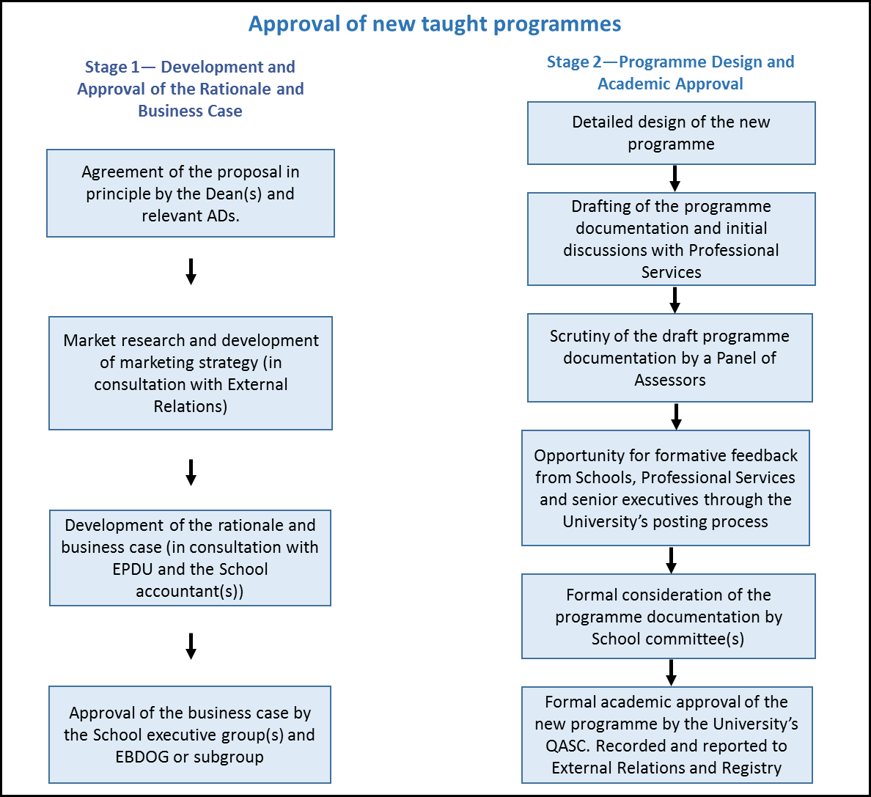

Appendix 3
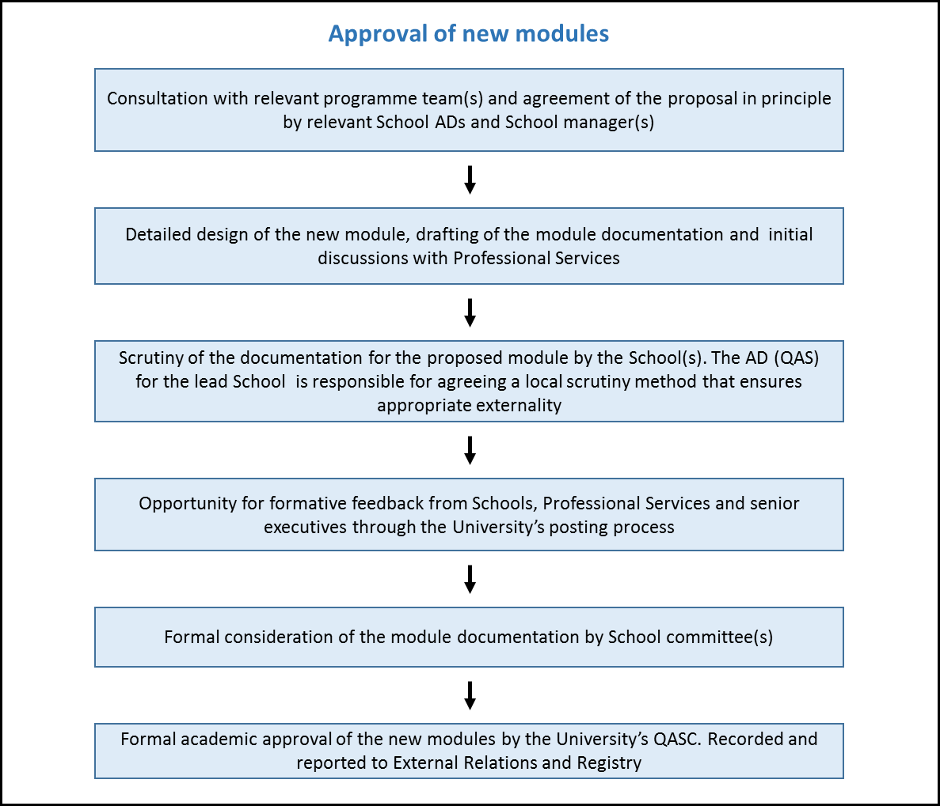

The PSSI documentation must include the separate marketing information in the ‘Update My Course’ form required by External Relations.
The School Quality and Academic Standards Committee (or equivalent) and/or the School Board depending on the arrangements for delegation of authority by School Boards.
The suggested minimum period is 2 years for undergraduate programmes and 1 year for postgraduate programmes.
The Equality Act 2010 describes the terminology of 'protected characteristics' to define groups covered under the legislation. These are Age, Disability, Gender Reassignment, Marriage and Civil Partnership, Pregnancy and Maternity, Race, Religion or Belief, Sex, and Sexual Orientation.

