Archiving is an important last step in the management of a research study. It is important to take the time to collate, prepare and record information accurately on the Archiving Record Form.

At the point of archive, the study must be complete and all relevant information must be filed in the Investigator Site File (ISF). Confirmation from Sponsor must have been received verifying the end of study date and that the study can proceed to archive. There should be no further access to the data required. For electronic media, consider retention of hardware and software.

If you need advice ahead of study archiving contact tay.tascarchiving@nhs.scot

Step 1: Where to Start - Preparing Archive Box Content

Collate all the relevant study information as specified in the Archiving Plan (as available) noting only Essential study documents are to be archived.

Essential study documents include:

- Investigator site file
- Study reference folder (if provided by Sponsor)
- Pharmacy file (for CTIMPs)
- Lab folder (if provided by Sponsor)
- Patient study information.

Only study specific information is required in the patient study information:

- CRFs
- Workbooks
- Patient diaries
- Sponsor generated results
- Copies of study ECGs etc with only participant study ID
- Original consent forms and recruitment log in a sealed A4 envelope (patient identifiable information).

Where required create a certified copy of data.

Source data to be archived should be anonymised and linked to subject ID. Any other identifiable source data should be removed and placed in the subject’s medical record.

Some sections of a trial master file do hold identifiable information e.g. enrolment logs and consent forms. Do not redact the names. Mark the index to state which sections contain identifiable information so this is clear to any future user and blind the data e.g. place in an A4 envelope.

Please keep in mind that all localised information must be filed in the subject’s medical record rather than being archived. If a patient is admitted to hospital it is important that all the information regarding the study and patient study visits is available. This may include:

- Localised blood results
- Localised tests i.e. ECGs, respiratory
- A copy of the consent form and patient information sheet (behind the red insert)
- Study visit information on NHS continuation sheets
- GP letters should be filed in the front of the subject’s medical record.

Step 2: When You Are Ready to Box Archive Documents

Contact tay.crc@nhs.scot to request the standard approved archive boxes for putting clinical research data into.
Give CRC an estimate of the number of archive boxes required together with number of archive storage bags plus plastic clips (if required) to help separate information within a box.
Agree a time to collect the flat packed boxes, archive storage bags and plastic clips from CRC reception.

It is vital the materials to be archived can survive archiving conditions. Paper will survive best whilst other materials will degrade over time.

- Take paper documents out of lever arch or other hard structure files as these add weight and may damage the archive boxes and data during transfer.

- Remove all metal tags, sellotape, coloured file dividers, elastic bands and polypockets. These rust, degrade or stain and may damage data.

- Photocopy items that are printed on thermal paper (e.g. ECGs, Spirometry), mark the photocopy as a copy, sign and date as a complete record. Ensure only the patient study ID is visible. The original is filed in the patient medical record.
- Avoid overfilling the archive boxes. An archive box should not contain more than one clinical research study due to the different retention times that will apply.
- Use storage bags and archive clips to partition sets of documents and hold them together. List the contents of the storage bag on the outside spine.

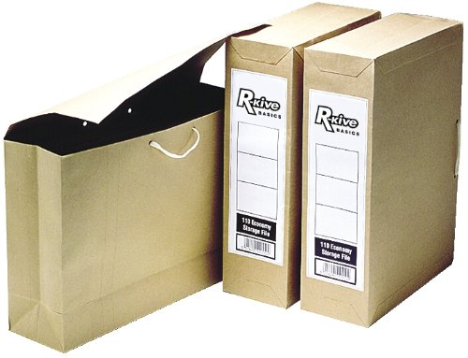

Step 3: Completing Your Archiving Record Form

- Complete one Archiving Record Form for each archive box. Email your draft Archiving Record Form(s) to tay.tascarchiving@nhs.scot
- The Archiving Record Form must specify the contents of each box i.e. ISF section 1 – 19; Patient Workbooks, Patient Original Consent Forms; Pharmacy File etc.
- You will need to have checked what retention requirement (how many years) will apply for study archiving as documented in the Protocol/IRAS, Contract agreement or other Sponsor documentation.
- Following review of the form the TASC Archivist will authorise archiving at a TASC designated off site archive facility.
Step 4: Boxes Ready to Archive – What Now?
Once you have a signed and authorised Archiving Record form, contact tay.crc@nhs.scot to agree when to take the boxes to CRC. CRC Admin will sign to confirm receipt of each box on the form.
CRC Admin will organise courier collection for box transfer to off site archive facility and email the study team with a final version of the Archiving Record Form including box identifiers.

