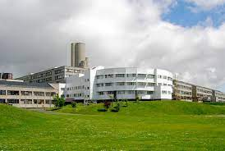

GO GREEN
MEDICAL SCHOOL SUSTAINABILITY STRATEGY
----------------------
2023-2025

We are not powerless against Climate Change

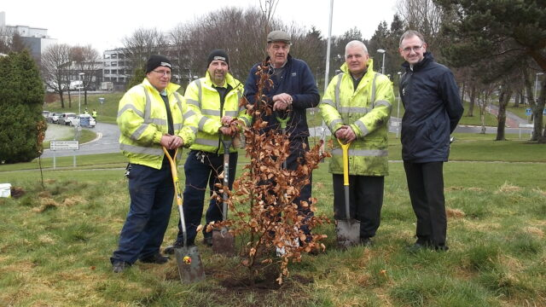

CONTENTS
AIM:
- Our Aim
- Our Mission Statement
- Our Policy
- Benchmarking Our Sustainability Activity
  - Planetary Health Report Card (PHRC)
- Objectives of the PHRC
  - Planetary Health Curriculum
  - Support for Student-Led Planetary Health Initiatives
  - Research in Health and Environment
  - School Sustainability
  - Community Outreach and Advocacy
- Introduction to the Sustainability Team
6.0 Objectives, Actions & Responsible Leads
6.1 Student Education
6.2 Staff Engagement and Education
6.3 Community Engagement
6.4 Energy
6.5 The Circular Economy:
Waste, Reduce, Reuse & Recycle
6.6 ‘Green Sustainability’
6.7 Travel
6.8 Sustainable Food
6.9 Sustainable Procurement
7.0 Resource
8.0 Conclusion
9.0 Appendix1: Measurable metrics for PHRC

Our Aim is to embed sustainability throughout our working practices, as well as integrate it into student education, research, and our professional support services.

MISSION STATEMENT: To incorporate sustainability into all aspects of the Medical School’s activities, including Research, Teaching and Administration, and by our actions aid the University of Dundee move towards a Net Zero stance. We will:
• Pass on to, and learn from, others’ Best Practice
• Send our students out into the world best equipped to attenuate climate change and build resilience to it.
• Achieve the highest possible level of sustainable behaviour in our labs, offices, and teaching areas
- Develop and implement plans to ensure that the Medical School achieves the University’s is commitment to achieve Net Zero carbon emissions no later than 2045

POLICY:
The purpose of this document is to set out plainly and simply the University's Medical School commitment to sustainable development and effective environmental stewardship as per the UoD Environmental and Sustainability Policy Statement.(https://www.dundee.ac.uk/corporate-information/environmental-sustainability-policy ). This policy is integral to its social purpose and determination to making a difference, as stated in the University Strategy 2022-27. As a “triple intensity” University, we are striving to contribute to a more sustainable future, locally and globally, through our education mission, impactful research and engagement and enterprise activities. The University of Dundee’s commits us to confronting head-on the challenges and uncertainties that society is facing and supporting the delivery of the UN Sustainable Development Goals. We will develop priority academic themes, actions and objectives to provide focus and concentrate our impact on those areas where we can make the most difference.

BENCHMARKING OUR SUSTAINABILITY ACTIVITY
The University as a whole has been assessed for its institutional approach to sustainability via the ‘People and Planet University ‘Green’ League’. This compares global Universities based on a wide selection of criteria, which considers issues such as sustainability in the curriculum and community engagement.
.Unfortunately, our university has come 124th out of 153, just falling into the ‘failed’ classification by 3 places. Since 2019, the University reports our activities as a signatory to the SDG Accord and submits evidence to The Times Higher Education University Impact Rankings which has provided further opportunities for comparison with other learning organisations in terms of our University’s commitment to supporting activity to achieve our carbon reduction. We aim to aid the University in improving its scores in these metrics.
The only measure of a Medical School’s Sustainability credentials, as a stand-alone school, is via the Planetary Health Report Card. Students from the Medical School submitted in 2020, and our aim is to improve on the scores allocated at that time for our submission in 2024.
We have also applied to be admitted to The Planetary Health Alliance who will scrutinise our activities so far. The Planetary Health Alliance is a consortium of over 340 universities, non-governmental organizations, research institutes, and government entities from around the world committed to understanding and addressing global environmental change and its health impacts. We hope to to be assessed and admitted as a full member.
Other metrics outwith those of the Planetary Health Report Card will be monitored and reported.

THE PLANETARY HEALTH REPORT CARD
The current strategy revolves around optimising the 5 metrics outlined in the Planetary Health Report Card (PHRC). This card report will provide a number of benefits. It allows focussed, targeted and achievable objectives; it involves all staff and students; and it will provide us with an external assessment of our work.
(https://phreportcard.org/)
The Planetary Health Report Card is a metric-based tool for evaluating and improving planetary health in health professional schools. At each participating institution, students, and faculty- teams fill out the report card, identifying opportunities for improvement and reaching out to relevant staff and faculty along the way. Results are published in an annual Earth Day report, which helps track institutional change over time.
The hope is that this initiative will inspires our engagement, for our future, and for our planet. We aim to submit by June 2024, and again, after feedback in 2025.
The 5 areas are as below.
1. Planetary Health Curriculum
Today's medical students will be on the frontlines of tackling the impacts of environmental degradation on human health. It is critical that medical education reflects those health threats. We are ensuring our Curriculum fulfils these needs.
We shall also ensure that all undergraduate and postgraduate students in the medical school, along with staff, are provided with opportunities for learning about Sustainability..
2. Research in Health and Environment
Interactions between health and the environment are complex and multifactorial. While climate change has been extensively studied planetary health is an emerging field. As we area a leading health institution with talented researchers and research resources, there should be research in:
a. studying environmental health
b. the health effects of climate change
c. climate solutions
We will assess all our publications for these areas, encourage interdisciplinary research with other schools e.g., geography, and provide information on relevant grant sources as required for future projects.
3. Community Outreach and Advocacy
It is important that our institution also directly engages with our communities. Although climate change is a problem largely created by those with power and resources, its impacts fall disproportionately on marginalized populations.
We will assess and support our level of engagement within the community of the whole of Tayside, in terms of Planetary Health, and encourage lecture, papers and podcasts for such activities.
4. Support for Student-Led Planetary Health Initiatives
Institutions should provide support for students to engage in sustainability quality improvement (QI) initiatives, discover mentors in their area of interest, & convene in student groups (funding for planetary health is available). We will encourage various student projects with sustainability themes, including healthcare design and avoiding harm and waste.'
We will build on our development of Planetary Health modules, and welcome suggestions for these from staff and students.
5. School Sustainability
The healthcare industry is a major contributor to greenhouse gas emissions as well as pollution that harms local, regional, and global ecosystems. Our medical school should sustainably source energy, food, and supplies; we should ensure institutional investments are free of fossil fuels and we will ‘green’ our lab spaces and hold ‘green’ events. Airmiles for researchers will be evaluated and virtual presentations at meetings will be encouraged. Waste and Energy are NHS issue, and we are liaising with them about these.

THE SUSTAINABILITY TEAM IN THE MEDICAL SCHOOL
To achieve high scores in these 5 metrics, we have established ‘LEADS’ in each area, forming the Medical School Sustainability Committee. They will take forward activities with ‘Sustainability Champions’ within their areas. Medical Students will be a key feature in each domain and provide both leadership and feedback for the PHRC. The PHRC Team is led by Anna Anas, and her team of medical students. We will be allocating students to each of the 5 areas to work with the staff teams below. Updates will be provided via our Newsletter, Webpage and SharePoint.
The current structure is below, showing the different areas and staff so far volunteering to work within the areas.
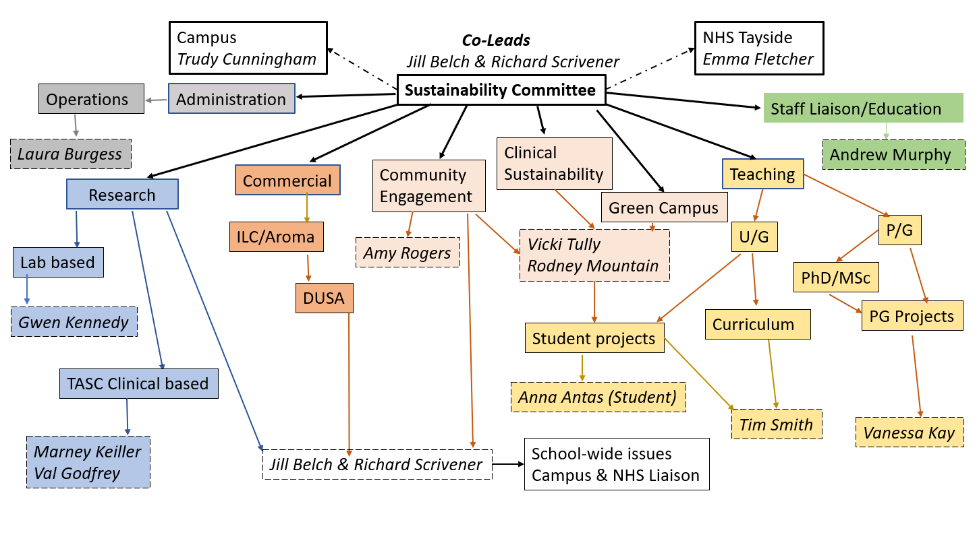
Leads as below:
Objective No 1a: Planetary Health Curriculum: Students
Tim Smith, Vanessa Kay, Rodney Mountain, Vicki Tully
Objective No 1b: Planetary Health Curriculum: Staff
Andrew Murphy, OPD Team
Objective No 2: Research in Health and Environment
Jill Belch, Discovery team
Objective no 3: Community Outreach and Advocacy
This area is led by Amy Rogers from Public Engagement.
Vicki Tully, Jill Belch will also focus on Outreach and Advocacy within the Community.
Objective No 4: Support for Student-Led Planetary Health Initiatives
Tim Smith, Vanessa Kay, Rodney Mountain, Vicki Tully.
Links with the Eden Project team – projects aimed at green health & wellbeing and initiatives aimed at supporting nature-based health and care

Objective No 5a: Laboratory and Clinical Research Sustainability
Gwen Kennedy, Laura Burgess, Val Godfrey, Marney Keiller.
Objective No 5b: Operations Sustainability
Laura Burgess, Richard Scrivener
Objective No 5c: General School Sustainability
Jill Belch, Richard Scrivener, Laura Burgess, Gwen Kennedy
Our team will continually review our planetary health engagement, and work to improve it, bringing in new people as needed. The agreed initiatives are listed below, along with objectives and responsible leads for each item.

- STUDENT EDUCATION:
Objectives: To embed the topics of planetary health and sustainable healthcare into the undergraduate medical curriculum, so that the default way of thinking for a Dundee Medical Graduate is to view the practise of medicine and clinical decision making through the lens of ecological sustainability, as this will ultimately benefit patients, public health and the natural environment.
Actions: To date, a number of lectures, workshops and SSCs have been integrated into the undergraduate curriculum. For further information there is a page on Medblogs:
Responsible Lead: Tim Smith
Undergraduate Year 1:
- Introduction to Planetary Health, Sustainable Healthcare and Environmental Advocacy (lecture)
- Sustainable Nutrition (lecture)
- Planetary health SSC
Year 2:
- Climate change and health workshop
Year 3:
- Our Natural Health Service SSC
Year 4:
- Environmental Sustainability Online Module (about to go live)
Year 5:
- Environmentally sustainable clinical practice / SusQI SSC
But there is more work to do, in order that these topics are not seen as of secondary importance to more traditional areas of teaching, or as an optional area of the curriculum. However, there are a number of other lectures and SSCs that are related to sustainable healthcare teaching, in that they share similar themes and principles, but which have not all been mapped. It will be important to map these, for the purposes of creating a meaningful environmental sustainability curriculum for the students, and for completion of the Planetary Health Report Card. For example:
- Realistic Medicine SSC (Year 3 – Rod Mountain)
- Global Citizenship teaching (Carolyn Tipton)
- BMSc in Global Health (Neil Merrilees)
Further Undergraduate and Postgraduate Actions:
- Completion of the PHRC for 2024 (Anna Antas and colleagues)
- Within all Healthcare Improvement SSC’s which are a core option fro students, sustainability teaching will be included and sustainability being a key focus when improving/designing new products, services and environments. (Vicky Tully, Rodney Mountain)
- Add elements of assessment
  - the online module will be assessed in the portfolio.
  - TS will work on some more SBA questions.
- Staff development
  - to support staff who wish to include sustainability topics in their teaching.
- Develop links with the proposed Eden Project Dundee (Vicky Tully, Rodney Mountain)
- Make use of the UoD Botanic Gardens for student projects, research, and community engagement initiatives (Vicky Tully, Rodney Mountain)
- Collaborating with the Living Lab and learning for sustainability at the UoD Botanic Gardens for student projects, research and community engagement initiatives (Vicky Tully, Rodney Mountain)
- Research
  - TS will be researching how to optimise planetary health education as part of his doctoral research
  - Encouragement and support for student research projects
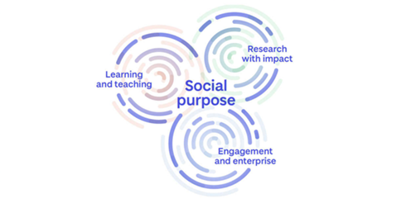
Responsible Leads: Tim Smith, Vanessa Kay, Vicki Tully, Rodney Mountain

- STAFF ENGAGEMENT AND EDUCATION:
We all understand the potential impacts of climate change on public health, health infrastructure, political stability, and global cooperation. Hopefully all of us within the Medical School will engage in the preparation of the June 2024 submission, and thereafter. Help is welcome! One of the ‘Threats’ in a SWOT analysis of this strategy document is staff involvement. An initial enthusiastic meeting was later met with unanswered emails, job moves and failed promises of replacements. It has been challenging and disappointing. However, the current revamped team are enthusiastic, informed, and have already started work in their areas. The enthusiasm of our student lead (Anna) has led to the recruitment of students for the PHRC in the double figures already.

- Staff Questionnaire:
Objective: To ask the question “How would you alter the Medical School to improve our climate & environment?” and to foster engagement and ideas.
Action: A questionnaire is being drafted to go onto webpage, SharePoint and Newsletter. A period of 4 weeks will be given to complete. A report of the analyses will be prepared
There is also a ‘Contact us’ section on the webpage and SharePoint.
Responsible Lead: Andrew Murphy

- OPD Training
Objective: To integrate Sustainability Training with formal OPD for the medical school.
Action: Discussions are ongoing with Trudy Cunningham, Eithne Graham, Andrew Murphy, Jill Belch, Ricard Scrivener to formalise Podcasts we have, and to set up an afternoon each year on Sustainability. Links to relevant Podcasts will be inserted into Newsletter, webpage and SharePoint.
Responsible Lead: Andrew Murphy
- Prestation of Strategy to Medical School at all-staff meeting
Objective: To raise awareness of the work of the Committee, to promote staff engagement, and to receive new ideas.
Action: Presentation at 25th April All staff meeting
Responsible Leads: Richard Scrivener, Jill Belch
- Lunchtime ‘Grand Rounds’
Objective: To reach a wider audience across NHS and Medical School regarding sustainability aim, gather ideas, and promote staff engagement
Action: To reserve a lecture slot in the next academic year.
Responsible Leads: Jill Belch, Richard Scrivener, Andrew Murphy.
- Sustainability School Champions
Objective: To develop a Sustainability School Champions network to allow staff and students to come up with their own sustainability initiatives, help develop the school’s projects, and make their areas sustainable, rewarding places to work.
Action: These champions will be a group of enthusiastic staff who help improve the environmental performance of the school by raising awareness of environmental issues within the Ninewells Campus.
They will promote environmental initiatives and run awareness campaigns on topics such as:
- reducing waste
- using energy and water efficiently
- sustainable travel
- sustainable purchasing
Suggestions can be made via our email: Med-Sustainability@dundee.ac.uk
Responsible Leads: Ricard Scrivener, Laura Burgess, Gwen Kennedy
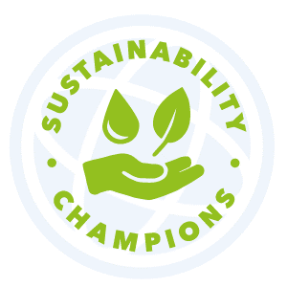
- Sustainability Action Week
Objective: To raise awareness on sustainability issues and engage staff with of our Sustainability endeavours.
Actions: Sustainability Action Week is due to be held ******* (possibly same week as tree planting? November ‘23.)
We will invite staff and students to join us for a dedicated week of activities and events to raise awareness about environmental and social issues. This year we're focusing on sustainable travel, waste and recycling, and the UN Sustainable Development Goals
Responsible Leads: Richard Scrivener, Jill Belch, Andrew Murphy
- SharePoint and Webpage.
Objective: To provide up to date news on activities, to encourage involvement, and gather new ideas. They will host initiatives such as the questionnaire, advertise such items as ‘switch off labels’ and timers, and provide information about the ongoing PHRC initiative.
Action: SharePoint is up and running
(Sustainability (sharepoint.com)), the Newsletter is already going out, and the webpages have been written, awaiting finalising
(draft: https://prod-acquia.dundee.ac.uk/medicine/sustainability )
We later plan to announce initiatives on the school large screen and will continue with our Newsletter.
Responsible Leads: Jill Belch, Richard Scrivener
- Go-Green tagline.
Objective: To have an easily recognisable tag line/image to which staff and students can identify our initiatives, raising awareness and encouraging involvement.
Actions: ’gogreen’ is an insight-based campaign that is being designed to reach out and connect with students and staff and provide a framework for all sustainability-based communication. ’gogreen’ will help us to demonstrate our commitment as a school to tackling climate change, as well as empowering everyone to step up, take action and ensure all know sustainable views matter.
In designing the campaign, we worked with our staff and students to better understand attitudes towards environmental sustainability. Through this we know that:
- They are keen for the school to be more sustainable place to work and study
- They want to know what the school is doing to increase recycling on the Ninewells Campus
- They are ready and willing to help the School on this journey
- They now want to know what action to take.
gogreen Logo designed by Richard Scrivener

- COMMUNITY ENGAGEMENT:
Objective: To embed sustainability in our dealings with our local community of Tayside, to educate, and to learn from them how they wish to help, give ideas and engage with the Medical School.
Action: To provide speakers for lay lectures, and to host a Saturday meeting as part of the UoD Saturday lectures. We have already given two lay lectures on Air Pollution, one to XRDundee, and the other to Royal Environmental Health Institute of Scotland, and a further one planned to Scotland’s Environment: Air Quality, Scotland. The Public Engagement Team will discuss this at their next meeting and will either allocate a representative or provide information.
Responsible Leads: Jill Belch, Vicki Tully, Amy Rogers

- ENERGY:
- ‘Switch off’ labels & Timers.
As below energy is the PRIMARY responsibility of the NHS. However, the Medical School can significantly reduce its own energy use.
Objective: To reduce energy use by switching off unnecessary lights and equipment, but to protect machines that must not be switched off. To ensure machines that need warm up time can utilise timers set early in the morning. as opposed to being left on all night, and be ready for use at start of working day.
Actions: Labels and timers already advertised in our Newsletter, SharePoint and Webpage. How to source these from Trudy (T.Z.Cunningham@dundee.ac.uk) also provided
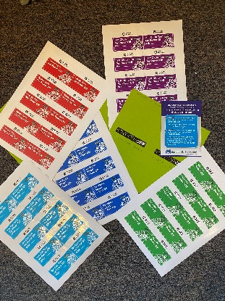
Responsible Lead: Jill Belch, Gwen Kennedy, Laura Burgess
- My Green Lab Freezer Challenge
Objective: The School of Medicine are planning on taking part in the My Green Lab Freezer Challenge 2023. Ultra- low (ULT) temperature freezers are one of the most energy-intensive pieces of equipment found in labs. A solitary freezer running at -70°C instead of -80°C can produce 30% energy savings. This equates to financial savings of around £300 annually.
Actions: To date a limited number of -80⁰C freezers have had their temperature decreased to -70⁰C. The School is registering for the my green lab freezer challenge in 2023, this will result in all -80⁰C freezers having their temperature reduced to -70⁰C. All research groups will have to inventory their -80⁰C freezer(s) and determine which samples can be disposed off, this could result in some freezers being switched off for a period if no longer required for a time. These measures will result in a significant reduction in energy consumption across the School.
Each lab group will be given a set of tasks under the headings good management practices, temperature tuning, retirements and upgrades, sharing and room temperature sample storage. Laura and Gwen from the SOM Sustainability Group will guide researchers through this process. Each group with then individually answer questions associated with these tasks. The answers will them all be combined for the whole school and submitted to the international My Green Lab Freezer Challenge 2023.
Responsible Leads: Gwen Kennedy, Laura Burgess
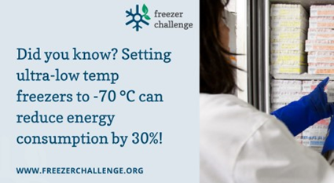

- CIRCULAR ECONOMY:
WASTE, REDUCE, REUSE & RECYCLE:
A circular economy focuses on reducing wastage and pollution with repair, reuse and reduction. In addition, it also emphasizes restoring natural systems while creating conditions for supporting regeneration.
- Sustainable Waste
Waste impacts the social, environmental and economic aspects of the sustainable development and the good governance of the university. Beyond legal compliance issues the University is committed to the hierarchy of Reduce, Re-use, Recycle and consideration of the whole life cycle of resources when specifying procurement at all levels. These principles are communicated to all who have relevant contact with the University such as contractors, suppliers and students.
Objective: To reduce the amount of waste produced by the Medical School
Actions: Working with our colleagues in NHS Tayside we are now setting the ambitious target of achieving a recycling rate of 80% and are also working with our waste contractors to set targets to reduce our total waste output.
Responsible Lead: Richard Scrivener
- Reduce
Objective: To reduce plastic bottle waste in the medical school
Action: We now have 3 water fountains placed in each of level 6, 4 in level 7 lab block, and two in the student area on levels 7 and 8. We have significantly reduced our plastic waste by removing the big plastic water containers. We are currently recycling two water fountains from the Mackenzie building to be placed on level 5 lab block and in the blue lino student area.
Responsible Lead: Jill Belch
- Reuse
  - Unwanted Stationary
Objective: To reuse as much stationary as possible by making it available for staff and students in a centrally located place.
Action: Currently this is a cardboard box in the ‘blue lino’ area, holding PollyPockets, folders, excess paper etc. Once the Mackenzie Building is emptied an unlocked cupboard will be available and staff will be encouraged to leave reasonable quality unwanted stationary therein.
Responsible Lead: Laura Burgess
  - Unwanted Kit
    - Many items have gone to the Mercy Ship circling round Madagascar & Freedom from Fistula, in Malawi, over the past year eg obsolete laryngoscopes to Malawi
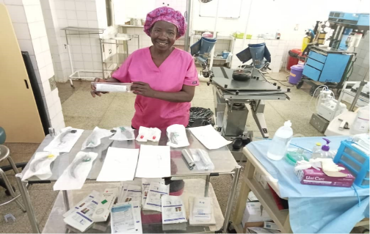
Underway is a collection of used medical staff scrubs, & sheets not up to UK standard but required in Africa.
    - MRI scanner has been donated to Romania.
    - Many unwanted articles went to Ukraine.
Action: Unwanted machinery and other items will continue to be donated where appropriate reducing our carbon footprint and contributing to social equality. One issue that prevents more going is arrangements that both the NHS and UoD have that IT obsolete/broken equipment cannot be reused but must be returned to the purchaser. We will investigate if this must be so. All excess drugs must be bar coded to be sent and so must come direct from the supplier, however where there is a large excess of drug from a clinical trial, the company may, if requested, re code the drug for onward travel to Africa via Intercare, which is a charity specialising in the transfer of unwanted medications to Africa.
Responsible Leads: All Committee
- Recycle
Objective: To ensure staff members are aware of correct recycling procedures
Action: Unwanted additions to recycling bins means much can be thrown out eg food stained containers, glossy paper etc. Staff education through our Newsletter, Webpage and SharePoint will be undertaken. Discussions are taking place with NHS Tayside to significantly improve the recycling rate within Ninewells hospital. We are now setting the ambitious target of achieving a recycling rate of 80% and are also working with our waste contractors to set targets to reduce our total waste output.
Responsible Leads: Richard Scrivener, Jill Belch, Laura Burgess, Gwen Kennedy
- Sustainable Laboratories
Our laboratories are some of the most resource-intensive places here at the School. But all laboratories users can take positive actions to reduce the environmental impact of their work.
Objectives: In addition to the Green Freezer challenge and circular economy work as above, a general effort will be made to reduce energy consumption and increase recycling within laboratories throughout the School.
Actions: We will ensure that:
- Surplus equipment is given to shared facilities or research groups to minimise unnecessary equipment purchasing.
- Improve on the currently limited number of laboratory plastics being recycled, currently only Starlab pipette tip boxes and empty Ethanol and Methanol bottles from VWR. We will investigate and implement what additional items associated with laboratory research can be recycled.
- Reduce sash height on fume hoods when not in use to reduce energy consumption, exhaust fan speed and volume of air extracted via extract system.
- Shut down safety cabinets when not in use to reduce energy consumption.
Actions: We will work to engage staff & students to:
- Be aware of the Laboratory Efficiency Assessment Framework (LEAF). LEAF contains actions which lab users can take to save water, energy, plastics and other resources.
- Recycling used Lab equipment & electronics is important. By recycling old equipment we are ensuring the hazardous contaminants are kept from landfills or locations where they impact the local environment
Responsible Leads: Gwen Kennedy & Laura Burgess
F: ‘GREEN SUSTAINABILITY’:
- Tree Planting
Objective: To continue to the ‘greening’ of the outside Ninewells’s estate, both outside and in.
Actions: As global temperatures continue to rise, we need to use every tool available to fightback against climate change. One of the greatest weapons we have is trees. Trees are fantastic for absorbing CO2 from the atmosphere and protecting nature and wildlife from the adverse impacts of climate change, and we need more of them!
The Woodland Trust are organising a big planting season over November 2023, where student communities across the UK will be planting trees to help combat climate change. With the Ninewells Garden we have applied for a 30 sapling pack will cover around one tennis court, or create 6-8 metres of double-row hedging. We will be looking for staff to help with our ‘medical student planting weekend’ in November. More info to follow nearer the time.
A planned wildflower garden outside the library will take shape, as will ‘greening’ round the Clinical Research centre area.
Responsible Leads: Anna Ananas, Jill Belch, Richard Scrivener
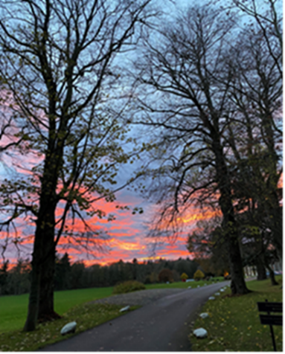
- Plants for Work
Objective: To continue to the ‘greening’ of the inside of the Ninewells’s estate. Having a growing plant in your room at work provides a pleasant ambiance and is ‘said’ to reduce stress (warning data not REF returnable ).
Actions: Cuttings have been taken providing20 new plants. On 5th May there will be FREE plants available on Level 7 blue lino area. We will also have a poster board to showcase our ambitions.
Responsible Lead: Jill Belch, Vicky Tully, Gwen Kennedy
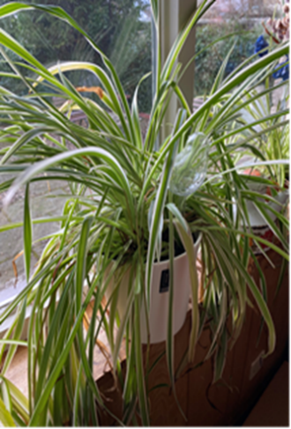
- Wildflowers
Objective: To continue to the ‘greening’ of the outside of the Ninewells’s estate
Actions: The planned Eden wildflower meadow is going to be planted at the front of the Medical School library building on Monday 15th May 2023 from 10 - 12 weather permitting. This will be a community sowing event so there will be information sent out over the next week to invite staff, students and the community to get involved. The larger meadow at the back of the hospital will be planted in September.
Responsible Lead: Vicki Tully

- Sustainable Art
Objective: To include ‘sustainable art’ in the portfolio of paintings on our walls to act as a reminder of sustainability, and of the reasons we want to keep our earth alive.
Action: Three new pieces of Art currently on display. These pieces all have one thing in common, Sustainability and Nature.
One piece is from award winning Dundee artist Katie Parkin with one of her pieces on display in the CRC reception area. The piece Auchmithie retinoates from her work exploring the geology of Scotland's coast through tactile natural materials such as ground rock from the cliffs together with charcoal as she investigates the rock formations, drawing attention to their variation and beauty while highlighting how erosion will change this coastline as sea levels continue to rise.
Responsible Lead: Richard Scrivener
- SUSTAINABLE FOOD
Objective: The University prides itself on being able to provide a wide and varied catering offer to enhance our staff and student experience here on the Ninewells Campus. This presents opportunities to ensure we do this in an ethical and sustainable way.
Action: The School of Medicine working closely with NHS Tayside for the procurement and provision of catering outlets across the Ninewells Campus especially in our own newly created Espresso Lab.

The Espresso Lab that opened in 2022 has been planned down to the last ‘bean’.

Responsible Lead: Ricard Scrivener

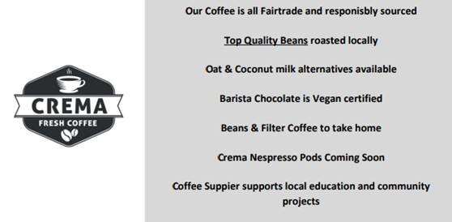

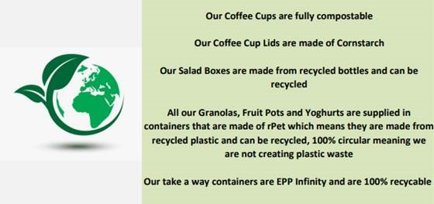

- SUSTAINABLE PROCUREMENT:
When spending University money (even if funds are provided by a research sponsor) we have a responsibility to get the best value. This does not always mean buying the cheapest and the suitability of the product or service, its reliability, flexibility of service, environmental impact, health and safety, insurance levels and associated costs are all critical factors in the decision to buy.

Action: In alignment with the European Union's Sustainable Development Strategy (EU SDS)1, true sustainable procurement we will take into consideration economic, environmental, and social factors.

- Economic impact of sustainability: e.g. Corporate governance, Ethical trading, Timely payment of suppliers

- Environmental impact of sustainability: e.g. Biodiversity, Climate Change

- Social impact of sustainability: e.g. Diversity in the workplace, worker's welfare and rights

The Benefits of Sustainable Procurement are:
- Minimise business risk.
- Provide cost savings - through focusing organisations on following a whole life costing methodology when sourcing goods and services. This would include reducing use, reusing, and recycling and ultimately reducing the amount of waste going to landfill.
- Enhance corporate image in the marketplace - by demonstrating purchasing and supply management's value to the organisation.
- Create markets for new products and services - by using technology to develop and market sustainable products that will initially attract consumers who are early adopters and command a premium price in the marketplace.
- Secure the supply of goods and services in the light of increasing environmental legislation Reduce waste and improve resource efficiency.

Objective: To ensure highest possible sustainability
Action: To use the sustainability checklist as below:
​​​​​​​
Checklist for Sustainable Procurement Consideration:
- Could I repair or refurbish the old item instead of purchasing a new one?
- Can I loan, lease or buy it from someone else/another department at the University?
- Is the product reusable or durable, have a long economically useful life and/or can be economically repaired or upgraded, compared to alternatives?
- All electrical goods must be A rated.
- Does the product make efficient use of resources? Does the product use energy, fuel or water more efficiently or uses less paper, ink, light or other resources?
- Is the product recyclable (and do local facilities exist that are capable of recycling the product at the end of its useful life)?
- Is the product biodegradable (will it take a long time to decompose in landfill)?
- Does the product contain recycled material? Do we really need to buy a virgin product when the recycled version is of the same quality?
- Does the product have minimal packaging and/or for which there will be take-back by the manufacturer/supplier of packaging?
- Does the product have minimal content and use of toxic substances in production and final product?
- Is the product purchased from local supplier, which minimizes the ecological footprint, such as transportation and packaging cost?
- Can the additional cost accounted for improved quality be reimbursed in lower operating costs over 5 years? If you are unsure about how to calculate the total costs of buying, operating and disposing of a piece of equipment (known more commonly as Whole Life Costing) please contact the Procurement Office who can assist you.
- Does the supplier have ISO 14001, another Environmental Management Standard or other Eco-Label that meets certain standards?
- For disposal, the University has an agreement in place with Transform who will arrange uplift without charge.
Responsible Lead: Richard Scrivener, Laura Burgess

- TRAVEL:
- Reduction in staff Air miles
Objectives: To reduce air travel and production of associated emissions by staff.
Action: Baseline travel for the School of medicine is being assessed via access to travel agent bookings. Carbon production is being estimated for 2020 and 2021 giving us a base to work from. Staff will be encouraged to try to convert, attend meetings to virtual or hybrid where possible.
Responsible Lead: Jill Belch
- Cycle to work scheme
Objective: To publicise and encourage staff to apply for the UoD cycle to work scheme. The scheme is an employee benefit that saves employees 25-39% on a bike and accessories. It also encourages alternative travel and reduces our environmental impact.
Action: There are two application periods: May and September, we will announce it on all our School sites
Responsible Lead: Richard Scrivener, Jill Belch
- Electric vehicles
Objective: The UoD has a number of eVans which is has given to various Schools we hope to be successful in obtaining one.
Action: We have already out in a request for this via UoD Sustainability Officer
Responsible Lead: Richard Scrivener
- Electric Bikes
Objectives: To reduce the reliance of staff on vehicles for travelling the short distance between Ninewells and other Campuses. This will reduce the air pollution associated with these short journeys as double the amount of air pollution emitted from cars occurs within the first 5 minutes of journeys. In addition to reducing air pollution associated with our travel the use of e-bikes may also have a positive impact on well-being.
Action: Baseline travel could be assessed by means of a short questionnaire enquiring into the number of journeys staff/students make to and from Ninewells campus. With the relocation of the resource unit, it is anticipated that the number of short journeys made be staff/students will increase, further impacting the issues associated with carparking and pollution. The reduction in carbon pollution will be monitored by completion of paperwork required for accessing the e-bike. Staff/students will be encouraged to convert from personal vehicles to the use of the e-bike, or to attend meetings virtually.
Responsible Lead: Michelle Cooper
- RESEARCH
The School of Medicine is committed to integrating sustainability into everything that we do, and research is no exception. ​Our researchers are pushing the frontiers of knowledge and discovery to shape a more sustainable future. Through our interdisciplinary and partnership approach we are advancing knowledge and creating solutions to local, national and global sustainability challenges. And, in line with our awareness and governance, we are committed to ensuring a sustainable approach to research, through reduced environmental impact, and increased social and community benefits.
Objectives: To assess a ‘baseline’ of sustainable research, publicise this, and improve it further
Actions: All publications will be scanned for evidence of ‘sustainability’ research, a data base established, and strategies devised to ensure such research continues in even larger amounts. We will ensure that the area on Discovery which classifies the sustainability of publications is correctly completed.
Responsible Lead: Jill Belch with Discovery Team
Clinical Research
Sustainability in TASC and the CRC will be led by Marney Keiller
Val Godfrey. Projects to follow
RESOURCE:
No formal resource in terms of staff time or finance have been allocated to Sustainability, however some funds have been found for some support, and grants can be written. It is fair to say however, that this will necessitate a slower progress than if otherwise, and expectations for this committee should be informed by this.
LIAISON WITH THE NHS
The NHS in Ninewells has a Policy Document on Sustainability and Environmental Management Policy due for review in 2023. We will try to have a UoD Medical School member on this committee as waste and energy are an NHS remit in Ninewells. We have already met with the NHS Sustainability Lead. Vicky Tully sits on both the NHS and Medical School sustainability committees and will provide liaison, along with Richard Scrivener.
CONCLUSION:
The latest IPCC synthesis report recaps its previous findings which includes warnings that we are approaching ‘irreversible’ levels of Global Heating, with catastrophic impacts becoming irreversible, and it is ‘now or never’ to take drastic action.
Through the actions outlined above we propose to significantly reduce our carbon footprint, encourage our community to join with us in this, address the inequalities we can, and help UoD achieve it net zero goal in 2045.
APPENDIX 1: MEASURABLE METRICS FOR PHRC
SECTION | ACTION | COMMENTS
PLANETARY HEALTH CURRICULUM
133.1 Did your medical School offer elective courses (student selected modules) to engage students in Education for Sustainable Healthcare or Planetary Health in the last year? | yes
133.2 Does your medical School curriculum address the relationship between extreme heat, health risks, and climate change? | yes
133.3 Does your medical School curriculum address the impacts of extreme weather events on individual health and/or on healthcare systems? | Unsure ask Tim
133.5 Does your medical School curriculum address the respiratory health effects of climate change and air pollution? | Yes
133.7 Does your medical School curriculum address the mental health and neuropsychological effects of environmental degradation and climate change? | Unsure ask Tim
133.20 Is your medical School currently in the process of implementing or improving Education for Sustainable Healthcare (ESH)/planetary health education? | Yes
133.21 How well are the aforementioned planetary health/Education for Sustainable Healthcare topics integrated longitudinally into the core curriculum? | Yes all years
133.22 Does your medical School employ a member of faculty to specifically oversee and take responsibility for the incorporation of planetary health and sustainable healthcare as a theme throughout the course? | ?Tim, Vicki and Vanessa?
RESEARCH IN HEALTH AND ENVIRONMENT
2.1 Are there researchers engaged in planetary health research and healthcare sustainability research at your medical School? | Jill, Discovery to sort
2.2 Is there a dedicated department or institute for interdisciplinary planetary health research at your institution? | Unlikely to acjieve?
2.3 Is there a process by which communities disproportionately impacted by climate change and environmental injustice give input or make decisions about the research agenda at your medical School? | Lay lectures – Jill/Richard and all. The Community Engagement Team are involved, also Eden project etc
2.4 Does your institution have a planetary health website that centralizes ongoing and past research related to health and the environment? | In progress
2.5 Has your institution recently hosted a conference or symposium on topics related to planetary health? | To be done, Jill Ricard to organise
2.6 Is your medical School a member of a national or international planetary health or ESH organization? | In progress once website up application will be put forward
COMMUNITY OUTREACH AND
ADVOCACY
3.1 Does your medical School partner with community organizations to promote planetary and environmental health? | Yes, lectures on areas at conferences, Societies, Government Bodies, Royal College
3.2 Does your medical School offer community-facing courses or events regarding planetary health? | OPD and other training opportunities being set up - Andrew
3.3 Does your medical School have regular coverage of issues related to planetary health and/or sustainable healthcare in university update communications? | Newsletter  SharePoint  Webpage news  Large Screens
3.4 Does the institution or main affiliated hospital trust engage in professional education activities targeting individuals post-graduation with the aim of ensuring their knowledge and skills in planetary health and sustainable healthcare remain up to date during their professional career? | Tim, Vanessa, Rodney, Vicki
3.5 Does your medical School or its primary affiliated hospital have accessible educational materials for patients about environmental health exposures? | ?Leaflets/Posters for OP Clinics?
3.6 Does your medical School or its primary affiliated hospital have accessible educational materials for patients about climate change and health impacts? | ?Leaflets/Posters for OP Clinics?
STUDENT-LED PLANETARY HEALTH INITIATIVES
4.1 Does your institution offer support for medical students interested in enacting a sustainability initiative/QI project? | T/v/r/v again
4.2 Does your institution offer opportunities for medical students to do research related to planetary health and/or sustainable healthcare? | ??
4.3 Does the medical School have a webpage where medical students can find specific information related to planetary health and/or sustainable healthcare activities and mentors within the medical School? For example, projects achieved, current initiatives underway at the medical School and/or contact of information of potential mentors. | In progress
4.4 Does your medical School have registered student groups dedicated towards fostering a culture of planetary health engagement, scholarship, and advocacy on campus, supported by faculty advisors? | Yes, Anna and her Team
4.5 Is there a student liaison representing sustainability interests who serves on a medical School or institutional decision-making council to advocate for curriculum reform and/or sustainability best practices? | Yes, Anna Anas on committee
4.6 In the past year, has the institution had one or more co-curricular planetary health programs or initiatives in the following categories? | Tim, Vanessa, Vicki, Rodney
- Projects where students are able to gain experience in organic agriculture and sustainable food systems, such as gardens, farms, community supported agriculture (CSA), fishery programs, or urban agriculture projects | Ninewells garden?
- Panels, speaker series, or similar events related to planetary health that have students as an intended audience | As above Jill, Ricard and all
- Events in which students learn directly from members of a local environmental justice community about the climate and environmental challenges they face, and how health professionals can partner with their community to address these exposures and impacts | ???
- Cultural arts events, installations or performances related to planetary health that have students as an intended audience. | ??
- Local volunteer opportunities related to building community resilience to anthropogenic environmental impacts. | Planned tree plant Oct 2023  Ninewells garden
- Wilderness or outdoors programs (e.g., that organize hiking, backpacking, kayaking, or other outings for students). | YES as part of UoD Student clubs
CAMPUS SUSTAINABILITY
5.1 Does your medical School and/or institution have an Office of Sustainability? | Yes, us
5.2 How ambitious is your medical School/institution’s plan to reduce its own carbon footprint? | 2045 net zero as part of UoD strategy so better than PHRC at 2050
5.3 Do buildings/infrastructure used by the medical School for teaching (not including the hospital) utilize renewable energy? | No
5.4 Are sustainable building practices utilized for new and old buildings on the medical School campus, with design and construction of new buildings and remodeling of old buildings conforming to a published sustainability rating system or building code/guideline? | To assess
5.5 Has the medical School implemented strategies to encourage and provide environmentally-friendly transportation options for students and reduce the environmental impact of commuting? | eBikes eVan ? for students
5.6 Does your medical School have an organics recycling program (compost) and a conventional recycling program (aluminium/paper/plastic/glass)? | Yes
5.7 Does the medical School apply sustainability criteria when making decisions about the campus food and beverage selections (e.g. local sourcing, reduced meat, decreased plastic packaging)? | To do
5.8 Does the medical School or associated institution apply sustainability criteria when making decisions about supply procurement? | Richard, Laura
5.9 Are there sustainability requirements or guidelines for events hosted at the medical school? | To do
5.10 Does your medical school have programs and initiatives to assist with making lab spaces more environmentally sustainable? | Yes via Gwen (and Freezer with Laura)
5.11 Does your institution’s endowment portfolio investments include fossil- fuel companies? | To find out

